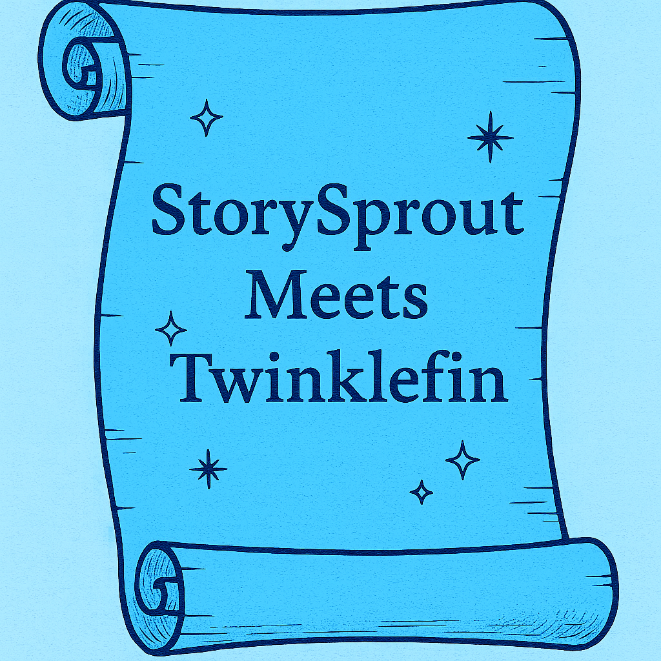

🌱 StorySprout’s Lakefront Secret
Whispers, Ripples, and a Magical Winter Friend

❄️StorySprout arrived at the south shore of Keuka Lake, before the sun even bothered to rise. After all of yesterday’s excitement, she decided to sit a spell before wandering through Hammondsport. Frost clung to the wooden dock like tiny crystal feathers, and the lake lay perfectly still — a mirror of midnight blue waiting for dawn’s first watercolor brushstroke. 🌙💧
She tiptoed along the planks, her sprout-sized boots making the faintest tap… tap… tap. 👢
With a shiver of delight, she sat at the very edge of the dock, dipped her toes toward the water, and whispered:
“Good morning, Keuka. What stories do you hold today?” 💬💧
The lake answered with a gentle ripple. 🌊
Then—PLINK!
A silver flash broke the surface. ✨🐟
Up leapt a trout unlike any she had ever seen.
His scales shimmered not just with color, but with memories — swirls of blue, flashes of gold, and tiny flecks that looked suspiciously like… stars. ⭐🌌
He hung in the air a moment before settling onto the dock beside her, perfectly dry and smelling faintly of pine and peppermint. 🌲🍬
“You’re StorySprout, aren’t you?” the trout asked, his voice warm and wise. 🎤🐟
She blinked. “I am! But… how do you know me?”
The trout smiled a very fish-like smile.
“I’m Twinklefin, guardian of Keuka’s deep stories. Every December, the lake grows quiet enough for magic to rise to the surface. I heard your laughter yesterday on the wind and followed it.” 🌬️✨
StorySprout gasped. “You followed my laughter?”
“Of course,” Twinklefin said.
“Laughter is just a story that’s learned to dance.” 💫🎶

And with that, he swished his tail and somehow painted shimmering streaks of starlight across the cold wooden boards. ✨🌟
They sat together at the edge of the world — elf and trout — watching the first softness of morning melt over Hammondsport’s hills. 🌄💚
Twinklefin told her stories kept only by the lake:
✨ How moonbeams sleep in the coves
✨ How the currents hum old lullabies
✨ How every snowflake ❄️ that falls on Keuka becomes part of its winter heartbeat
“Before you go,” he said at last, “take a piece of our stillness with you. A story travels farther when it begins in quiet.” 🌬️✨
He touched her hand with the tip of his fin — and a spark of silvery glow drifted into her satchel, settling beside her Sprout Scrolls. 💼🌟
StorySprout placed her palm gently on the trout’s head.
“Thank you, Twinklefin. I’ll share your magic with every child I meet today.” 🐟❤️
With a flick, he slipped back into the lake, leaving rings of light expanding across the surface. 🌊✨
As the sun finally stretched its golden fingers over the south end, StorySprout stood, heart humming. ☀️💛
A new story waited to be told, and thanks to a magical trout, it shimmered brighter than morning. 🌟🌅

🌱 Sprout Scroll
“A Sparkle from the South End” ✨
This morning I tiptoed onto the frosty dock ❄️ at the south end of Keuka Lake.
The world was quiet — the kind of quiet that glows. ✨
That’s when a magical trout named Twinklefin leapt beside me 🐟,
his scales shimmering like stardust. 🌟
He whispered a secret only the lake knows:
✨ “A story travels farthest when it begins in quiet.”
So today, slow your steps… listen for the hush of winter 🌬️…
and let your own story shimmer as brightly as Keuka at sunrise. 🌅
— StorySprout 🌱💫

