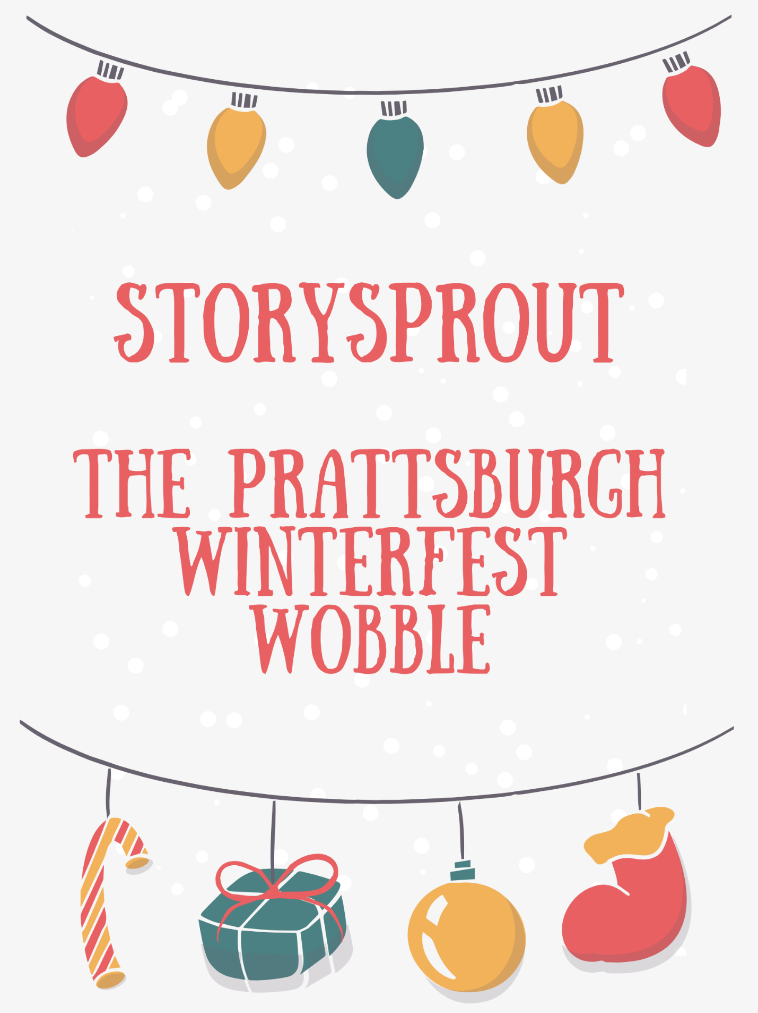
❄️🎄 StorySprout and the Prattsburgh Winterfest Wobble

On the chilly morning of December 5th, StorySprout fluttered toward Prattsburgh with her soft grey coat buttoned tight and her satchel full of blank scrolls. ❄️🧣✨
Winter rested gently on the hills, sparkling like sugared frosting, and excitement bubbled in the air. 🍬❄️
Tomorrow was Winterfest — a day filled with music, cocoa, laughter, and small-town magic. 🎶☕🎄
As she neared the village park, StorySprout saw volunteers bustling everywhere. Garland wrapped around lamp posts 🌟🕯️, wreaths hung from shop doors 🎀, and children tied red ribbons along the fences. The whole park glowed with anticipation.
But when she reached the center of the village green, a worried hush drifted across the workers.
The gazebo — the heart of Winterfest, the stage for music, Santa visits, and storytelling — was leaning. 😨🌲
Not falling over…
but leaning enough to make the lights crooked 💡😖, the garland droop 🎀⬇️, and everyone’s cheer wobble just a little.
“Oh no…” whispered a volunteer.
“That wind last night must’ve shifted it.” 🌬️
“We can’t have Winterfest without the gazebo!”
“How will we fix it in time for tomorrow?” 😟
StorySprout pressed a tiny hand over her heart. ❤️🌱
The gazebo was the centerpiece of Winterfest — without it, the entire celebration would feel dimmer.
She tiptoed closer, examining the wooden posts, the lights tangled around the railings, and the garland spilled across the snowy ground. 🎄❄️
“Hmmm,” she whispered. “This looks like a classic Gazebo Wobble.” 🤔✨

She rubbed a pinch of cinnamon sugar between her fingers and let the sparkles drift into the air. 🍂✨
The magic settled over the gazebo and revealed the source of the trouble:
One corner had sunk into softened ground from last night’s thaw. 🌧️➡️❄️
StorySprout straightened her tiny hat.
“Teamwork time!” she announced — even though only those with the magic of December could hear her clearly. 🧤💫
The volunteers suddenly felt a warm burst of determination. 🌟
Two men grabbed wooden blocks to brace the sinking corner. 🪵💪
A group of teens steadied the railing.
A child gathered the fallen garland and lights with surprising focus. 🎀
Another brushed snow from the base. ❄️🧹
StorySprout zipped around the gazebo, dusting cinnamon-sugar sparkle into every crevice. 🍂💫
The gazebo straightened…
a little…
a little more…
And then —
THUNK. 🛠️🎉
It settled securely into place, standing tall once more.
A cheer rose across the park:
“It’s fixed!” 🙌
“Winterfest is saved!” 🎄💖
“The gazebo looks perfect again!” 🌟
But StorySprout wasn’t finished.
She gathered the lights the children had untangled, looped them gently around the gazebo pillars 🌲💡, then flicked her fingers — sending a soft burst of shimmering magic through the bulbs.
They blinked…
glowed…
and then shone with warm, joyful brilliance. ✨💛
The gazebo transformed into a glowing heart of holiday cheer — sparkling like a postcard come to life. 📮🎄✨
Children gasped. 😲
Adults smiled. 😊
Someone whispered, “That’s Prattsburgh magic for you.” 💫
StorySprout giggled.
“Or maybe,” she whispered, “just a sprinkle of story magic.” 🌱✨
Before she fluttered away, she tucked a tiny scroll into the wreath hanging on the gazebo railing. 🎀📜
It read:
“When things tip,
when plans go askew,
a little help —
and a hopeful heart —
can pull the magic through.” ✨❤️🌲
With Winterfest saved and the gazebo glowing beautifully, StorySprout lifted into the frosty sky — cinnamon sugar swirling behind her like fairy snow. ❄️🍂🧚‍♀️
Tomorrow’s story was already calling. 🌙✨

