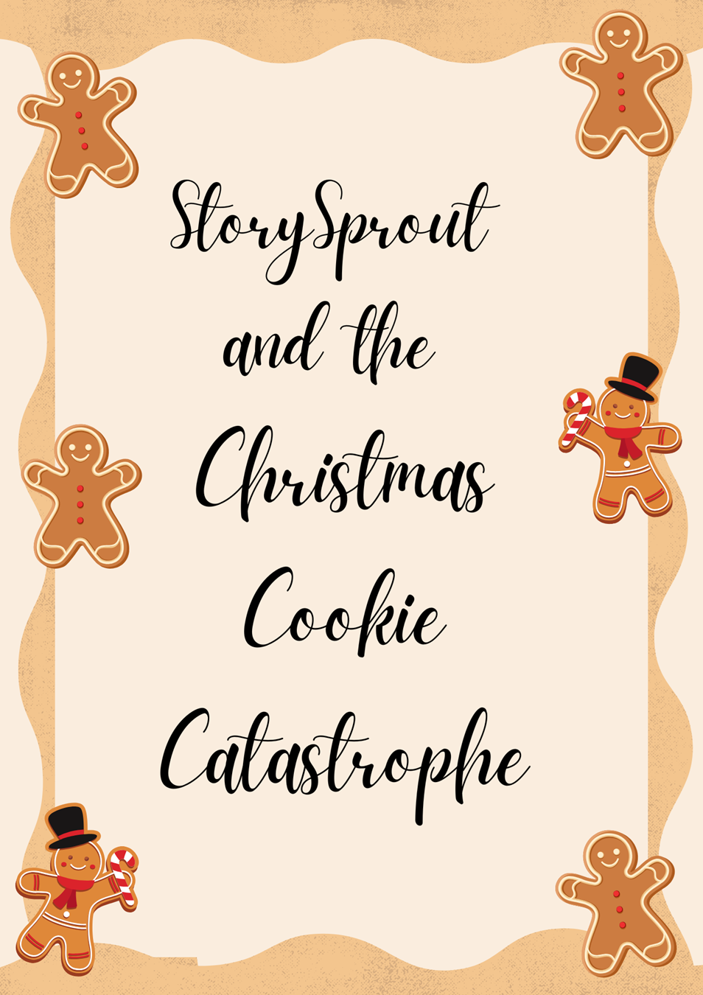

❄️🍪 StorySprout and the Christmas Cookie Catastrophe
With Cinnamon Sugar & StorySprout Magic

On her second morning around Keuka Lake, StorySprout woke to a smell so warm and sweet that even the snowflakes paused in midair to sniff it. ❄️👃✨
“Goodness,” she murmured, tugging on her soft grey coat. “What could that be?”
The scent drifted through Penn Yan like a friendly whisper—vanilla… ginger… and a swirl of cinnamon-sugar, her very favorite smell in the world. 🍪✨🌿 It tugged at her scarf like a playful elf and guided her straight toward a cheerful little bakery tucked beside Main Street.
Outside, a wooden sign read:
“Holly & Hearth Bakery – Christmas Treats Made Daily!” 🎄🍬
A few early birds waited on the porch, stamping their feet against the cold and peeking in the windows to see what treats might appear today.
StorySprout fluttered closer and saw row after row of Christmas cookies resting on cooling racks. Gingerbread people smiled up at the ceiling 😊, sugar-sparkled snowflakes shimmered ❄️✨, and candy-cane twists lay in perfect pepperminty stripes. ❤️🤍
“Oh, how lovely,” StorySprout breathed.
But just then…
just as she placed her hands on the windowsill…
something terrible—and slightly wobbly—happened. 😳
A stack of cookie trays, piled too high on the counter, tilted…
teetered…
wiggled like a bowl of Christmas pudding—
CRASH! 💥🍪😱
Flour puffed into the air like a snowy explosion ☁️❄️.
Sprinkles scattered across the floor like tiny holiday confetti 🎉.
Gingerbread people tumbled as if they were practicing somersaults in the North Pole gym. 🤸‍♂️🍪
Two children—baker’s helpers for the day—stood frozen in place, mouths open like Christmas stockings.
“Oh no!” one cried. 😨
“Not the gingerbread army!” gasped the other. 🍪🏃‍♂️🍪
The baker hurried over, wiping her hands on her apron. “It’s all right, loves. It’s just… a bit of a mess.”
“A big bit,” StorySprout whispered from the window.
She slipped inside through the tiniest crack in the door and landed softly on the counter, brushing cinnamon-sugar sparkles from her coat. 🌟🍂 The children gasped, for they had never seen a grey-coated elf before.
StorySprout put her hands on her hips.
“This,” she announced, “is a Christmas Cookie Catastrophe!” 🍪🚨✨
The children stared at the scattered cookies.
Some had smudged smiles. 🙂
Some had missing arms. 😬
One gingerbread man had frosting eyebrows on his chin. 😅
“I’m so sorry,” one helper sniffled. “We were trying to help.”
StorySprout shook her head kindly.
“You were helping. You just need a bit of Sprout-style teamwork.” 💛🌱✨
The baker smiled. “All right then, little one—show us your magic.”
StorySprout rolled up her sleeves (all the way to her tiny elbows) and began.
She showed the children how to hold the frosting bag gently, as if squeezing a snowflake. ❄️🤲
She taught them to rescue broken cookies by trimming the edges into stars and hearts. ⭐❤️
She dusted each tray with a special blend of cinnamon sugar—her signature scent—that made even the crumbled cookies smell like Christmas warmth. 🌟🍂🎄
“Remember,” she said, “mistakes are just stories waiting for a sprinkle of teamwork.” ✨👫🌱
Soon the bakery hummed with happy work.
The children giggled as they piped new smiles onto gingerbread faces 😂🍪.
The baker decorated the biggest cookie of all—a giant Christmas tree covered in gumdrop ornaments 🌲🍬.
StorySprout added a finishing sparkle of cinnamon sugar that glittered like morning frost. ❄️✨
By the time the first customers stepped inside, the trays were full again—so beautiful that no one could tell a catastrophe had ever happened. ✨🍪🌟
The baker bent down and whispered, “Thank you, sweet friend.”
StorySprout winked. 😉 “Thank the team. I just sprinkled the magic.”
Before she left, she set a tiny scroll beside the cookie display. The children found it when they swept the floor at closing time.
It read:
“Mistakes happen.
Magic happens too.
And when we work together…
the sweetest stories grow.”
-StorySprout 🍪✨💛
With her satchel warm with cinnamon-sugar and her heart a little fuller, StorySprout slipped out the door—
ready for whatever story tomorrow might hold. 🌙❄️💫

