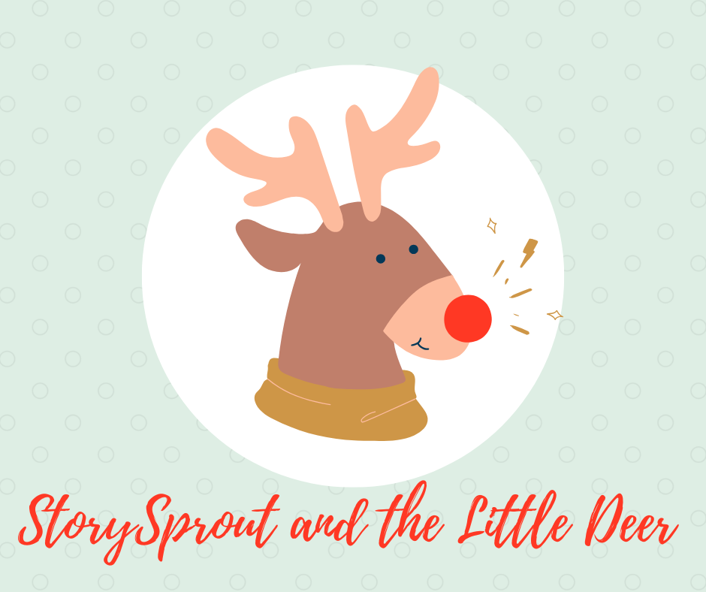

The Deer Who Dreamed of Reindeer Magic ✨
🌲 Deep in the Woods Above Keuka

❄️🌬️StorySprout fluttered into the quiet woods at dawn, the air crisp and silvered with frost. The branches overhead shimmered with tiny icicles, each one catching the faintest hint of morning light.
She loved this part of December — the hush, the calm, the gentle winter heartbeat of the forest. 🌲💫
As she followed a trail of soft hoofprints in the snow, she heard a gentle sigh.
There, beneath a tall pine, stood a young deer — soft brown eyes, speckled winter coat, and the most wistful expression she had ever seen. 🦌💭
“Good morning,” StorySprout whispered, fluttering closer. “Why so glum on such a glittery day?”
The deer lowered his head.
“I… I wish I were a reindeer,” he said quietly. “One of Santa’s team. Strong. Brave. Magical.” ✨🎅🦌
StorySprout’s heart gave a tender little squeeze.
“Oh, friend,” she said, settling onto a snowy stump, “and what makes you think you aren’t magical already?”
The deer pawed at the snow.
“I don’t have antlers… I don’t fly… I’m just an ordinary woodland deer.”
He looked up at the sky, where a few early snowflakes drifted lazily. ❄️
StorySprout reached out and touched his muzzle softly.
“Let me tell you a secret,” she whispered, her voice glowing like a lantern in the dark.
✨ “Magic doesn’t begin in antlers or wings — it begins in the heart.” ✨
The deer blinked.
“In the heart?”
“Oh yes,” she nodded. “Do you know how Santa chooses his team?”
The deer shook his head.
“He looks for kindness… courage… and the quiet wish to help others. And you, dear deer, have all three.” 🌟💗
A little sparkle flickered in his eyes.
StorySprout fluttered up to a branch and shook it gently — sending soft flakes cascading in a snowy curtain around them. ❄️🌨️
“Close your eyes,” she said.
He did.
“Now imagine,” she whispered, “what it would feel like to run so fast the wind can’t catch you… to leap so high the stars cheer you on… to carry Christmas magic inside you.” 🌠✨
The deer lifted his head, breath puffing white into the morning air.
For a moment — just a moment — he felt it:
The rush.
The shimmer.
The reindeer magic rising inside him.
His eyes flew open.
“StorySprout… I felt it! I really did!”
She clapped her tiny hands. 🌱👏
“I knew you would! And someday, when the time is right, I think Santa will feel it too.”
The deer’s heart glowed warm and bright — brighter than any lantern, brighter than any star. 💛🌟🦌
As she fluttered off, StorySprout called back over her shoulder:
“Remember! You don’t have to look like a reindeer to have reindeer magic!”
And the young deer, standing tall beneath the pine, whispered to himself:
“Maybe… maybe I’m magical after all.”
The woods held its breath…
and agreed. 🌲✨❄️

🌱 Sprout Scroll
“The Reindeer Magic in Your Heart” ✨
I wandered through the snowy woods this morning, ❄️🌲
and found a gentle deer with a wishing heart. 🦌💭
He longed to be a reindeer — strong, brave,
one of Santa’s magical team. 🎅✨
So I whispered a secret into the winter air:
✨ “Magic doesn’t begin in antlers or wings — it begins in the heart.” ✨
When he closed his eyes, he felt it —
the rush, the shimmer, the glow of reindeer courage
dancing inside him. 🌟💛
And you, dear friend, can feel it too.
Because magic finds anyone who dares to believe. ✨🦌
— StorySprout 🌱💫

