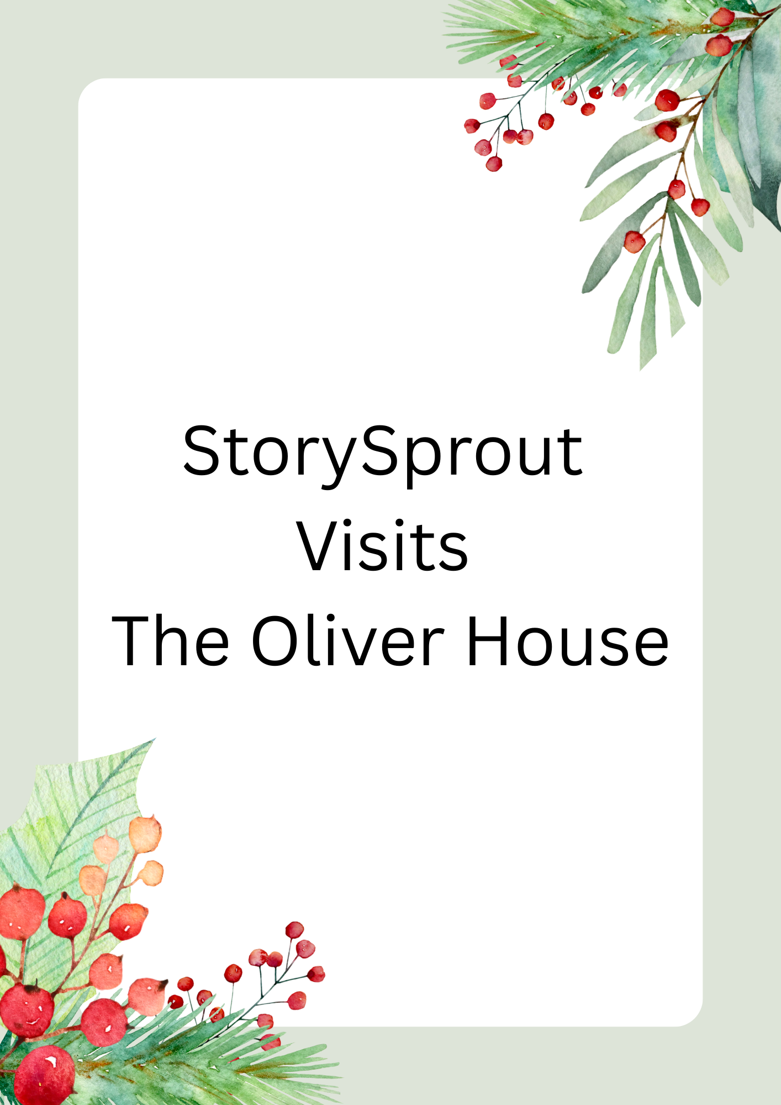
🏛️✨ StorySprout Visits the Oliver House
Mrs. Oliver Remembers Her Old Friend

On the crisp morning of December 4th, StorySprout arrived in Penn Yan just as the sun brushed the rooftops with soft winter gold. ❄️✨
She wrapped her grey coat snugly around her and breathed in her favorite scent — cinnamon sugar drifting through the chilly December air. 🍂✨
But another feeling fluttered past her…
something familiar…
something warm with memory. 🕯️💭
She followed it to a stately brick building trimmed in garland and glowing with the charm of centuries past. 🎄🏛️
The sign read:
“Oliver House Museum — Penn Yan Historical Society.” 📜✨
StorySprout’s heart fluttered.
“Oh… this place remembers me.” 🌱💛
Inside, the museum was peaceful, as though the walls were holding their breath. The parlor Christmas tree stood tall but lacked its sparkle — its lights flickered weakly 💡😟, ornaments drooped 🎀, and the air felt a little dim.
Mrs. Avery, a volunteer, fussed with a crooked bow. 🎀😩
“I don’t know what happened,” she sighed. “The tree was perfect yesterday.”
But StorySprout knew better.
Old houses didn’t simply lose their sparkle.
Sometimes their memories tried to speak, but nobody heard them. ✨🏚️
She placed a hand gently on a branch. 🌲🤍
“It’s all right,” she whispered. “Show me.”
The tree shivered. ❄️🌲
Then, a swirl of mist rose slowly above it. 🌫️✨
It twirled once… twice… forming the outline of a woman in an old-fashioned dress, her eyes warm and kind. 👒🕊️
StorySprout gasped.
“Mrs. Oliver?” 🥹💫
The spirit brightened, shimmering like candlelight. 🕯️🌟
And then she smiled.
“My little storyteller,” she whispered, her voice soft as snow. ❄️🌬️
“How long it has been.”
StorySprout’s boots tapped happily on the floor.
“You remember me!” she cried. 💛🌱
“How could I ever forget?” Mrs. Oliver replied.
“You fluttered through these halls when they were still new — gathering stories when this house was only beginning its tale.” 📚🏡
StorySprout, overflowing with joy, held out her mittened hands. 🧤✨
“May I?”
Mrs. Oliver nodded.
And then — in the quiet parlor of the Oliver House —
the two old friends danced. 💃🧚‍♀️✨
Mrs. Oliver twirled like a golden mist, her gown whispering through the air. ✨👗
StorySprout spun beneath her, leaving tiny curls of cinnamon-sugar sparkle behind. 🍂💫
Around them:
- The lights brightened 💡✨
- The ornaments chimed softly 🔔🎄
- The garland lifted with pride 🌿
- The tree stood straighter and straighter 🎄🌟
Magic filled the room like warm cocoa steam. ☕💛
Mrs. Avery felt the air shift.
“Oh! The tree — it’s glowing!” 😲🎄✨
At last, Mrs. Oliver drifted upward, swirling gracefully into the star at the top of the tree. ⭐🌙
It lit with a soft, warm fwoomph.
StorySprout pressed a hand to her heart. 💛
“Til next time, old friend.”
The star pulsed gently in reply. ✨⭐
Before leaving, StorySprout tucked a tiny scroll into the antique secretary desk. 📜🖋️
The volunteers would find it later.
It read:
“Friendship never fades,
memory never ends,
and when old stories awaken…
light returns again.” ✨🤍🌲
With her satchel glowing warmly from her magical reunion, StorySprout stepped back into the December morning —
ready for whatever story tomorrow would tell. ❄️🌙✨

🏛️✨ About the Oliver House Museum
Nestled in the heart of Penn Yan, the Oliver House Museum is a cherished treasure of Yates County—an elegant, 1850s Italianate home filled with stories that have shaped the community for generations. Once the residence of the Oliver family, the home now welcomes visitors into beautifully preserved rooms, historic artifacts, and exhibits that celebrate local life, industry, and heritage. From its ornate parlor and winding staircase to its period furnishings and lovingly curated displays, the Oliver House offers a gentle step back in time, inviting guests to imagine the lives, hopes, and traditions of those who once walked its halls. It’s a place where history feels warm and personal—where every room holds a whisper of Penn Yan’s past, ready to be rediscovered.
Key Details About the Oliver House Museum:
- Built in 1852 by Dr. Andrew Oliver as a grand brick Italianate home—a wedding gift for his son, Dr. William A. Oliver.
- The Oliver family lived in the home for generations, including Dr. William, his wife, and their children Jennie, William, and Carrie. When Carrie Oliver passed away in 1942, she gifted the home to the Village of Penn Yan so its stories would be preserved and shared.
- Address: 200 Main Street, Penn Yan, NY 14527 — located at the corner of Main & Chapel, and part of the Yates County History Center.

