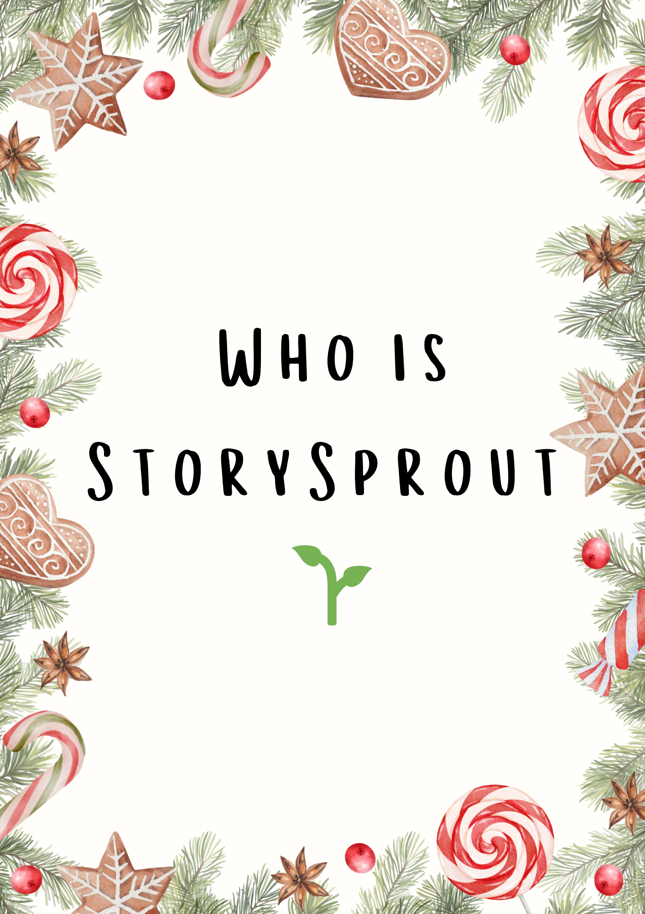
🌱 The Beginning of StorySprout
Long, long ago, before anyone in Penn Yan or Hammondsport ever found a tiny scroll on their pillow or perched on the shelf in one the shops around town, something magical happened deep inside the heart of Christmas. ✨🎄
Far to the north—where the winter wind practices its whooshing ❄️💨 and where snowflakes learn to dance ☃️✨—there grows a special garden called the Kindness Grove. It is not a vegetable garden at all, but a magical one, where every sprout begins with a moment of goodness: a shared cookie 🍪, a warm hug 🤗, a whispered “thank you,” or a smile given freely. 💛
One November night, as the first snowflakes drifted down like sleepy feathers ❄️😴, a glowing seedling pushed up through the frosty soil. Maple Merryweather, the gardener elf, leaned close in wonder. 🎄👀
“Oh gracious! A Story Seed!” Maple cried. ✨🌱
Story Seeds only sprout when a child somewhere wishes very hard for Christmas magic to return. ⭐❤️🎁
The little seedling shimmered gold, then silver, then a warm candle-glow. 🕯️ Its leaves unfurled, and the stem stretched tall—taller—taller still. 🌟🌿
And then, with a soft poof of cinnamon-scented snow ❄️✨🥰, an elf stepped out of the blossom.
She was about 18 inches tall, just the right size to perch on a windowsill or peek over a stack of books. 📚✨
She wore a soft grey winter coat stitched with thread that sparkled like morning frost ❄️🧵, and her boots were cozy knit wool, perfect for December adventures. Her hair curled like spruce tips, and her eyes shone with curious warmth. 🎄👀
“What am I?” she asked in a gentle voice, smooth as fresh snow. ❄️💬
Maple placed a hand over the elf’s heart.
“You,” she said, smiling warmly, “are StorySprout—born from kindness 🌟, grown from hope 💛, and sent to bring stories and wonder to the world.” ✨🎁
StorySprout blinked up at her.
“And what do I do?” 🌱❓
“You listen,” Maple said. “You notice the little things. You collect moments that people forget to see—kindness, bravery, giggles, and goodness. 💫 Then you write them into scrolls and leave them where children will find them.” 🎀📜✨
StorySprout tugged her cozy grey hat into place and stood tall. 🎩🌨️
“Where do I start?” 🌟
Maple pointed south—toward a lake shaped like a wishbone, glittering in the winter moonlight. 🌙✨💧
“There,” she whispered. “Keuka Lake. The stories are waiting.” 🎄📖
So before the sun even stretched awake on December 1 ☀️😴, StorySprout slipped her satchel of blank scrolls over her shoulder 🎒📜 and set off. She walked through snowy forests 🌲❄️, tiptoed across frosted fields ✨, and followed the shimmer of twinkle lights all the way to the cozy towns around the lake. 🎄✨🏘️
That was the first day she ever fluttered into Penn Yan, Hammondsport, Branchport, Dundee and even Prattsburgh, too—
the first day she listened… 👂✨
the first day she wrote… ✍️🎁
the first day she brought her magic to Keuka Lake. 🎄💫
And from that December morning on, the Christmas stories of the lake were never the same. ✨❤️🌱

