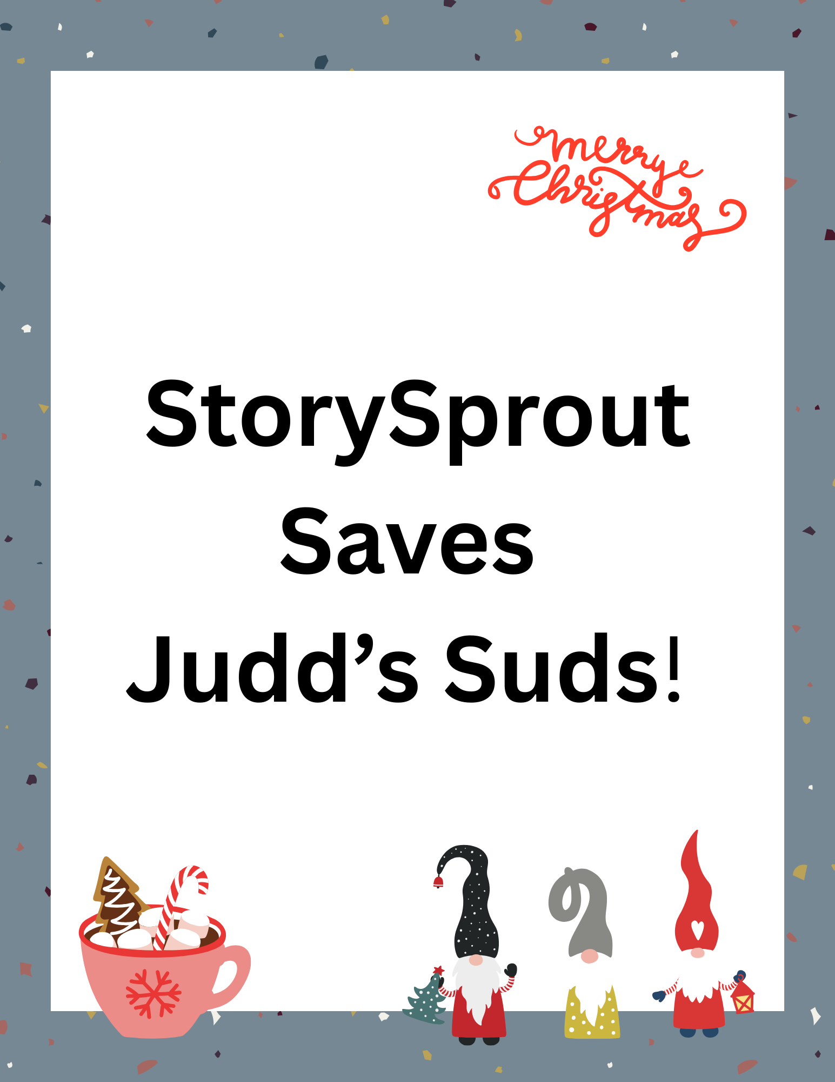

✨ StorySprout Saves Judds Suds! ✨
A Sudsy Surprise at the Soap Shop

StorySprout fluttered into Penn Yan just as the village was stretching into morning. The Christmas lights along Main Street shimmered softly, and the shop windows glowed with warmth and holiday sparkle. 🎄✨
She adored this part of town — especially the rows of cozy boutiques that smelled like cinnamon, pine, and peppermint dreams.
But today, the air carried something… unexpected.
Blub… glub… BLURRRRP!
StorySprout’s wings snapped to attention.
“That,” she whispered, “is not a normal Penn Yan morning sound.”
She followed the curious gurgle until she reached the cheerful pastel door of Judds Suds, the beloved local shop that sells handcrafted soaps, whipped body butters, silky liquid soaps, and lotions that smell like every good memory wrapped in a bow. 🧼✨🎁
But today…
Bubbles were drifting out from underneath the door.
Not one or two.
Hundreds — little glossy spheres rolling across the sidewalk like winter snowballs made of soap. 🫧🫧🫧
“Oh my… oh my! What should I do?” 🌱😱
She hurried to the window and peered in.
Inside, the displays were sparkling in a not normal way — towers of suds frothing out of a central table where the holiday-scented soaps were stacked. A waterfall of foam poured from a large decorative bowl labeled:
“NEW! Sugarplum Whipped Soap!”
StorySprout gasped.
“She's overflowing!”
She slipped through the door — poof! — and was immediately swallowed by a soft pillow of bubbles.
When she resurfaced, her hat covered in suds, she declared:
“This is a magical emergency.”
Her wings fluttered as she examined the scene.
The Sugarplum Whipped Soap was growing, its fluffy swirls expanding like enchanted marshmallow fluff. Every pop released a puff of scent — plum, vanilla, and sparkle-dust.
“No wonder the bubbles are escaping,” she said. “Someone must have added too much shimmer-glitter to the batch! It’s reacting with the winter magic in the air!”
She dug into her satchel and pulled out:
The Tiny Taming Scoop of Sparkle Control ✨🥄
(a perfectly ordinary spoon… unless wielded by an elf).
With a swirl and a tap-tap-tap, she whispered:
✨ “Settle your sparkle, soften your swell.” ✨
The whipped soap shimmered, hiccupped, and slowly deflated back into its bowl — now calm, fluffy, and well-behaved.
The free-floating bubbles gently drifted to the floor, popping in soft little piff! sounds, leaving the shop smelling like sugarplum wishes.
StorySprout smoothed her dress, brushed a sud from her sleeve, and sighed happily.
“There now. Judds Suds is safe — and extra magical today.”
Before she fluttered out, she left a tiny Sprout Scroll on the display table:
✨ “Even beautiful things can get carried away —
but a little care brings everything back into balance.” 💛🌱
She stepped onto Main Street once more, leaving behind a faint trail of sparkles and sugarplum scent as she headed toward her next Penn Yan adventure.

🌱 Sprout Scroll
“The Sugarplum Suds Surprise” ✨🫧
I fluttered into Penn Yan this morning
and followed a trail of drifting bubbles
right to the door of Judds Suds. 🫧🏪✨
Inside, the Sugarplum Whipped Soap
had grown a little too excited,
sending suds swirling like sparkling snow. ❄️🧼💗
So I gave it a tiny tap of magic and whispered:
✨ “Settle your sparkle, soften your swell.” ✨
The bubbles calmed, the scent sweetened,
and the shop glowed with gentle holiday magic once more. 🎄💫
If you ever feel your feelings bubble over,
remember: even the brightest magic
can find its calm again with a little care. 💛🌱
— StorySprout 🫧✨

