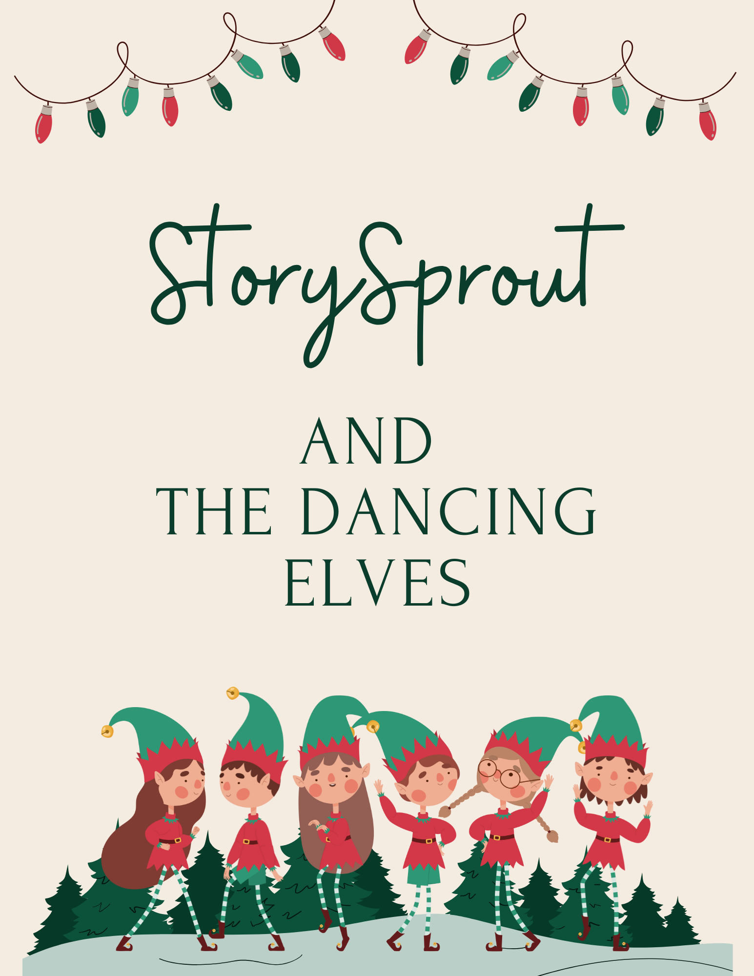

✨ Christmas in the Park: StorySprout Joins the Dancing Elves ✨
Pulteney Square Wrapped in Magic

StorySprout fluttered into Hammondsport’s Christmas in the Park just as dusk melted into a warm golden glow. Pulteney Square twinkled like it had dressed up just for the night — garlands sparkling, candy-cane lights lining the walkways, and the giant Christmas tree shimmering like a star caught right in the center of town. 🎄✨
Children ran in loops of excitement.
Vendors ladled steaming cocoa into mittened hands.
Carolers warmed the air with familiar notes.
And everywhere StorySprout looked, the world felt soft, festive, and wrapped in pure Hallmark wonder. ❄️❤️
She fluttered above the square, taking in the lights and music, when she heard them before she saw them:
The Dancing Elves.
A cheerful jingling.
A swirl of red and green.
A burst of laughter that sent the winter air wobbling with joy.
Twelve elves — not as tiny as StorySprout, in fact they weren’t elf-sized at all,
but their faces and hearts were pure elf magic.
They danced in a wide circle around the glowing Christmas tree. Their boots kicked high, their bells chimed bright, and every hat flopped in perfect, ridiculous rhythm. 🎶🧝‍♂️🧝‍♀️✨
They were merry, full of bright eyes and rosy cheeks…
and absolutely overflowing with mischievous sparkle —
the kind of giggly magic that makes snowflakes swirl sideways
and lanterns flicker with delight.
StorySprout’s whole face lit up.
“My goodness,” she whispered, “look at them go!”
She zipped down with excitement, twirling in a spiral of winter air until she landed right outside their dancing circle.
The elves paused mid-twirl, bells quivering in place.
One stepped forward — tall, cheery, with a hat slightly too long for her head.
“Well butter my biscuits,” she grinned. “If it isn’t StorySprout of Keuka Lake!”
The others gasped with delight.
“The tiniest teller of tales!”
“The sprout with the scrolls!”
“The elf who saved that peppermint soap shop!”
“The one who tamed the runaway bubbles!”
StorySprout blushed, wings fluttering in a flurry of sparkles.
“Oh goodness… that was just a bit of everyday magic.”
The elves linked hands and held the circle open for her.
“Dance with us!” they chimed.
“No rules — just joy!”
StorySprout nodded so quickly her hat bobbed.
“I’d love to!”
And just like that, she joined them — hopping, twirling, spinning through the crisp December air. Her boots tapped the rhythm, her wings caught the lantern light, and her laughter echoed like a tiny silver bell. 🌱💫
Children along the square pointed in excitement.
“Look! The elves have a new friend!”
“Is she real?”
“Mom, I saw her wings sparkle!”
The elves lifted her gently into the air during the chorus of the song, spinning her in a circle before placing her back onto the snowy ground with a soft plop.
“Carefree whimsy,” the eldest elf whispered with a wink,
“is the best kind of December magic.”
When the final note drifted into the evening, the elves bowed, and StorySprout gave a tiny curtsy — cheeks rosy, heart glowing like embers.
She fluttered to the base of the Christmas tree and tucked a tiny Sprout Scroll beneath the lowest branch:
✨ “May your heart dance even when your feet don’t.
Joy is a step you take inside.” 🌱💛
With that, she lifted into the winter sky, leaving behind a soft trail of sparkles —
just another piece of Christmas magic twirling through Hammondsport.

🌱 Sprout Scroll
“A Dance of Pure December Joy” ✨💃
Tonight I fluttered into Christmas in the Park,
where lights twinkled and laughter filled the air. 🎄✨
That’s where I found twelve joyful elves —
not tiny like me, not elf-sized at all,
but with faces and hearts glowing with pure elf magic. 💫❤️
They opened their circle and invited me in:
✨ “No rules — just joy!” ✨
So I twirled, hopped, and spun beneath the lantern lights,
my wings catching every shimmer as I danced with them. 🌟💃
And I learned something wonderful:
Sometimes the best kind of magic
is simply letting your heart be light. 💛✨
If you ever find music calling your name,
step toward it — even if your feet don’t know the dance.
Joy will teach you. 🎶🌱
— StorySprout 💫

