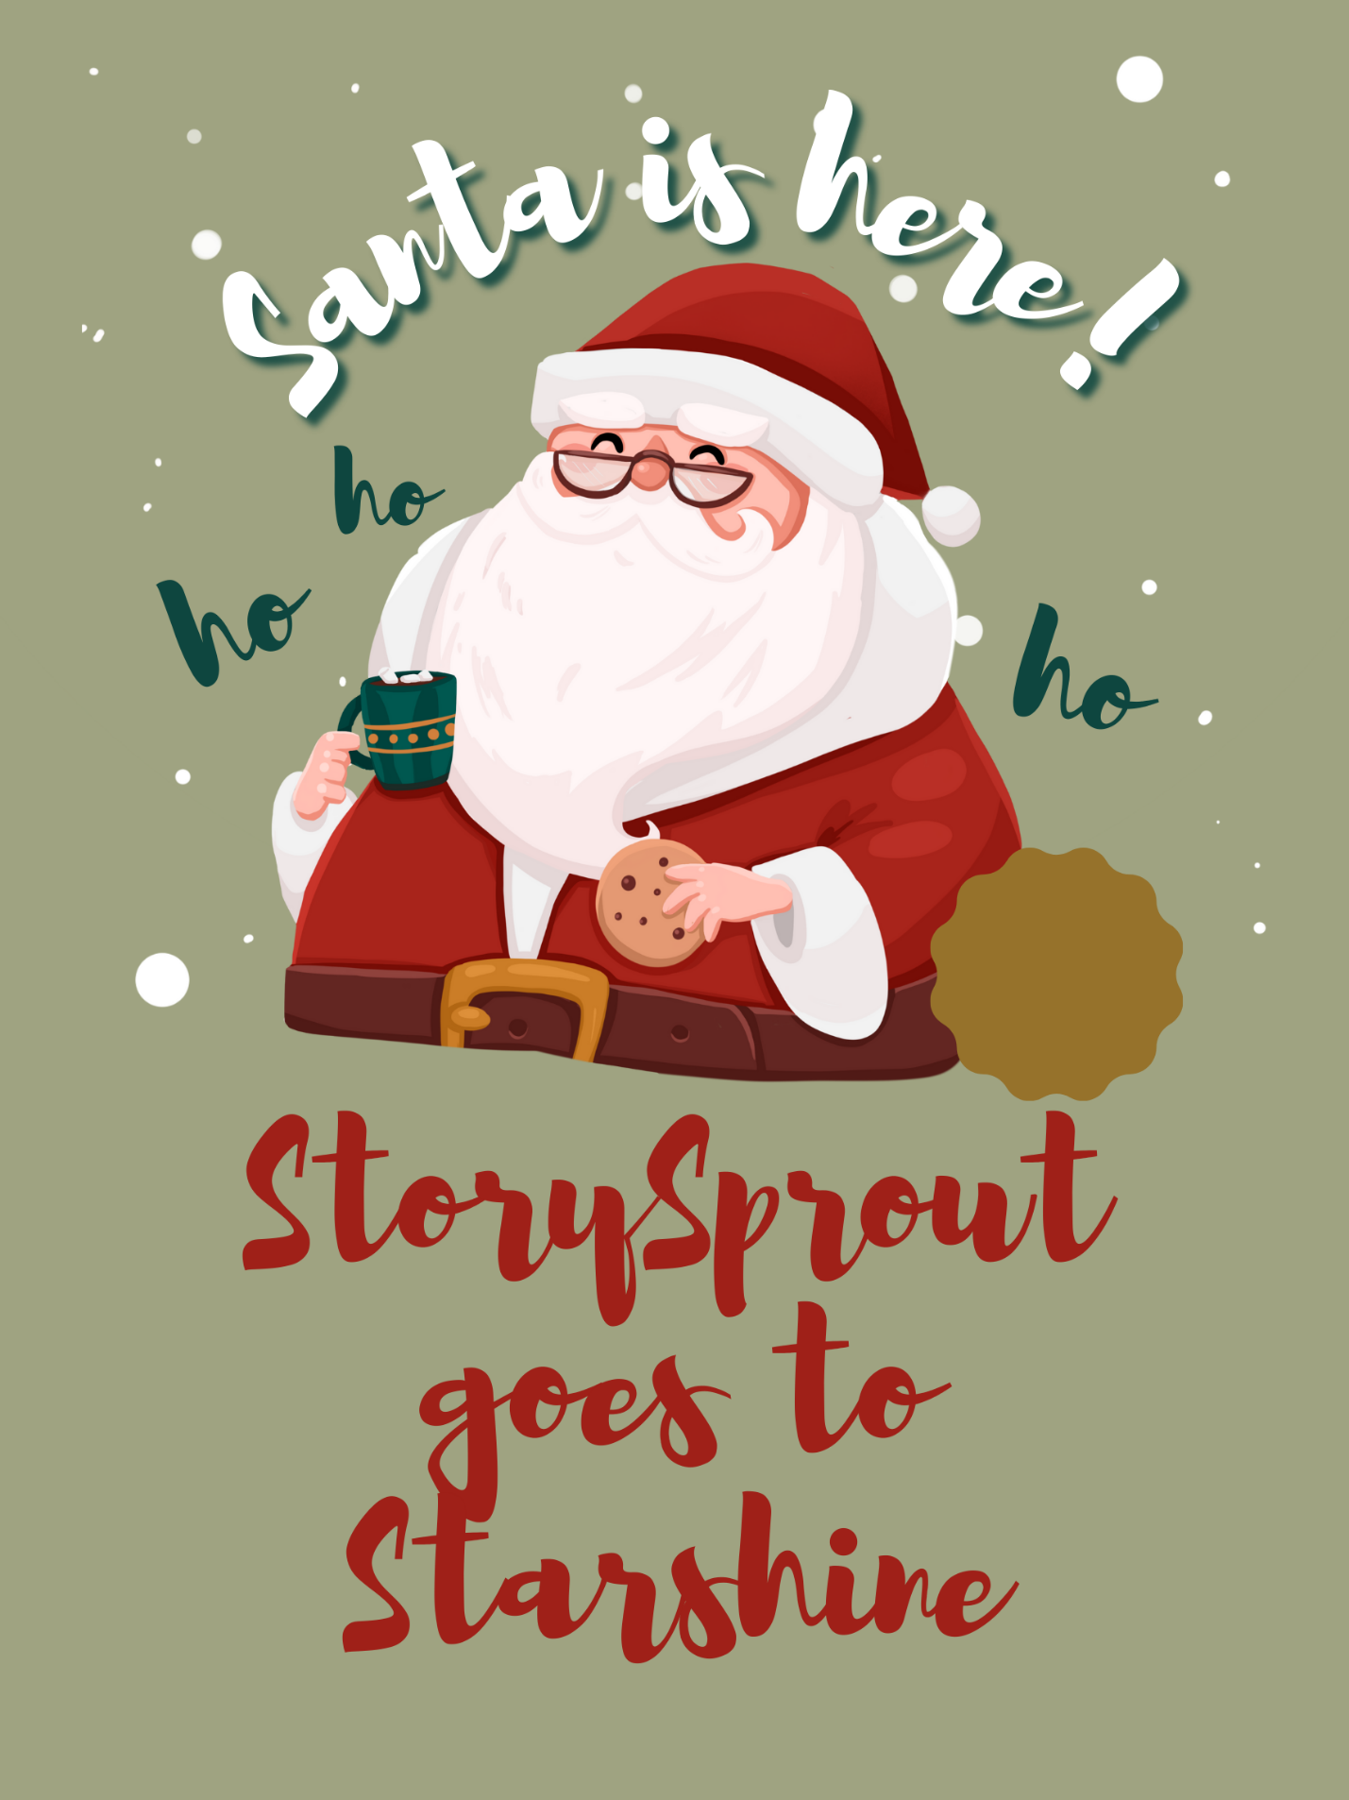
✨🎄 StorySprout Goes to Starshine
“A Night of Sparkles, Stories, and Starshine Magic”

✨🌙📚 On the twinkling evening of December 6th, StorySprout fluttered toward Penn Yan with excitement fluttering in her tiny heart. ❄️💫
Tonight was Starshine — the night the whole village shimmered with magic, music, and Christmas wonder. 🎶🎄✨
As she reached Main Street, she gasped softly.
Lights draped from rooftops like glowing ribbons ✨🏠,
the smell of cocoa swirled through the air ☕❄️,
and children darted past with mittened hands waving jingle bells. 🔔🧤
“Oh my,” StorySprout whispered. “What a perfect night for gathering stories.” 🌱💛
She slipped through the crowd like a swirl of cinnamon-sugar sparkle. 🍂✨

📚 A Cozy Stop at Longs Cards & Books
Inside Longs Cards and Books, warm light spilled onto the sidewalk. Families cozied into corners with holiday books 📖🎄, while children giggled over picture books stacked like colorful towers.
StorySprout perched lightly on a chair back and listened:
A little girl whispered her favorite memory of the first snow ❄️💕
A boy told his dad he hoped to become an author someday ✍️✨
Friends compared their favorite Christmas books like treasure trading 🌟📚
StorySprout’s satchel glowed as she gathered each moment into her little heart-shaped pockets of magic. 💛🍂
Before leaving, she brushed her mittens along the shelves — leaving behind a glimmer that made the books seem to sparkle with stories waiting to be found. ✨📘

🍬 A Sweet Stop at Keuka Candy Emporium
Next, she slipped into Keuka Candy Emporium, where peppermint danced through the air. 🍬❄️
Rows of candy canes lined the counter like cheerful soldiers ❤️🤍,
jars of ribbon candy glittered like edible jewels 💎🍭,
and children giggled as they chose treats for the night.
StorySprout tapped a candy cane and heard the tiniest ping! of joy. ✨🍬
She tucked the smallest one she could find into her satchel.
“For a midnight nibble,” she giggled. 😄🌙
Then she heard:
“Do you think Santa will bring any elves tonight?” a boy whispered to his little sister.
StorySprout froze.
Elves.
Santa.
Tonight.
“…maybe,” she whispered, “just maybe he brought friends with him.” 🎅🧝‍♂️✨
Her heart fluttered with excitement.

🎅 Santa Arrives at Starshine
Outside, a crowd had gathered down Main Street. 🌲💡✨
Carolers sang, children held glowing wands 🪄🧤, and the night felt like a snow globe come to life.
Then—
A fire truck rolled in, the last in the Parade of Lights and it too was decorated in lights and cheer 🚒🎄✨,
and perched proudly on top was—
Santa Claus. 🎅❤️
He waved, laughed, and filled the whole square with warmth.
StorySprout darted closer, hopeful.
She peeked behind him…
around the truck…
above his shoulders…
“No elves?” she whispered sadly.
But then—
Santa’s eyes flicked upward.
Right to her.
He winked. 😉
StorySprout nearly tumbled out of the air.
“Santa can see me?!”
Of course he could.
He knew every storyteller—
big, small, magical, and Sprout-sized. ✨🌱

🌟 A Starshine Scroll
When the festive crowd began drifting home, StorySprout fluttered toward the great Christmas tree. She nestled a tiny Sprout Scroll into the branches. 🎄📜✨
It read:
“On Starshine Night,
the world glows bright,
for every story, wish, and dream
becomes part of the Christmas light.” ✨💛
She lifted into the star-filled sky, cinnamon-sugar magic trailing behind her like shimmering dust. 🍂🌙✨

Starshine had filled her satchel—
and her heart—
with stories to last all December.
Tomorrow’s adventure was already whispering. 🌟❄️💫

