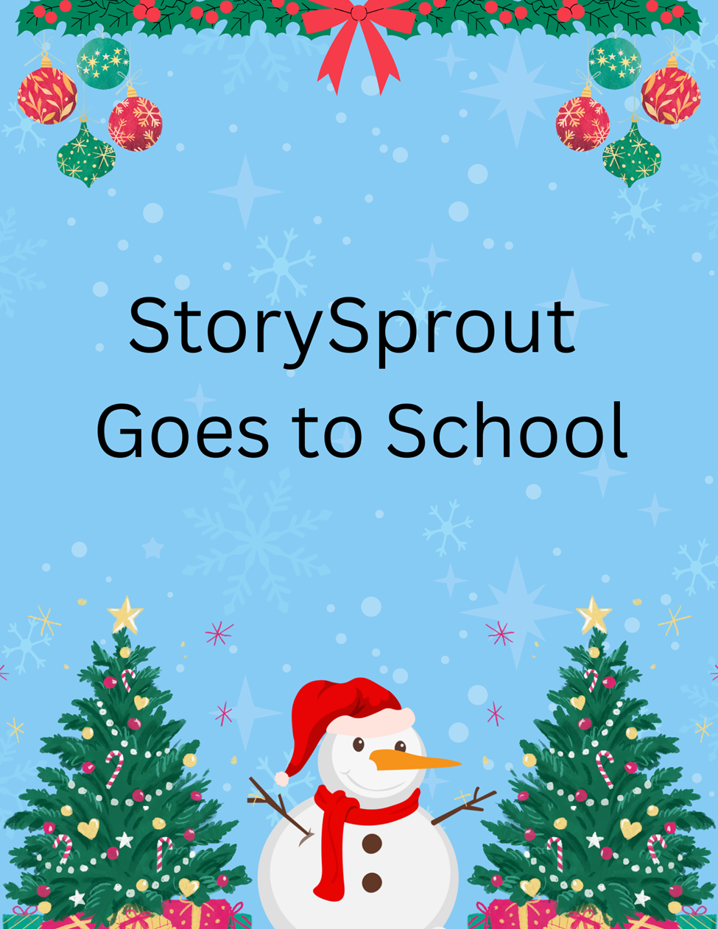

✨ StorySprout Goes to School ✨

🎭 A Solo Filled With Courage ⛄🎶

StorySprout fluttered toward the school just as the morning bell chimed across the quiet village. ❄️🔔Fresh snow dusted the playground, and little boots pattered inside the warm brick building, leaving tiny trails of wonder behind them. 👢✨
She slipped through the open doors — unnoticed, as elves often do — and found herself in the heart of cheerful chaos: the school’s Christmas play rehearsal. 🎄🌟
Teachers bustled. Paper snowflakes dangled from the ceiling. Laughter drifted through the halls like jingling bells. 🎶❄️
But in the corner of the auditorium sat one little girl, shoulders tucked, hands folded, staring nervously at her sheet music. 📄💗
Her solo?
“Frosty the Snowman.” ⛄🎵
Her heart?
Beating louder than the snare drum in the band room. 🥁💓
StorySprout felt the flutter of worry from all the way across the stage.
She tiptoed closer — sprout-sized boots making the softest tap… tap… tap on the polished floor — and perched on the back of a chair behind the girl. 👢🌱
“Why so quiet, Snowflake?” she whispered gently, her voice warm as cocoa steam. ☕💫
The girl didn’t see StorySprout, but she felt something…
A soft swirl of cinnamon-scented courage drifted around her. ✨
A tiny sparkle brushed her cheek. 🌟
She lifted her head.
“I’m scared,” she murmured to herself. “What if I mess up?” 😔

StorySprout smiled, tucking her tiny hands beneath her chin.
She fluttered up to the girl’s ear and whispered a truth only elves know:
“Courage isn’t loud, dear heart.
It’s the little spark that shines when you sing anyway.” 🌟💛
A warm glow settled in the girl’s chest — a glow StorySprout pressed there with a sprinkling of quiet magic. ✨💗
When the music teacher announced it was time for the solo, the girl stood. Her voice trembled — only for a moment.
StorySprout gave her a tiny nod, wings shimmering. 🧚‍♀️💫
And then…
She sang.
Clear. Sweet. Brave. 🎤✨
Her “Frosty the Snowman” drifted through the auditorium like falling snow — light, gentle, and full of joy. ⛄❄️🎶
Teachers beamed. Students cheered. 👏💖
Even the stage lights seemed to glow a little brighter. 🌟🎭
StorySprout clapped silently, proud as could be. 🌱👏
Before slipping away, she left something on the girl’s music stand:
a single feather-light Sprout Scroll tied in silver thread. 📜✨
It read:
“Your voice is a gift.
The world shines brighter each time you share it.” 💛🌱
Then, with a swirl of cinnamon sugared wind, she fluttered out the window toward her next December adventure — leaving courage, confidence, and Christmas magic blooming in Hammondsport School. 🎄💫🏫
🌱 Sprout Scroll

If your heart ever trembles too, remember:
✨ You don’t have to be fearless.
You only have to begin. ✨

— StorySprout 🌱💫

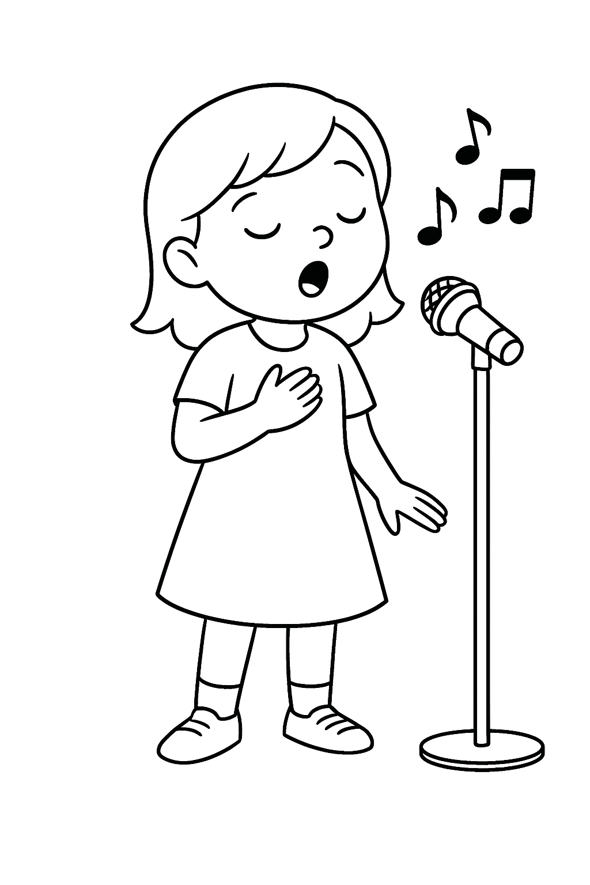
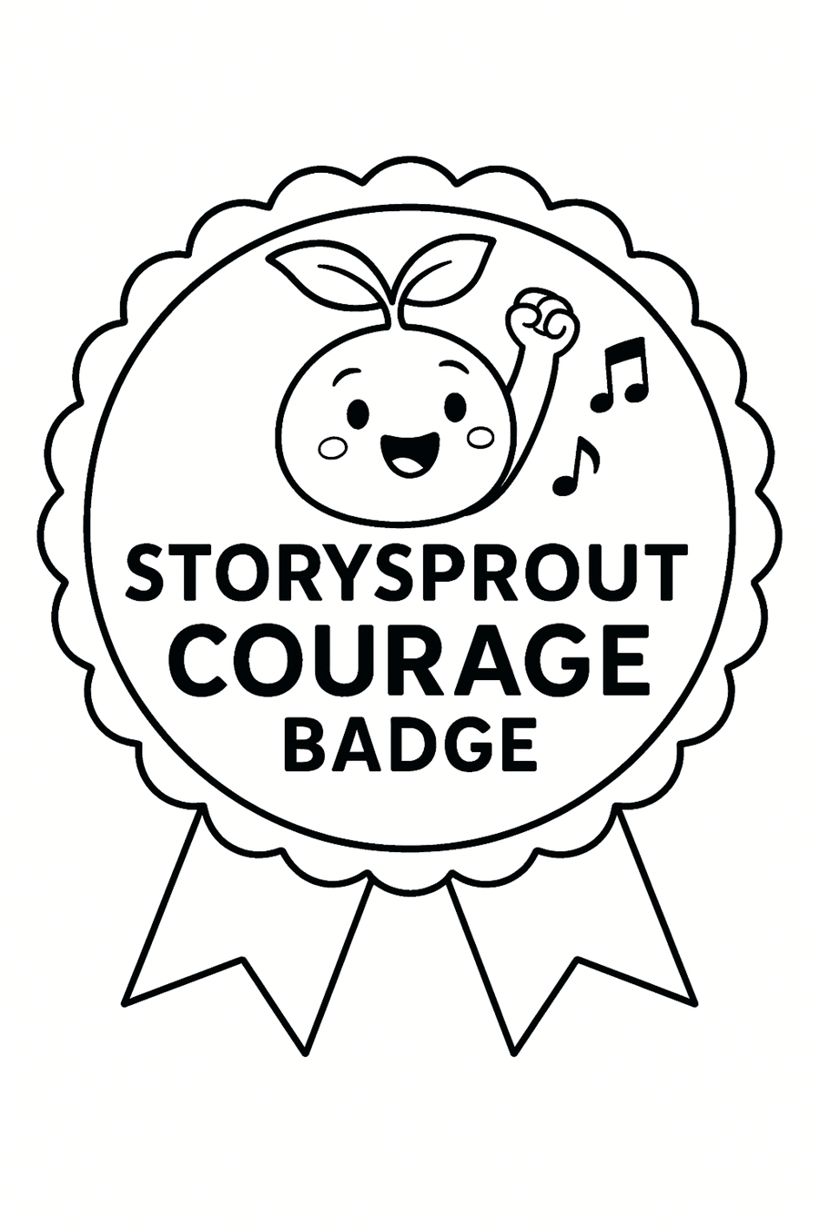

⛄ “Frosty’s Courage Song” 🎵
Frosty the snow friend,
Made of winter bright, ❄️⛄
Wiggled when the magic hat
Filled him up with light. 🎩✨
He danced with all the children
In the sparkling snow, ❄️💫
Teaching them that courage
Helps your brightest self to show. 🌟💛
And when the sun came shining,
He waved and said, “Don’t fear—” 🌞👋
“Whenever winter whispers,
I’ll come back each year!” ❄️🎄

