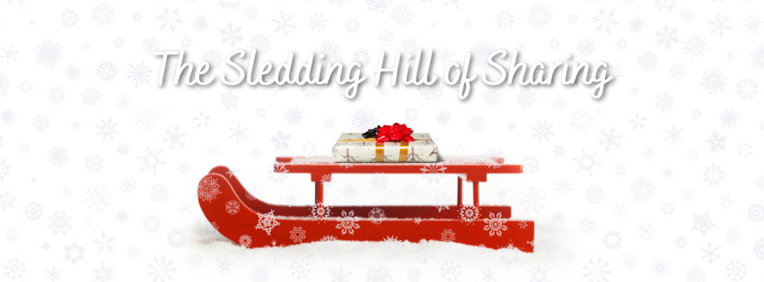

✨ StorySprout & the Sledding Hill of Sharing ✨
A Snowy Slope of Kindness

Snow had fallen soft and fluffy over all the towns that hugged Keuka last night — the kind that sparkles like sugar under the winter sun. ❄️✨
As StorySprout fluttered over town at first light, she heard it:
The unmistakable sound of children sledding —
laughter tumbling down a hill,
squeals of delight,
the swish of sleds carving snowy paths like silver ribbons. 🛷💫
StorySprout loved sledding day.
She zipped toward the big hill behind the park, where children were zooming one after another, scarves flying, boots kicking, joy spilling through the cold morning air. 🧣🌬️😂
But not everyone was sledding.
StorySprout spotted a little girl sitting off to the side on a small snowbank — knees tucked to her chest, chin resting on her mittens. Her name, she soon learned, was Denver. 💛
Her eyes followed every sled — every giggle, every whoosh — with a quiet ache. 😔❄️
StorySprout fluttered down beside her, landing gently on Denver’s mitten.
“Why aren’t you sledding, Snowdrop?” 🌱💬
Denver looked down, embarrassed.
“I… I don’t have a sled.” 🛷💭
StorySprout’s heart gave a soft squeeze. 💗
“Oh,” she murmured. “That is hard.”
They both watched another group of kids race by, snow spraying like tiny diamonds. ❄️💎
Denver whispered, “I wish I could join them… but I don’t want to ask. They look like they’re having too much fun.”
StorySprout placed her tiny hand on Denver’s thumb.
“Sometimes,” she said gently, “sharing doesn’t happen because someone is selfish. It happens because someone didn’t notice the need yet.” 🌟🌱
Denver blinked.
“What do you mean?”
“Well,” StorySprout said, fluttering up to eye level, “those children are racing down the hill so fast, they can’t see the child who’s wishing.” 🛷✨
She smiled. “But I can.”
With a shimmer of courage in her wings, StorySprout swooped toward the sledding group. 💫🧚‍♀️
She zipped in front of the children, scattering a trail of glittery flakes. The kids gasped — because everyone knows when StorySprout appears, a magical moment is close behind. ❄️✨🌱
“Hello, winter adventurers!” she called. “Do you know the joy of sledding?”
“YES!” they shouted. 🎉
“Do you know,” StorySprout continued, “that joy grows even bigger when shared?” 💛✨
The children looked at one another — puzzled, then curious.
She pointed toward Denver at the edge of the hill.
“She wants to join the fun… but she doesn’t have a sled.” 🛷😢
The sledders grew quiet. Then one boy stepped forward.
“She can ride with me,” he said.
“And me!”
“Take my sled next turn!”
“She can join our group!”
“We have room!” 🙋‍♂️🙋‍♀️🙋‍♂️💛
StorySprout beamed so brightly her wings glowed gold. 🌟💫
Together, the children ran to Denver.
“You can sled with us!” they said in a chorus of kindness. 🎶❤️
Denver’s face lit up like sunrise. 🌅✨
“Really?”
“Really,” they promised.
Within minutes, she was flying down the hill — sharing sleds, making friends, laughing until her cheeks glowed pink. 💗🛷✨
Her first run was so joyful she let out the happiest little “WOOHOO!” the hill had ever heard. 😂❄️💨
StorySprout watched from a snowy branch, heart humming with pride. 🌱💛
As she fluttered off, she whispered a tiny message that drifted across the hill like soft winter magic:
✨ “Joy grows when shared…
and kindness is the warmest kind of sled.” 🌟🛷💛
And the children — without even knowing why — kept sharing their sleds all morning long. ❄️💖

🌱 Sprout Scroll
“The Joy of Sharing” ✨💛🛷
I visited a snowy sledding hill today,
where children were laughing and racing through the winter air. ❄️😂🛷
But one little girl — Denver — sat quietly to the side,
wishing she could join the fun. 😔💗
She didn’t have a sled…
and she didn’t want to ask.
So I whispered a gentle truth:
✨ “Sometimes people don’t forget to share —
they just haven’t noticed the need yet.” ✨🌱
When the children saw Denver’s wish,
their hearts grew bright and warm. 💛
They shared their sleds,
made room for her in their laughter,
and welcomed her into the joy. 🛷❄️💖
If you ever see someone left out,
let your kindness slide toward them like a sled on snow.
✨ Joy grows when shared. ✨
— StorySprout 🌱💫

