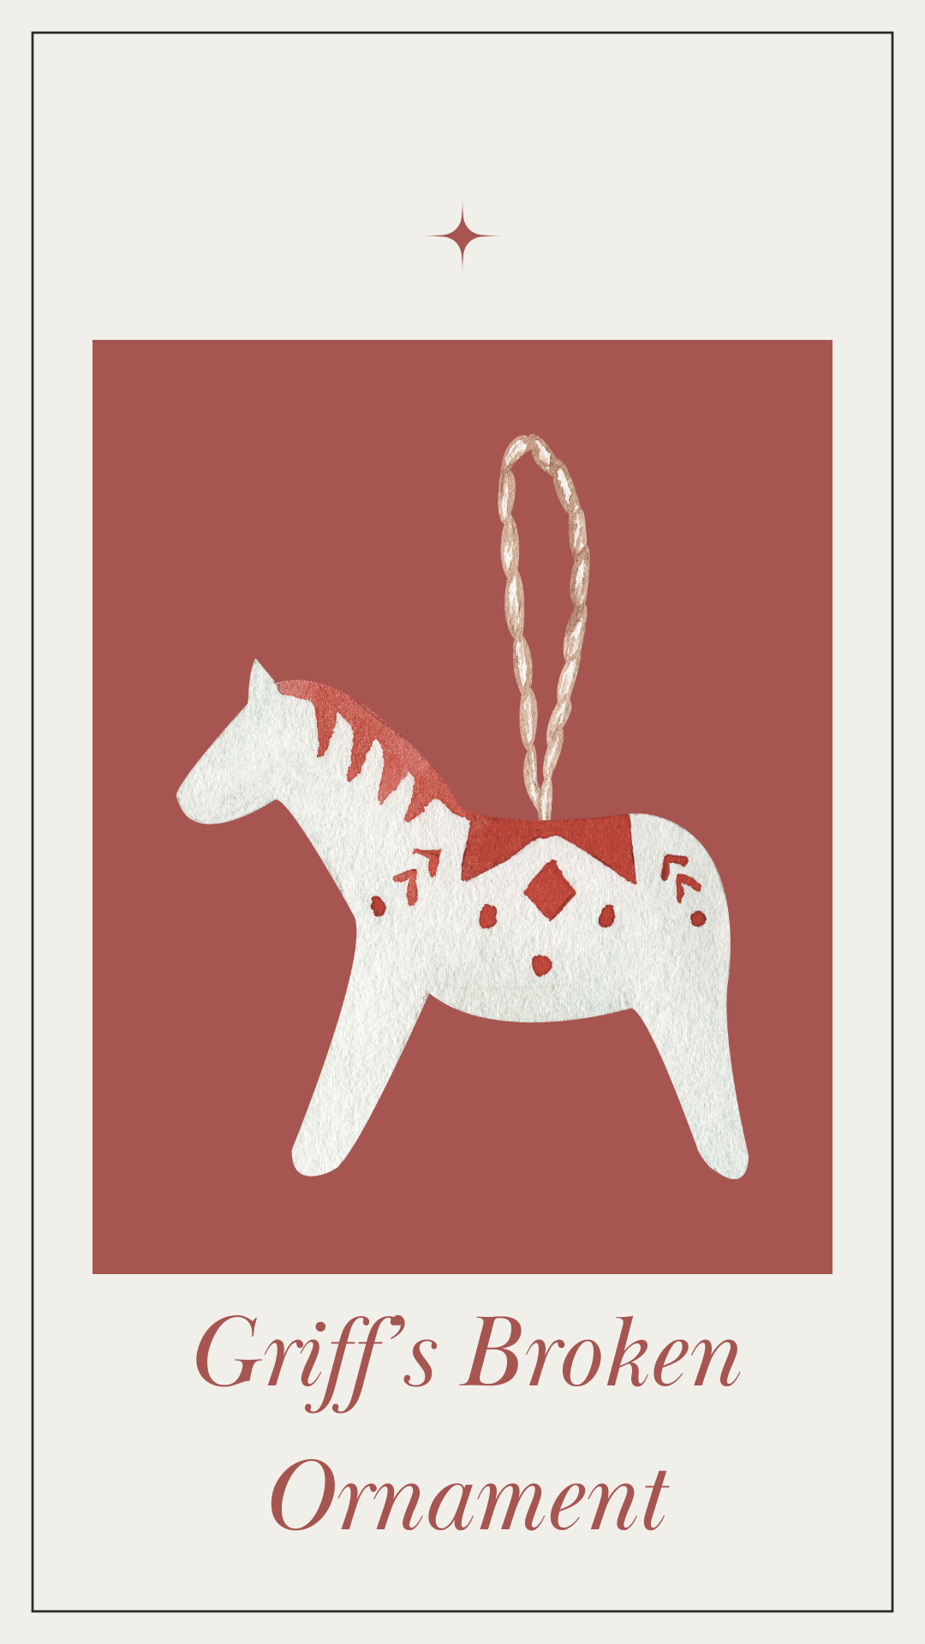
✨ StorySprout & Griff’s Broken Ornament ✨
A Lesson Wrapped in Forgiveness
StorySprout was fluttering past a row of twinkling windows in Penn Yan when she heard something unusual —
not laughter,
not jingling bells,
but a small, choked-up sort of cry.
She paused midair.
That was a December sound she couldn’t ignore.
She followed the soft sniffles to a porch decorated with evergreen garland and glowing gold lights. A little boy sat on the top step, mittens in his lap, tears slipping down his cheeks.
His name, she soon learned, was Griff. 💛
And beside him, on the porch floor, lay the pieces of what had once been a beautiful Christmas ornament — tiny shards of painted glass shaped like a snow-covered cabin.
StorySprout landed gently beside him.
“What’s the matter, Snowflake?” she asked softly.
Griff wiped his eyes with his sleeve.
“Somebody broke my ornament. My favorite one. I—I think it was an accident but… I’m still mad. And sad. And I don’t know what to do.”
StorySprout nodded, her little heart glowing with empathy.
She touched one of the glittering pieces.
“It’s okay to feel sad,” she said.
“And it’s okay to feel mad, too.”
Griff sniffled again. “But… I miss it. I had it since I was a baby.”
StorySprout folded her wings behind her and sat down next to him on the cold step.
“Do you know what forgiveness is?” she asked gently.
Griff looked down. “Kinda.”
“It’s like this,” she explained, picking up two tiny pieces of the ornament.
“When something breaks… your heart can feel like it’s in pieces too.”
He nodded.
“But forgiveness,” she continued, “is choosing to hold onto love instead of the hurt.
It doesn’t fix the ornament…” — she tilted the broken shards in her hand —
“…but it fixes you.”
Griff’s lip wobbled.
“Can’t StorySprout magic fix things?”
She smiled kindly.
“I can fix spilled sparkles, runaway soap, and even bubble mountains… but hearts? Hearts are something you get to fix.”
She placed the pieces gently in his mittened hands.
“Forgiveness doesn’t say the broken thing didn’t matter.
It says the person matters more.”
Griff thought about the friend who had been playing near the tree earlier.
He thought about how surprised that friend looked when the ornament fell.
He thought about how much they always played together.
Finally, Griff whispered, “I… think I can forgive him.”
StorySprout’s wings fluttered with joy. 🌱✨
“That’s very brave.”
She reached into her satchel and pulled out a tiny, shimmering acorn-shaped charm.
“This is for you,” she said, placing it in his palm.
“A reminder that new things can grow from broken moments.”
Griff smiled for the first time that afternoon.
A small smile, but a real one.
He looked at the broken ornament pieces, then at his charm.
“Can I keep the pieces?”
“Of course,” StorySprout said. “Every piece holds a memory. And your forgiveness… that’s the spark that keeps Christmas bright.”
Griff stood, brushing snow from his pants.
“I’m gonna tell him I’m not mad anymore.”
StorySprout beamed, her heart warm and glowing.
“That, dear Griff… is the real magic of December.”
She fluttered away as he ran inside, leaving behind a faint shimmer on the steps —
a little trail of forgiveness twinkling in the winter air.

🌱 Sprout Scroll
“The Magic of Forgiveness” ✨💛
I found a little boy sitting sadly on his porch today,
holding the broken pieces of his favorite ornament. 💔🎄
His name was Griff, and his heart felt just as shattered
as the tiny painted glass in his hands.
He asked me what to do with the hurt inside him.
So I whispered a truth wrapped in winter magic:
✨ “Forgiveness doesn’t fix the broken thing…
but it helps fix the broken feeling.” ✨
Forgiveness means choosing love over the hurt,
even when the memory still matters. 💛
And when Griff chose to forgive,
his heart glowed brighter than any ornament on the tree. 🎄✨
If ever your heart feels cracked or heavy,
remember: new light can grow from broken moments.
— StorySprout 🌱💫

