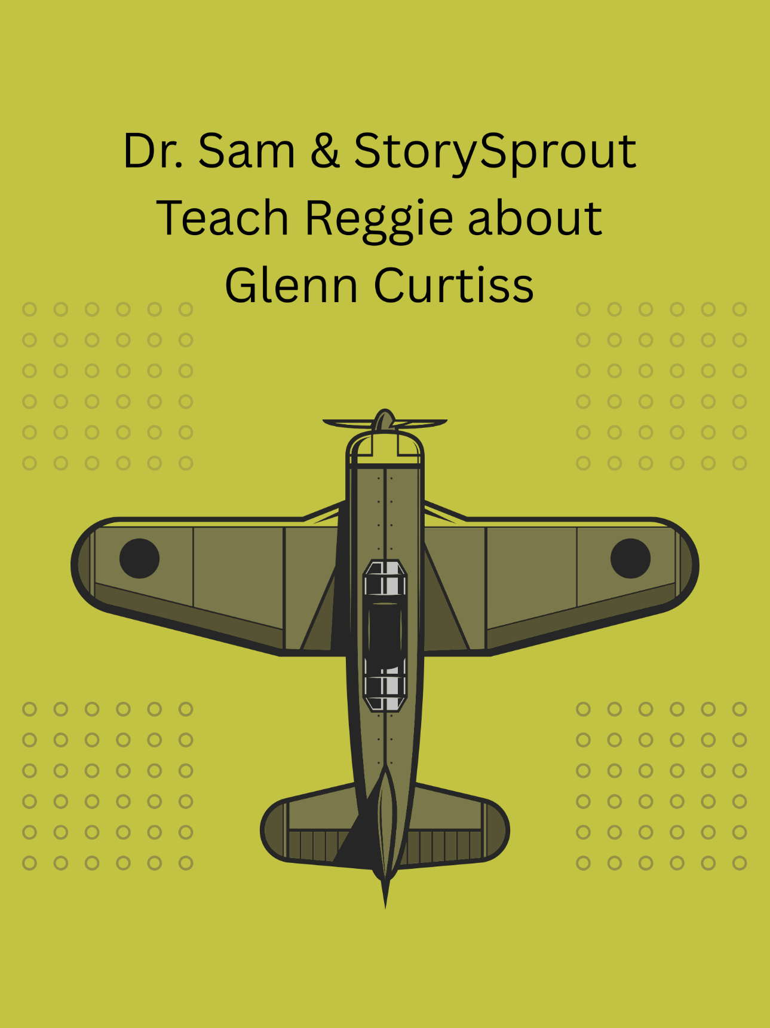

✨ December 17 — Dr. Sam, StorySprout & the Boy Who Loved Questions ✨
Hammondsport • A Dentist with a Heart Full of History

Reggie did not like going to the dentist.
Well… he liked Dr. Sam. Everyone in Hammondsport did.
But the chair? The tools? The bright light shining straight into his imagination?
No thank you.
But the moment Reggie stepped into Dr. Sam’s office in Hammondsport, he froze.
Because this wasn’t an ordinary waiting room.
It was a story museum.
📸 Old photographs lined the walls
📰 Fragile newspaper clippings filled shadow boxes
✈️ Early airplanes soared across framed prints
🏍️ And in nearly every picture, the same name appeared:
Glenn Curtiss.
Reggie tilted his head.
“Who’s that guy?” he asked, pointing to a photograph of a man beside an unusual motorcycle.
Dr. Sam peeked around the corner, eyes twinkling like Christmas lights. ✨
“That, my friend,” he said warmly, “is Glenn Curtiss — Hammondsport’s own aviation hero. A man who dreamed big enough to lift the world into the sky.”
Reggie stepped closer, forgetting all about his appointment.
“That plane looks… old,” he said softly.
“Oh, it is,” Dr. Sam chuckled.
“One of the very first. Curtiss built flying machines when folks said humans belonged on the ground.”
Reggie frowned thoughtfully.
“Did you ever meet him?”
Dr. Sam laughed.
“Me? No. Glenn lived long before I was born. But someone in this room did.”
Reggie blinked.
“Who?!”
A tiny voice chimed from the model airplane shelf:
“I did, Snowflake.” 🌱💫
Reggie whipped around.
There, sitting on the wing of a wooden biplane, was StorySprout — glowing just enough to make the dust sparkle.
“You knew Glenn Curtiss?” Reggie whispered.
StorySprout nodded proudly.
“Oh yes. Glenn was my friend. A wonderful friend. He believed in possibilities the way some people believe in Christmas morning.” 🎄✨
Dr. Sam grinned.
“She’s a keeper of magic, and I’m a keeper of history. Makes us a good team.”
StorySprout fluttered down to the arm of Reggie’s chair as Dr. Sam set up his tools.
“You know,” she said, “I used to watch Glenn work late into the night. He tinkered, muttered, and wiped grease on his sleeves… and he built things no one had ever imagined.” 🛠️✈️
“Was he brave?” Reggie asked.
“Brave enough to trust his own imagination,” StorySprout said.
“And brave enough to crash a few times along the way.” 😄
Dr. Sam added,
“Glenn Curtiss lived right here in Hammondsport. Every kid in this village carries a little piece of his courage.”
Reggie’s chest puffed just a bit.
StorySprout whispered,
“He used to tell me, ‘Magic is believing you can do something before anyone else understands how.’”
Reggie looked at the pictures again —
planes with canvas wings,
motorcycles that looked like rockets,
a man with a wide grin and adventure in his eyes.
“Wow,” he breathed.
“I want to do something big someday too.”
Dr. Sam tapped Reggie’s nose gently. 👃✨
“You will, Reggie. Big things begin with big curiosity.”
“And brave hearts,” StorySprout added. 🌱💛
By the time Reggie settled into the dentist chair, he felt lighter — not because he wasn’t nervous anymore, but because he suddenly felt part of a bigger story.
StorySprout perched on the dental light, humming the tune Glenn Curtiss used to whistle while building motors in his workshop. 🎶✈️
When the appointment ended, Dr. Sam handed Reggie a sticker shaped like a tiny airplane.
Reggie held it tightly.
“Dr. Sam? Why do you have so many pictures of Glenn Curtiss?”
Dr. Sam smiled, warm and wise.
“Because stories matter. And someone has to keep them alive.” 📖❤️
StorySprout nodded, wings glowing.
“That’s why I visit here too. Dr. Sam protects the stories, and I protect the spark.”
Reggie grinned.
“Maybe I’ll protect stories someday.”
“You already are,” StorySprout whispered.
“Every time you wonder.” 🌟
As Reggie walked out into the crisp December air, the village lights twinkling across Pulteney Square, he felt something he hadn’t expected—
A bit like he could fly. ✈️💫

If ever you wonder about your dreams,
remember the boy from Hammondsport who built wings,
and the doctor who keeps his stories shining.
Believe in your spark.
It might just help you fly. ✨✈️💫
— StorySprout 🌱💖

