AWARD-WINNING COMEDIAN RONNIE NEVILLE BRINGS
‘ALL IRISH COMEDY’
TO THE FRINGE
*DEBUT SHOW*
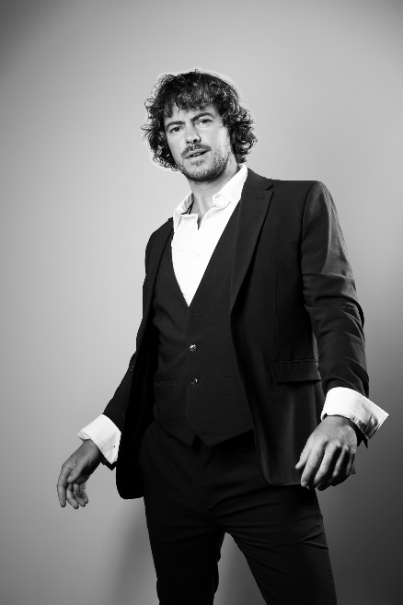
Venue: Just the Tonic, Nucleus – Sub Atomic Room
38-140 Pleasance, Edinburgh EH8 9RR
1st August – 25th August at 5.50pm (exc 12th)
TICKETS
“A welcome breath of fresh air…hilarious" ★★★★ X-Press Magazine
"Don’t miss this comedian" ★★★★ Fringefeed

The Irish have a supreme talent for spinning a yarn, and globetrotting Irish comedian Ronnie Neville has a suitcase crammed with hilarious tales—and he knows just how to tell them. Indeed, this man is either a genius or a lunatic. Watch All Irish Comedy , and you decide!

Award-winning comedian and viral breakout star Ronnie Neville’s journey has taken him from Cork to Edinburgh via New York, Perth, and Melbourne. Sharing tales from the bogs and streets of Ireland, watered and grown on the floorboards of Irish pubs, he shares the ‘craic’ with his own unique passion, flair, and charm.

All Irish Comedy was one of the highest-selling shows at this year’s Perth Fringe, fuelled by word of mouth, repeat customers, and Ronnie’s unwavering ability to ‘treat the audience as if they were close friends, ensuring that everyone has a good night’ (X-Press Magazine).

With Ronnie’s wild anecdotes and crazy life experiences ranging from a garden maintenance indecent proposal to the tricky art of selling kitchenware at a sex fair, strap yourself in for an absolutely off-the-rails hilarious show.

Ronnie says: “We all love a good joke, but we never forget a good story. I’ve got over fifty stories ready to go, and I’m excited to cram six of the best tales into my one-hour set at Ed Fringe.”

Tickets: HERE

Instagram

TikTok

FFI, review tickets or to arrange an interview, please contact faye@jvpublicity.com / 07826 935579

