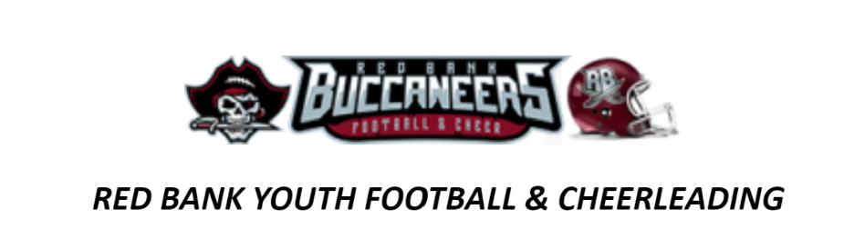
Parents: Complete this form and submit it to your child’s sports organization. Turn in one application per child, per season.
Child’s First Name: | Parent/Guardian First Name:
Child’s Last Name: | Parent/Guardian Last Name:
Date of Birth: | Street Address:
Age: | City, State, ZIP:
Gender: | Daytime Phone and email:
School: | Parent Employer:
Number of Siblings in family: | Description of hardship:
During which season is your child registered to play? (circle one)
Spring Summer Fall Winter
Which sport is your child interested in playing? (circle one choice per season)
Cheerleading Competition Football Flag Cheerleading Game Day
Which type of assistance are you requesting? (circle one)
Registration Fee Waiver: Documentation allowing all of the athlete's league fees to be waived for the season due to economic hardship. Must quality for free or reduced lunch program in school.
Registration Fee Assistance: Partial funding provided towards your athlete’s registration, due to economic hardship

CONSENT AND CONDITIONS
I understand that my child’s participation in this program requires a commitment to attend a minimum of 85% of the scheduled practices and games.
I understand that a work bond of $250 will still be due upon registration. This check will not be cashed if the volunteer hours are completed and equipment is returned on time.
I understand I will need to complete a new scholarship form in the beginning of each new season.
I understand there are a limited numbers of scholarships and they will be selected at the discretion of the Board of Directors of Red Bank AYF/AYC.

Signature of Parent/Guardian Date:

For more information, call Dana Soden at 908-461-1720

