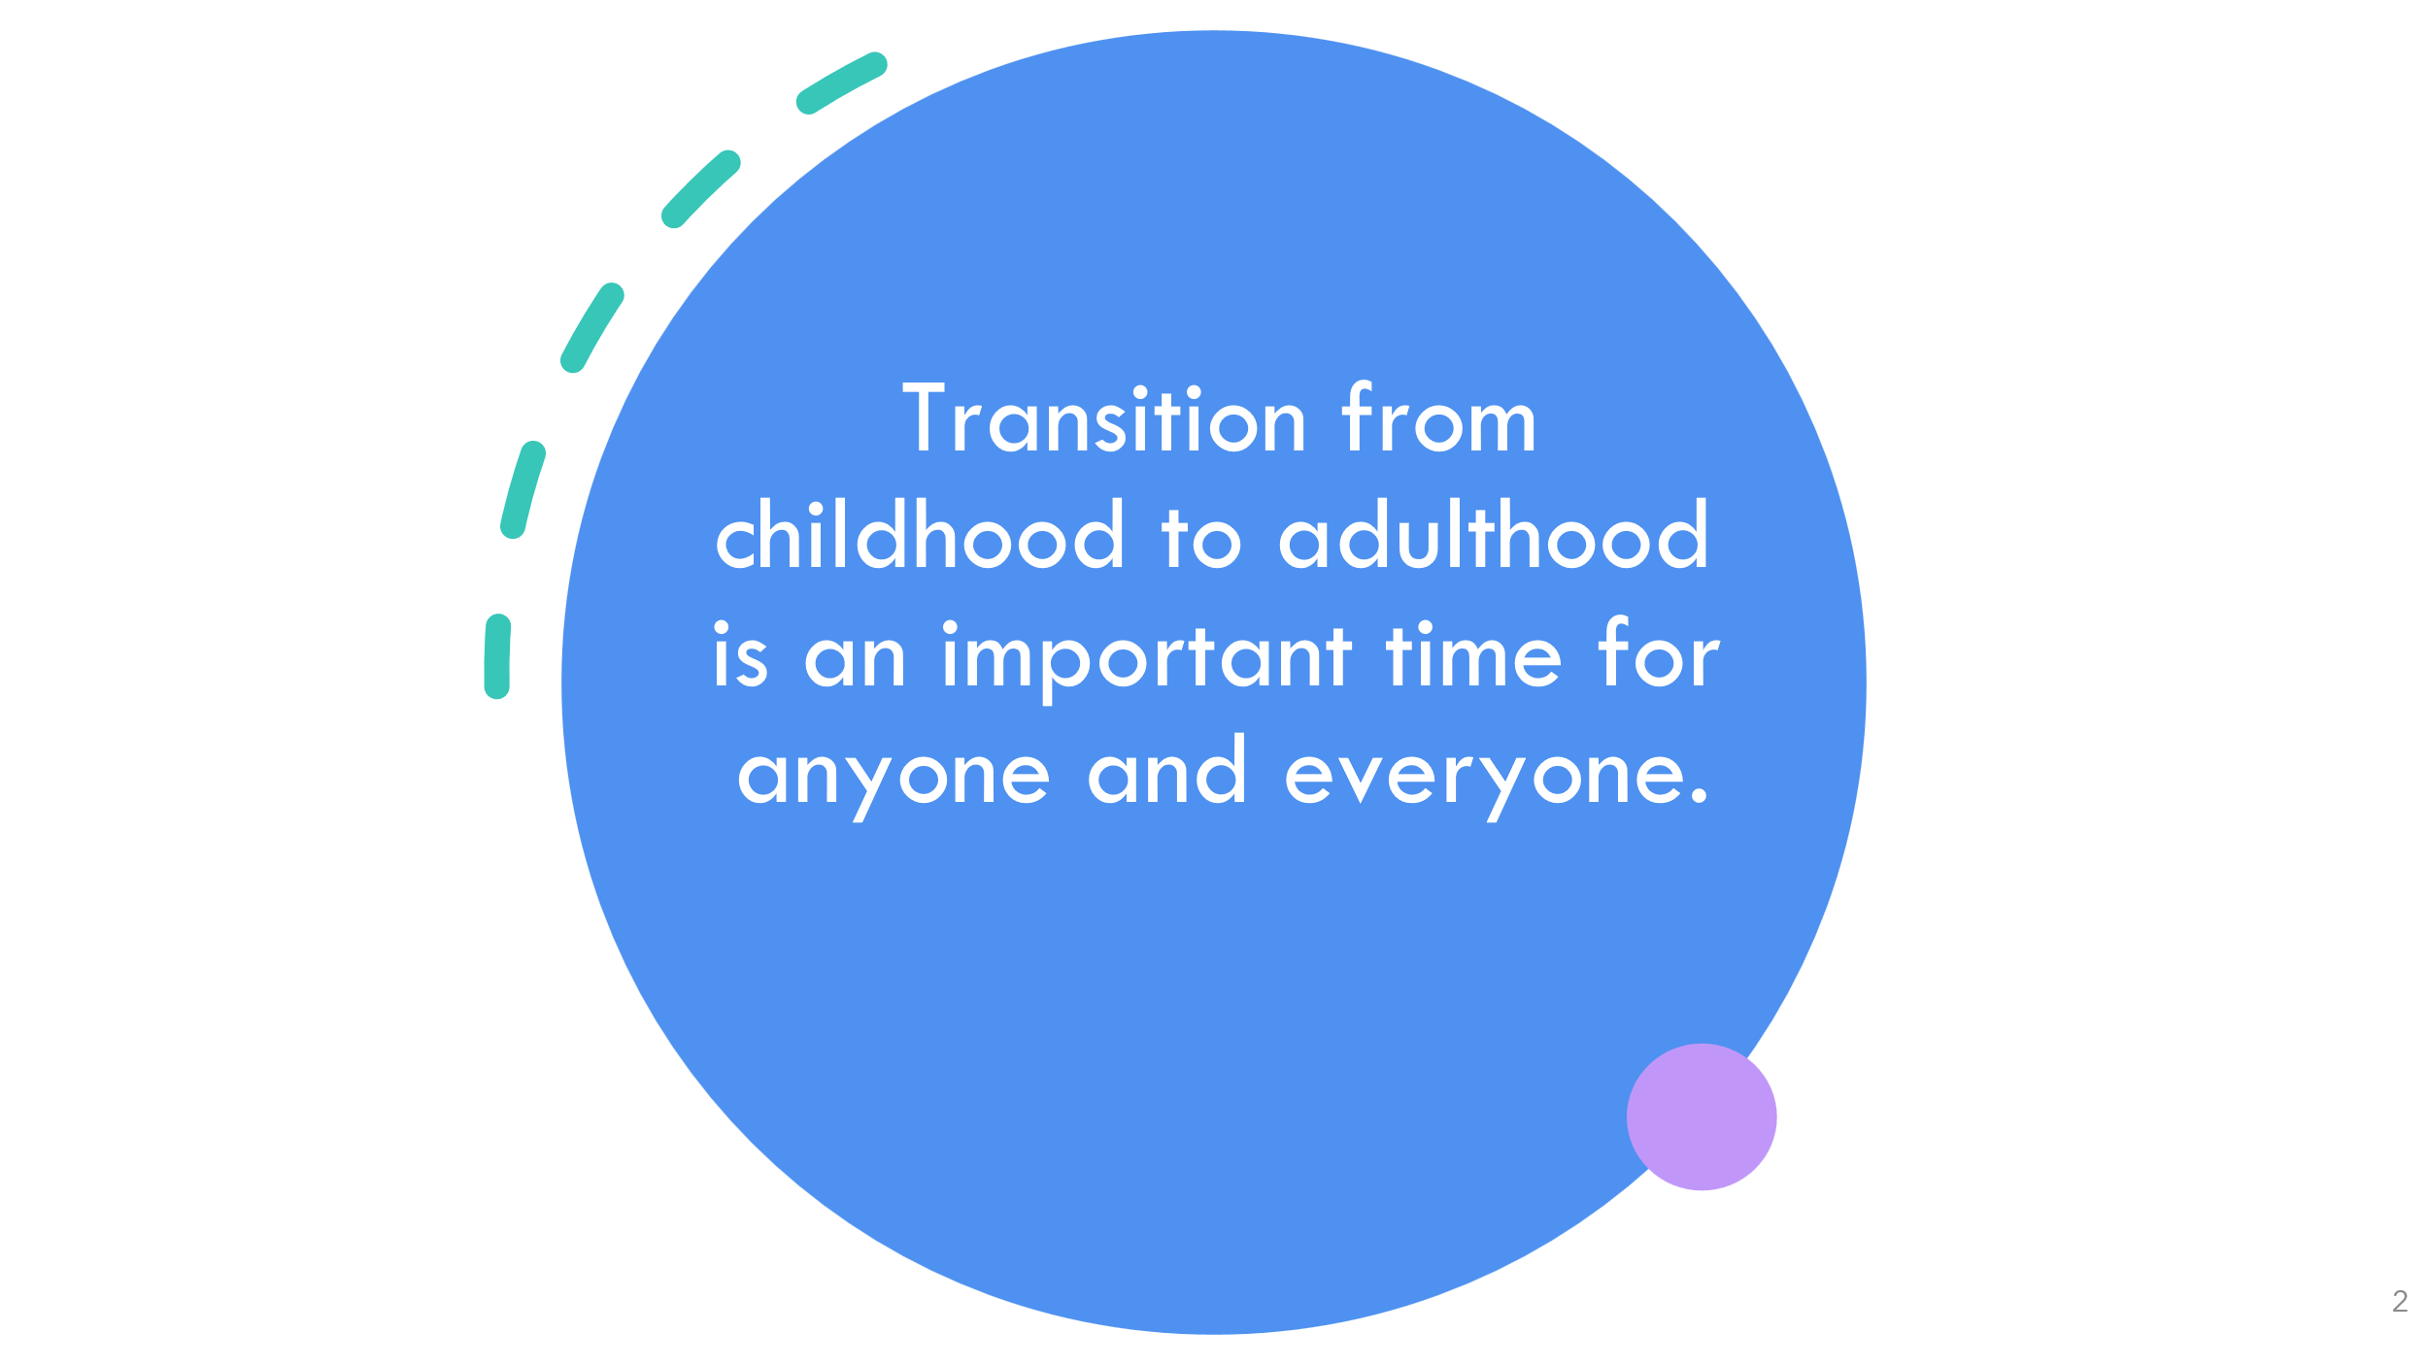

Transition Plan

Preparing for Adulthood is often referred to as Transition to Adult Services and means ‘change’. This period of Transition involves a longer time to plan and discuss important issues for you such as developing your Independent Living skills, Education and Employment skills, having friends and participating in the local Community, maintaining healthy Relationships, your Health and Wellbeing as you move successfully from childhood to adulthood.

The Transition Plan ensures the person’s voice is heard and celebrates what they can do for themselves whilst ensuring they have the support and help to achieve their aspirations for the future.

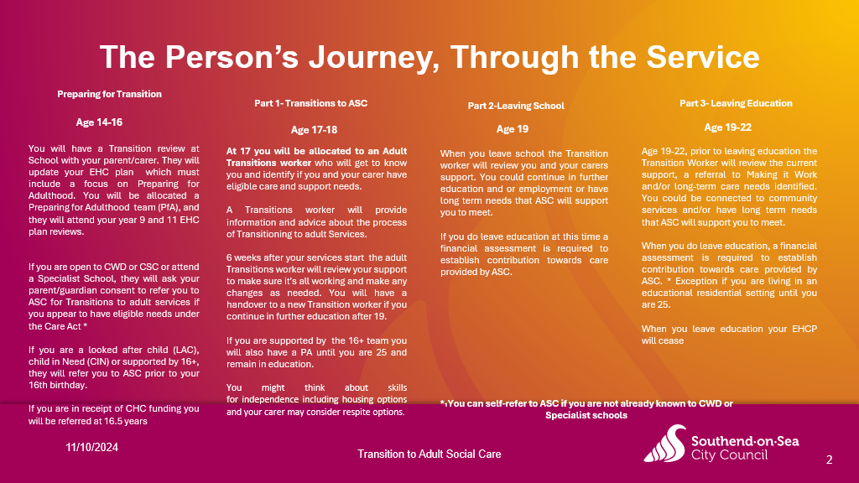

Person's Life
We have conversations with people to discover what they want from life and the care, support and housing that will enable this.
Personalisation is rooted in the belief that people want to have a life not a service. Making it Real is a framework and a set of statements that describe what good, citizen-focused, personalised care and support look like from the point of view of people themselves

Social Worker should consider the following outcomes that matter to the person in their life and which in turn promotes their wellbeing:
- Personal dignity (including treatment of the individual with respect)
- Physical and mental health and emotional wellbeing
- Protection from abuse and neglect
- Control by the individual over their day-to-day life (including over care and support provided and the way they are provided)
- Participation in work, education, training, or recreation
- Social and economic wellbeing
- Domestic, family, and personal domains
- Suitability of the individual's living accommodation
- The individual's contribution to society

Eligibility Outcome

Do the Person's needs arise from, or are they related to, a physical or mental impairment or illness?

As a result of the Person's needs, please select the care and support outcomes that they are unable to achieve for any of the following reasons:

- Unable to achieve it without assistance;
- Able to achieve it without assistance, but doing so causes them significant pain, distress or anxiety (this is a determination made using professional judgement);
- Able to achieve it without assistance, but doing so endangers or is likely to endanger the health and safety of the person or others; or
- Able to achieve it without assistance but takes significantly longer than would normally be expected (this is a determination made using professional judgement).
Maintaining a Habitable Home Environment
Managing and Maintaining Nutrition
Maintaining Personal Hygiene
Managing Toilet Needs
Being Appropriately Clothed
Being able to Make Use of the Home Safely
Accessing and Engaging in Work, Training, Education or Volunteering
Making Use of Necessary Facilities or Services in the Local Community, including Public Transport, and Recreational Facilities or Services
Engaging in recreational activities

Have two or more care and support needs been identified, and as a result the Person is unable to achieve the specified outcomes?

As a consequence of being unable to achieve these outcomes there is, or there is likely to be a significant impact on the Persons' wellbeing?

What The Team Do & How We Can Support individuals & Their Families

- Commission Services for individuals to meet their assessed eligible needs
- Direct Payments for the individual to purchase services to meet their needs
- Respite for Carers
- Making It Work (Voluntary or Paid Employment Opportunities)
- Travel Training
- Accessing College Courses
- Housing (Shared Lives, Supported Living, Residential or Independent Housing)
- Health Needs (Annual Health Action Plans, Hospital Passports)
- Learning Disability Health Input (Essex Learning Disability Partnership
- Advocacy Referrals
- Safeguarding
- Applications to Court of Protection if required for management of an individuals property & affairs if they lack capacity

