COUCHICHING FIRST NATION

EMPLOYMENT OPPORTUNITY

Communications Coordinator
Couchiching First Nation

Couchiching First Nation is seeking a highly motivated and creative Part-Time (20-25hrs per week) Communications Coordinator for a six-month contract. This role will be instrumental in enhancing the First Nation's internal and external communications, promoting community initiatives, and sharing our stories effectively. The Communications Coordinator will work closely with leadership and various departments to develop and distribute engaging content across multiple platforms.
The ideal candidate will have post-secondary education in communications, marketing, or a related field, along with experience in content creation, social media management, and strategic communications. Strong writing and editing skills, attention to detail, and a passion for community engagement are essential. Experience working with Indigenous communities and an understanding of First Nations governance and protocols are highly valued assets.
Applicants must meet the following criteria:
- Post-secondary diploma or degree in communications, marketing, public relations, or a related field.
- Minimum 1 year of experience in a communications, marketing, or public relations role.
- Demonstrated experience with content creation for various platforms (e.g., social media, websites, newsletters).
- Strong organizational and time-management skills, with the ability to manage multiple projects and meet deadlines.
- Excellent written and oral communication skills, with a keen eye for detail.
- Proficiency in Microsoft Office (Word, Excel, PowerPoint, Outlook) and familiarity with social media platforms and digital communication tools.
- Prior experience working with Indigenous communities and/or organizations is preferred.
- Knowledge of Indigenous governance, culture, and community dynamics is a strong asset.
- Ability to speak Ojibway or a willingness to learn the language is considered an asset.
- Current First Aid and CPR certification or a willingness to obtain the same.
- Must provide a Criminal Vulnerable Sector Check.
- Must possess a valid Ontario Driver’s License – Class “G”, and able to submit a current driver’s abstract.

Deadline: July 30, 2025, by 4:00PM CST.

How to Apply:
Applicants should include their resume, cover letter and 3 references. References must include three employment related references and written permission to contact those references. You can submit your application to Couchiching First Nation Human Resources by email, mail, or in person.
By Email: recruitment@couchiching.ca
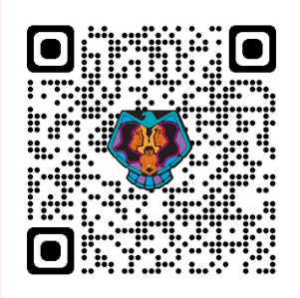
Postal mail, or in person at:
Human Resources: Couchiching First Nation
RMB 2027, RR2, Fort Frances, Ontario P9A 3M3

All suitable, qualified Couchiching Band members shall be given first preference.
While we appreciate all who apply, only those selected for an interview will be contacted.
All late applications will be returned unopened.
All incomplete applications will be returned to the applicant.
CFN welcomes applicants from people with disabilities. Accommodations are available upon request. for candidates taking part in all aspects of the selection process.

