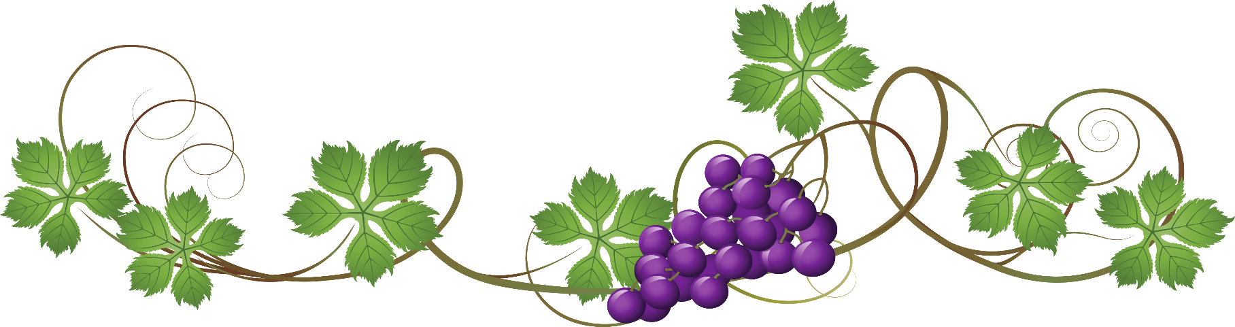
Wine Stone Inn

White Wine Varietals
CHARDONNAY | GLASS | BOTTLE
PRISONER | 20 | 62
DAOU | 16 | 42
EDNA VALLEY BUTTERY | 12 | 36
SAN SIMEON | 11 | 33
SAUVIGNON BLANC
TOOTH & NAIL | 16 | 48
BRANDER | 14 | 44
RABBLE | 12 | 40
SPECIALTY WHITES

ZACA MESA VIOGNIER | 15 | 42
FABLEIST ALBARINO | 13 | 38
EDNA VALLEY PINOT GRIGIO | 12 | 34
FESS PARKER REISLING | 11 | 32
ROSE’
DAOU | 13 | 44
RABBLE | 11 | 34

SPARKLING
LAETITIA BRUT CUVEE | - | 46
LAETITIA BRUT ROSE | - | 44
LAMARCA PROSECCO BRUT | 12 | 38
FREIXENET CAVA | 11 | 28

