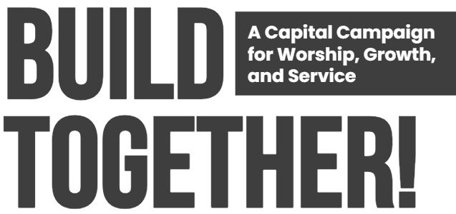
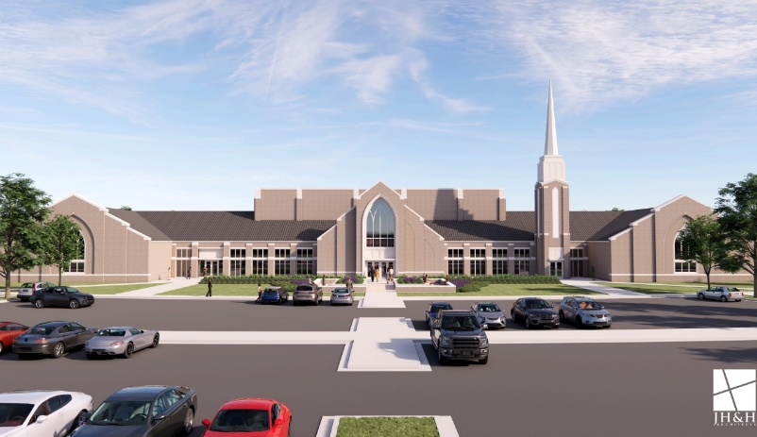


CAPITAL CAMPAIGN FORM

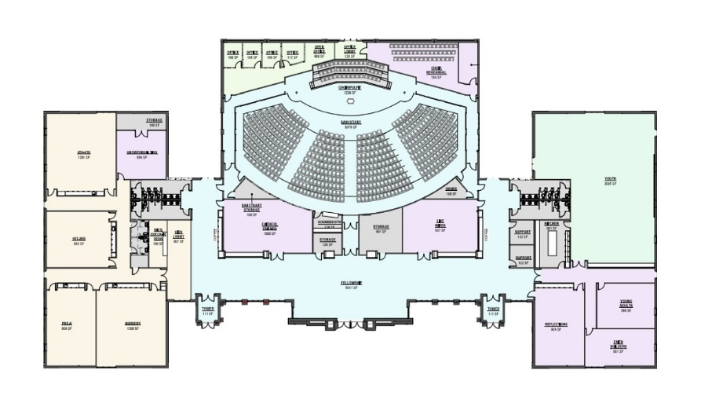

___________________________________________
Pl ease PRINT name

___________________________________________
Email address

___________________________________________
Physical address 1

___________________________________________
Physical address 2

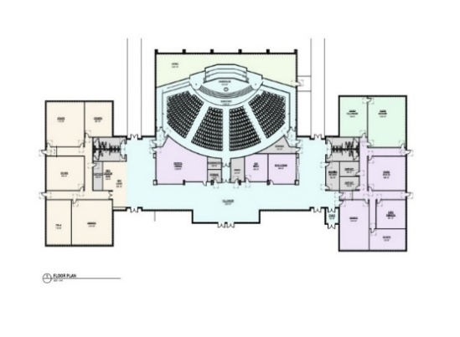
My commitment to the BUILD TOGETHER! Capital Fund Campaign is:

$ _________________ for 2026 $ _________________ for 2027 $ _________________ for 2028

I will contribute: ___ Online ___ By check ___ Other
“Unless the Lord builds the house, the builders labor in vain. “
– Psalm 127:1
Here’s how you can BUILD TOGETHER! with us:

- Pray for SGMC!
- Visit stkgmc.org/BuildTogether for more information.
- Make a gift! Gifts can be made by:

Cash Qualified Charitable Distributions
Check Retirement Plan/Annuity Beneficiary
Estate Planning (consult with your financial advisor first)
Insurance Beneficiary Donor-Advised Funds
Securities/Stock Transfer

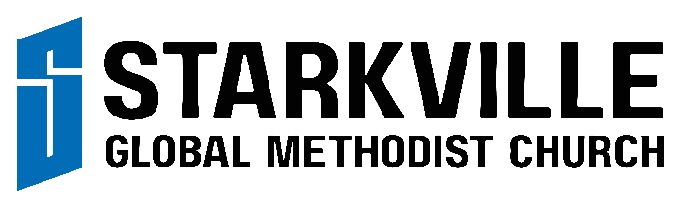

Mail: P. O. Box 1791; Starkville, MS 39760 | Office: 530 Vine Street; Starkville, MS 39759
Worship Location: Starkville Academy, Springer Center; 505 Academy Road; Starkville, MS 39759

If necessary, this commitment may be adjusted by contacting
Marianne Field, our Finance Assistant (662-268-8390; finance@stkgmc.org).

