SwimFIT

SESSION TIMES

Monday | 6-7pm
Tuesday | 6-7pm
Wednesday | 6-7pm

PRICES
Single Session  10 Session Pass |  | $12  $95

SwimFit is a squad developed for swimmers aged 14yrs + that focuses on improving fitness, technique and getting the most from your pool workouts. Our SwimFit sessions cater for a range of speeds and abilities, and swimmers are grouped in lanes accordingly.

Who would SwimFit be suitable for?
The squad caters for those participating in triathlons, ocean/open water swimmers, water polo players, Masters Swimmers, and those who wish to maintain a general swimming fitness.

It is also a great option for our current squad swimmers who are looking to maintain their swimming fitness without the commitments of being in a competitive squad.

How long are the sessions?
Swimmers are in the water for 1 hour.

Do I need to book?
No, bookings are not required.

How far will I swim each session?
Squad swimmers will swim from 1.5km to 4km per session, depending on an individual’s ability.

Is there a coach for the session?
Yes. Our coaches are qualified swimming industry professionals who have experience excelling in the pool and as a coach. They’ll be able to work closely with you to improve your swimming ability and reach your swimming goals, whatever they may be. It can be hard swimming on your own, particularly if you don’t have a lot of motivation! Our coaches plan and write up sessions for you, so you can follow the session plan and take the guesswork out of your swimming.

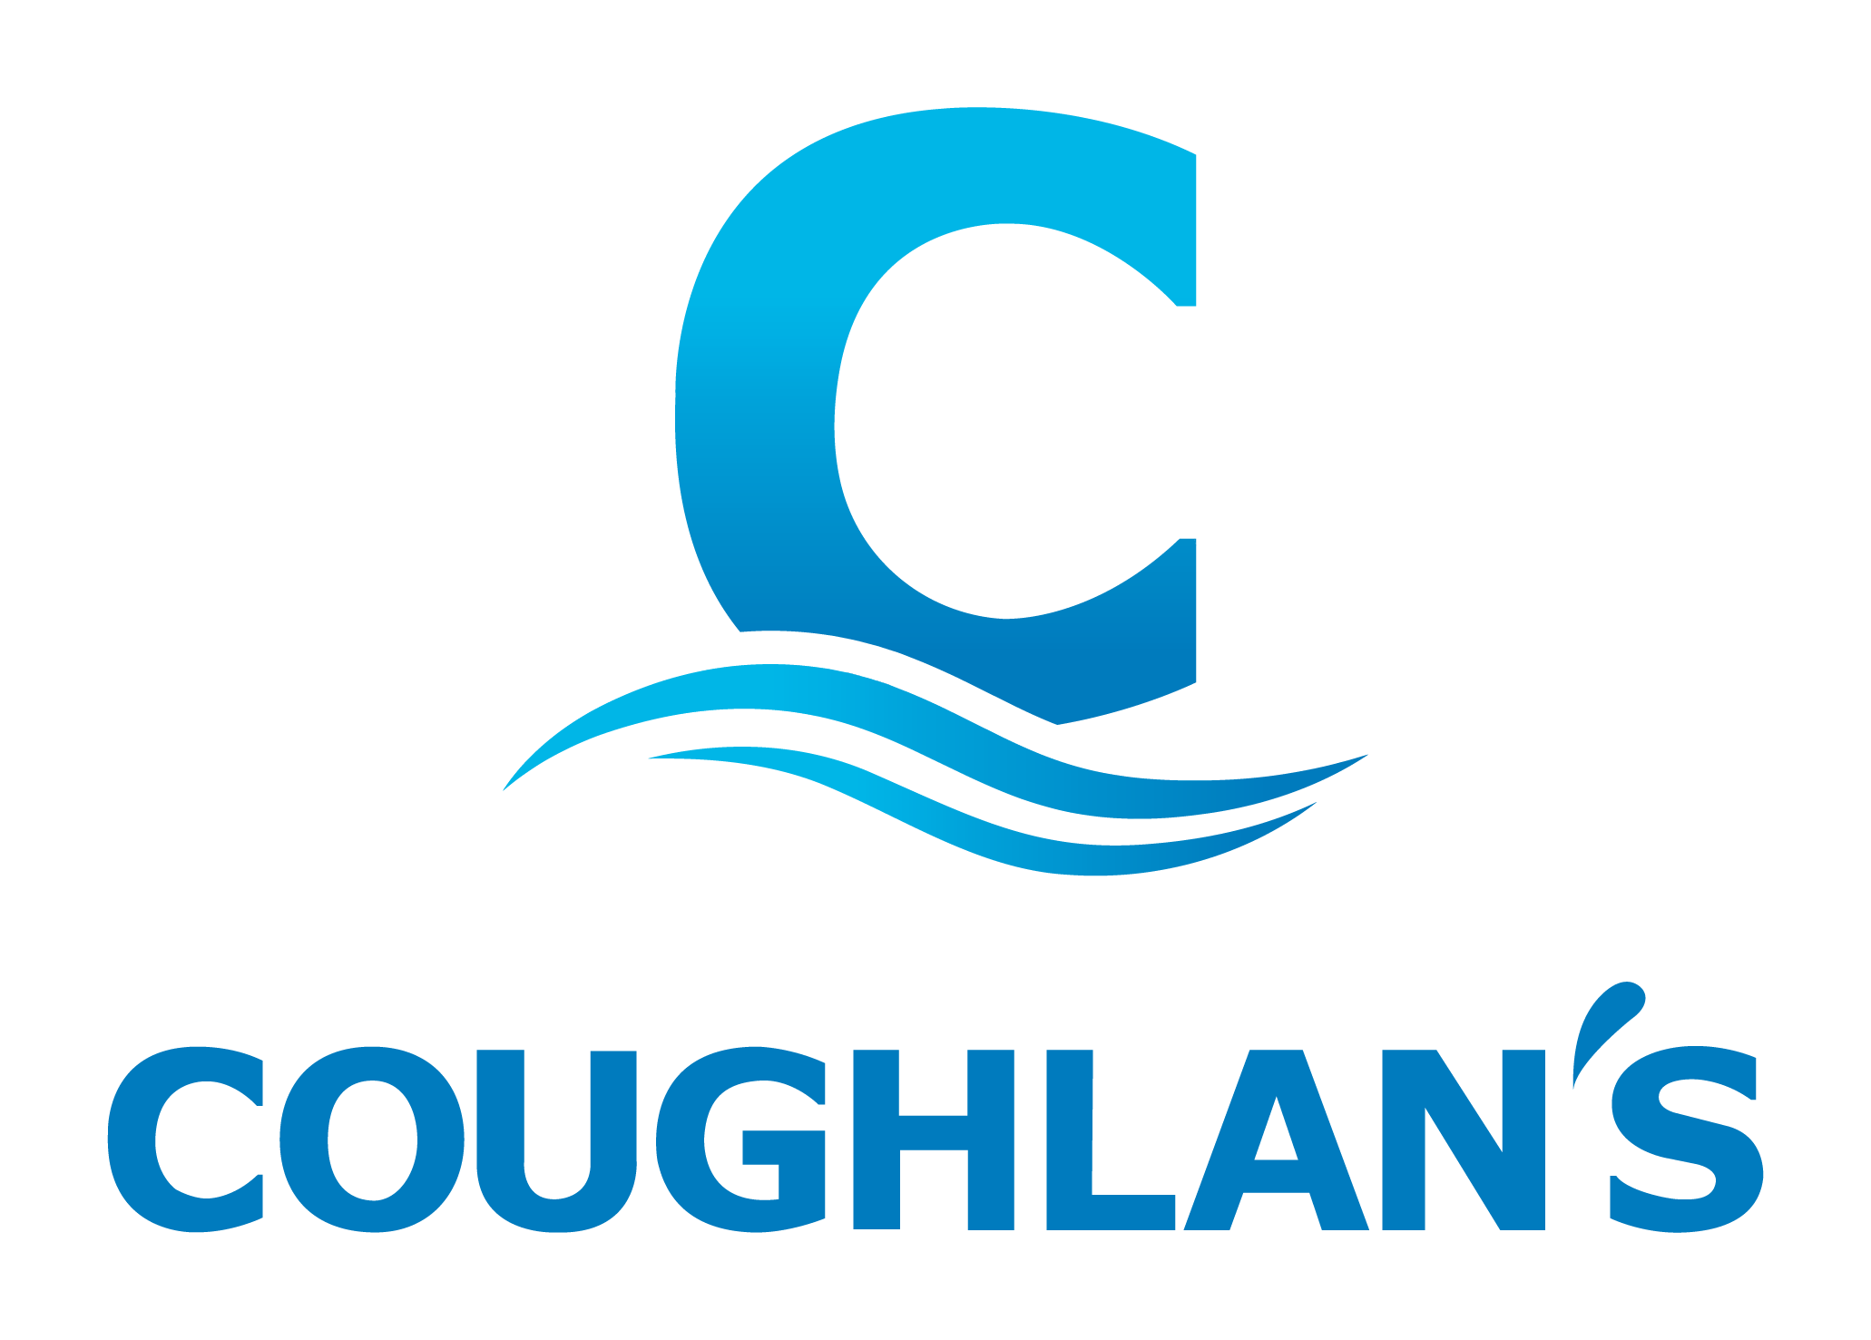
What do I need to bring?
Swimmers, goggles, drink bottle and a towel. Caps and fins are optional.

SwimFIT

SESSION TIMES

Monday | 6-7pm
Tuesday | 6-7pm
Wednesday | 6-7pm

PRICES
Single Session  10 Session Pass |  | $12  $95

SwimFit is a squad developed for swimmers aged 14yrs + that focuses on improving fitness, technique and getting the most from your pool workouts. Our SwimFit sessions cater for a range of speeds and abilities, and swimmers are grouped in lanes accordingly.

Who would SwimFit be suitable for?
The squad caters for those participating in triathlons, ocean/open water swimmers, water polo players, Masters Swimmers, and those who wish to maintain a general swimming fitness.

It is also a great option for our current squad swimmers who are looking to maintain their swimming fitness without the commitments of being in a competitive squad.

How long are the sessions?
Swimmers are in the water for 1 hour.

Do I need to book?
No, bookings are not required.

How far will I swim each session?
Squad swimmers will swim from 1.5km to 4km per session, depending on an individual’s ability.

Is there a coach for the session?
Yes. Our coaches are qualified swimming industry professionals who have experience excelling in the pool and as a coach. They’ll be able to work closely with you to improve your swimming ability and reach your swimming goals, whatever they may be. It can be hard swimming on your own, particularly if you don’t have a lot of motivation! Our coaches plan and write up sessions for you, so you can follow the session plan and take the guesswork out of your swimming.

What do I need to bring?
Swimmers, goggles, drink bottle and a towel. Caps and fins are optional.

