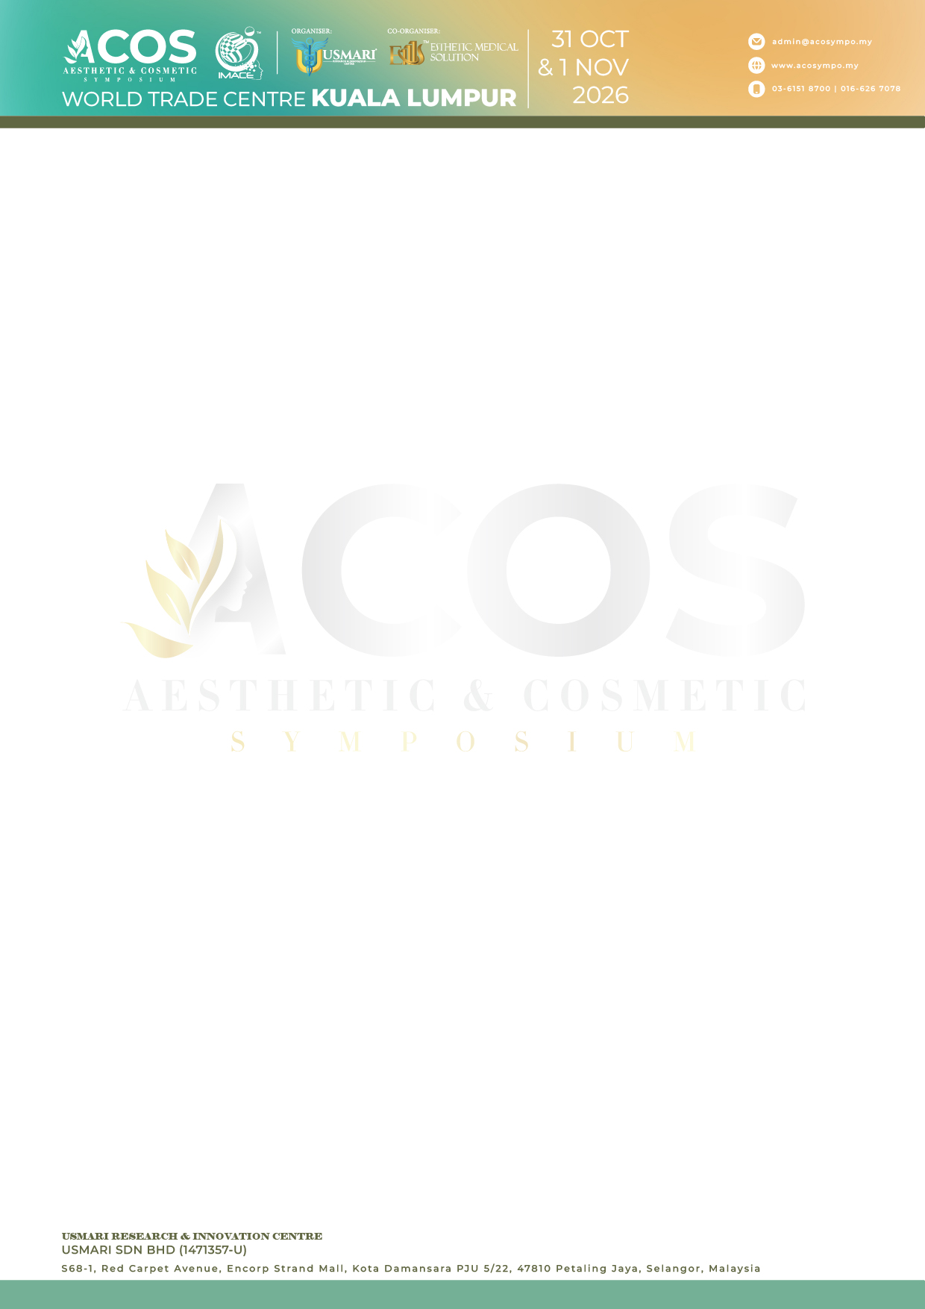

ACOS 2026 ABSTRACT TEMPLATE

Title: Font Times New Roman 16-point font, Bold, Title Case
List of authors’ full name: Font Times New Roman 12-point font, Bold
*Name of first author1, Name of second author2, Name of third author3…………….

The institution’s name: Font Times New Roman 11
¹First author’s institution name
²Second author’s institution name
³Third author’s institution name
*Please note that authors from the same institution should use the same number

*Corresponding author name & email

ABSTRACT

Please type of your abstract here. Use single spacing and Times New Roman, 11-point font. Abstract are written in English with maximum 300 words and formatted as a single paragraph. The abstract should be clear, descriptive and should provide brief information to the problem. This should generally be followed by a statement regarding the methodology and a summary of result. The abstract should end with a comment on the significance of the result or a brief conclusion. DO NOT cite references, figures or tables and minimize the use of abbreviations. Abstract will be subjected to minimal editing, therefore, it is advisable for authors to proofread the text content prior to submission.

Keywords: Minimum of 3 and maximum of 5 keywords separated by comma (,).

