St Felix Facilities Update for March 15-16 Bulletin
Church and Gym Interiors and Accessibility Enhancements: 2026 – 2027
St Felix parish and school community will meet to review the St Felix Plan for its campus facilities on March 29 and 30th, following the Saturday and Sunday Masses in the gymnasium. St Felix continues to work with River Architects of La Crosse, which has worked with many churches and schools in the region. New drawings will be presented for discussion and feedback.
This March 15-16 bulletin update describes the needed changes to church’s interior, which was last refurbished by the parish with Fr Conway in the 1993-94. The space and furnishing needs addressed in this phase can include:
Church Interiors
- Accessibility upgrades to the 3rd street entrance (wheelchair, walker etc)
- New greeting/family space created by a glass wall plus a bathroom;
- Plaster repairs, decorative painting plus new flooring;
- Pew repairs and refinishing;
- Adoration chapel and music room;
- Sanctuary accessibility updates;
- Lighting upgrades;
- Bluetooth sound loop for hearing aids.
Gymnasium: Heating, Ventilation and Air Conditioning
Office: Handicapped ramp to Office
A preliminary drawing is enclosed on the back of this insert. Larger viewing drawings will be at the meetings.
You are invited to attend and be involved in the discussions at 5:30 PM on March 29 and 10:30 AM on March 30, in the gym.
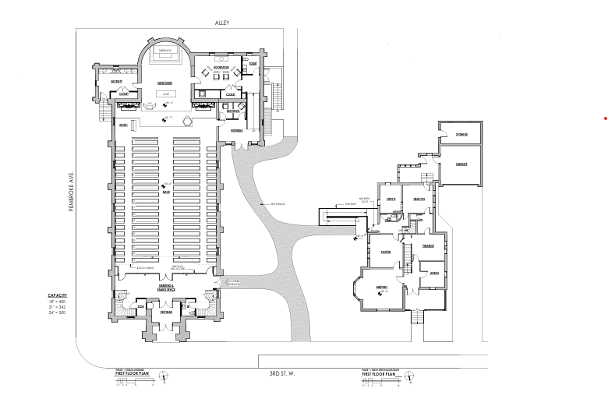
The dark blue arrow shows the greeting and family space with a bathroom.
The green arrow shows the barrier free entrances to the church and office.
The red arrow shows the adoration area / interim music area, prior to the gathering space is built.

