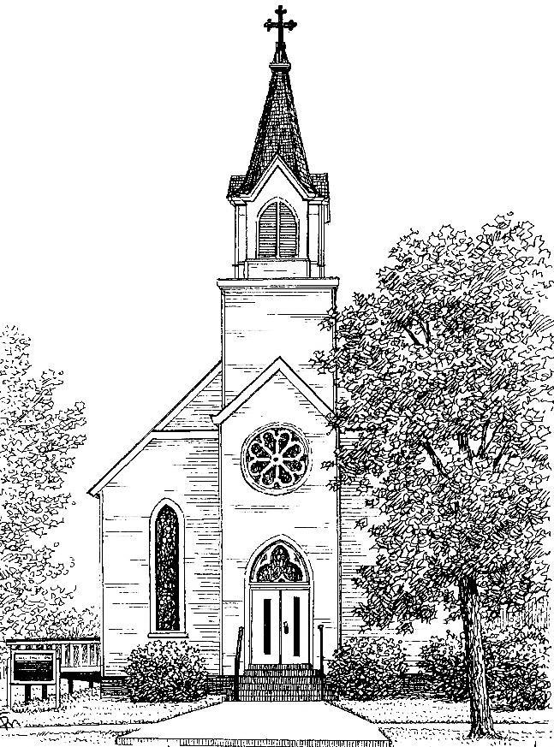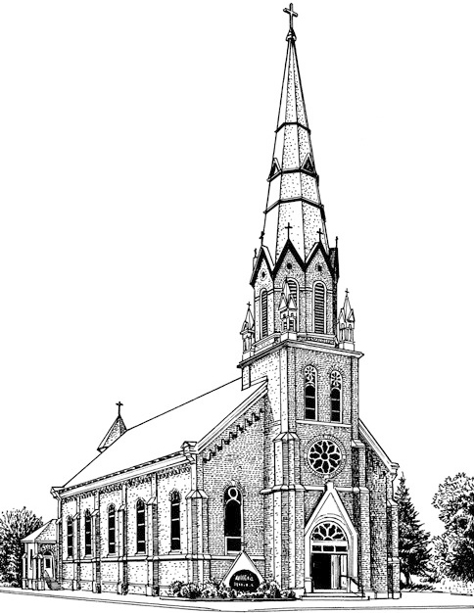 St. Felix, Wabasha St. Agnes, Kellogg
Roman Catholic Parishes
117 3rd St W ∙ Wabasha, MN 55981
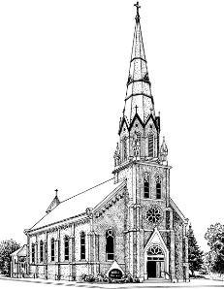
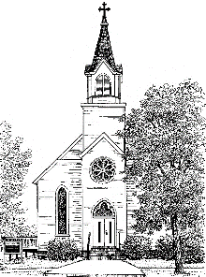
Ph: (651) 565-3931

CONFIRMATION SACRAMENTAL REGISTRATION FORM

Candidate’s Full Name: _____________________________________________________________
First Middle Last

Candidate’s date of birth: ___________________ Place of Birth: ___________________________
City State

Father’s Name: ____________________________________________________________________
First Last

Mother Name: ______________________________________________________________
First Maiden Last

Address: ________________________________________________________________________

Phone Number: _______________________ Email Address: ______________________________

Has your child been baptized? No___ Yes ___ If yes, exact date of baptism: ___________________
month/day/year

Church of Baptism: ______________________ Church location: ___________________________________
City State

Has your child received their First Eucharist? No ___ Yes ___

Candidate’s Saint name: ____________________________________

Candidate’s Confirmation Sponsor: __________________________ (must be 16, and fully initiated Catholic)

If your child was Baptized in another parish, we will need a copy of the Baptismal Certificate from that parish. You can get one by calling and asking for one, or we can assist you in that process if asked. This is needed for the parish records at St. Felix and St. Agnes. If your child was Baptized at St. Felix or St. Agnes, the above form is all that is needed.

