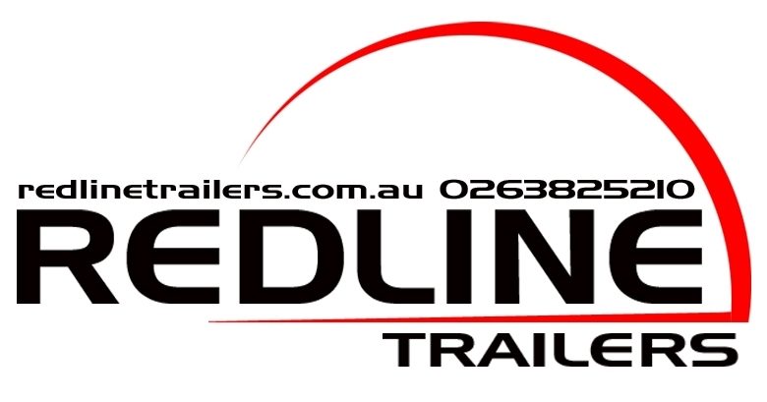

Operators Manual

94 Old Temora Rd, Young
Phone 02 63825210 Fax 02 63824727
Email: sales@redlinetrailers.com.au

Thank you for purchasing a Redline Trailer.

We Take Pride in our product.

To ensure safe and trouble-free towing, please read this manual and become familiar with the operation and maintenance of your trailer before setting out.

Your trailer is fitted with a VIN plate containing relevant information regarding maximum loads and tyre requirements. Please familiarise yourself with the information in this manual before operating, maintaining,
or adjusting the trailer.

Introduction

Welcome to the Redline Trailers Operator's Manual!

As the proud owner of a Redline Trailer, you've made an excellent choice in selecting a high-quality, versatile, and reliable trailer designed to meet all your hauling needs. This manual is your comprehensive guide to operating and maintaining your new trailer, ensuring a safe and enjoyable experience.

At Redline Trailers, we take pride in our commitment to craftsmanship and engineering excellence. Our trailers are built using state-of-the-art manufacturing techniques and premium materials to provide a durable and reliable product that you can trust for years to come.

To help you make the most of your Redline Trailer, this manual covers all aspects of trailer operation, including:

- Safety guidelines and precautions: Learn how to safely hitch, load, unload, and transport your cargo, as well as how to navigate various road conditions and maintain a safe driving environment.
- Trailer components and features: Familiarise yourself with the various components of your trailer, including the hitch, axles, brakes, lights, and other essential features.
- Assembly and setup: Follow step-by-step instructions for assembling and setting up your trailer, ensuring it's properly configured and ready for use.
- Loading and unloading: Master the art of efficiently and securely loading and unloading your trailer to maximize its capacity and protect your cargo.
- Maintenance and troubleshooting: Keep your trailer in optimal condition by performing regular maintenance tasks and learn how to diagnose and resolve common issues that may arise.
- Accessories and customization: Discover the range of available accessories and customization options for your trailer, allowing you to tailor its performance and appearance to your specific needs.

We encourage you to read through this entire manual to familiarize yourself with your Redline Trailer's features and capabilities. Our team is dedicated to providing top-notch customer support, and we're always here to help should you have any questions or concerns. With proper care and handling, your Redline Trailer will serve as a dependable companion for countless adventures and projects.

From all of us at Redline Trailers, we thank you for choosing our products, and we wish you many successful journeys ahead!

Happy hauling!

Table of Contents
Introduction 3
Safety 6
Safety Precautions 6
Trailer Specifications 7
Tyre Specifications 8
VEHICLE & TRAILER COUPLING 9
Revised coupling ratings, based on towing motor vehicle GVM 9
IN summary there is a derating of the permissible ATM and the greater the GVM the lower the revised and enforceable ATM 9
(see table ) 9
Caution 12
Proper hitching and unhitching procedures: 13
Guide to Correct Use Of 50mm Hitches 13
Guide to Correct Use of Cruisemaster's DO35 Hitch 15
Guide to Using the DO45 Plus Hitch 17
Guide for Handbrake Use 19
Handbrake Maintenance and Safety Guide 20
CRUISEMASTER™ Electric Brakes Operator's Manual 21
CRUISEMASTER™ ATX Air Suspension User Guide 22
Redline Trailers Load Sharing Suspension 24
Loading and unloading cargo: 25
Securing cargo using tie-downs, straps, or other means: 25
Balancing the load to ensure proper weight distribution: 25
Connecting trailer lights and verifying proper function: 25
Safe towing practices, including speed limits, braking, and turning: 25
Maintenance and Inspections 26
Troubleshooting 27
Maintenance of Your Trailer 28
Warranty and Support 29
General safety 30
Checks during a trip 32
Loading your trailer 32
Safe Tipping 35
Maintenance of your trailer 37
Safe installation of the safety strut 38
Servicing your tipper unit 39
Spare Parts 40
Your vehicles performance 41
How towing a trailer affects your driving 41
Warrantee 42

Safety
You are responsible for the safe operation and maintenance of your Redline tipping trailer. You must ensure that you and anyone else, who is going to operate, maintain or work around the trailer be familiar with the operating and maintenance procedures and related safety information contained in this manual. This manual will take you step by step through using your tipping trailer and alerts you to good safety practises that should be adhered to while working with your Redline tipping trailer.

Remember you are the key to safety. Good safety practises not only protect you but also the people around you. Make these practises a working part of your safety program. Be certain that everyone operating this equipment is familiar with the recommended operating and maintenance procedures and follows all the safety precautions. Most accidents can be prevented. Do not risk injury or death by ignoring good safety practises.

- Redline trailer owners must give operating instructions to operators or employees before allowing them to operate the trailer.
- The most important safety device is a safe operator. It’s the operator’s responsibility to read and understand all safety and operating instructions in the manual and to follow these. All accidents can be avoided.
- A person who has not read and understood all operating and safety instructions is not qualified to operate machinery. An untrained operator exposes himself and others to serious injury or death.
- Do not modify the equipment in any way. Unauthorized modification may impair the function and/or safety and could affect the life of the equipment.
- Think safety! Work safety!

Safety Section of the Redline Trailers Operator's Manual

Safety Precautions
Before operating your Redline Trailer, it is important to follow these general safety precautions to ensure a safe and efficient experience:
- Properly secure all loads to prevent shifting or falling during transit.
- Use the correct hitch and towing equipment specified for your trailer to ensure a secure connection to the towing vehicle.
- Observe all weight limitations, including the gross vehicle weight rating (GVWR) and cargo capacity, to avoid overloading the trailer or combination.
- Conduct regular inspections and maintenance on the trailer, including checking for wear, damage, and proper function of all components.
- Familiarize yourself with the trailer specifications and proper operation procedures to ensure a safe towing experience.

Trailer Specifications
Nominal measurements
Model | Tray length (m) | Tray Width (m) | Total Length (m) | Total Width (m) | Height (mm)  based on a 1000mm headboard
600T | 3 | 1.8 | 4.55 | 1.95 | 1650
600T | 3.6 | 1.8 | 5.15 | 1.95 | 1650
600FT | 3 | 2 | 4.55 | 2.15 | 1650
600FT | 3.6 | 2 | 5.15 | 2.15 | 1650
600FT | 4.2 | 2 | 5.75 | 2.15 | 1650
600FT | 4.2 | 2.35 | 5.75 | 2.5 | 1650
600FT | 4.8 | 2 | 6.35 | 2.15 | 1650
600FT | 4.8 | 2.35 | 6.35 | 2.5 | 1600
Model | Tray length (m) | Tray Width (m) | Total Length (m) | Total Width (m) | Height (mm)
750FT | 3 | 2 | 4.55 | 2.15 | 1800
750FT | 3.6 | 2 | 5.15 | 2.15 | 1800
750FT | 4.2 | 2 | 5.75 | 2.15 | 1800
750FT | 4.2 | 2.35 | 5.75 | 2.5 | 1800
750FT | 4.8 | 2 | 6.35 | 2.15 | 1800
750FT | 4.8 | 2.35 | 6.35 | 2.5 | 1800
Model | Tray length (m) | Tray Width (m) | Total Length (m) | Total Width (m) | Height (mm)
900T | 3 | 1.8 | 4.55 | 1.95 | 1950
900T | 3.6 | 1.8 | 5.05 | 1.95 | 1950
900T | 3.6 | 2 | 5.15 | 2.15 | 1950
900FT | 3 | 2 | 4.55 | 2.15 | 1950
900FT | 3.6 | 2 | 5.15 | 2.15 | 1950
900FT | 4.2 | 2 | 5.75 | 2.15 | 1950
900FT | 4.2 | 2.35 | 5.75 | 2.5 | 1950
900FT | 4.8 | 2 | 6.35 | 2.15 | 1950
900FT | 4.8 | 2.35 | 6.35 | 2.5 | 1950

Tyre Specifications

Tyre  Size | Load Rating | Recommended Pressure for 1000kg Load (KPA) | Recommended Pressure for 1000kg Load (PSI) | Recommended Pressure for 3500kg Load (KPA) | Recommended Pressure for 3500kg Load (PSI) | Recommended Pressure for 4500kg Load (KPA) | Recommended Pressure for 4500kg Load (PSI)
195/50  R13 | 104 | 620-690 | 90-100 | 700-770 | 101-112 | 750-820 | 109-119
225/70  R15 | 112 | 280-320 | 41-46 | 320-360 | 46-52 | 360-400 | 52-58
235/65  R16 | 121 | 280-320 | 41-46 | 320-360 | 46-52 | 360-400 | 52-58
245/75  R16 | 120 | 340-380 | 49-55 | 380-420 | 55-61 | 420-460 | 61-67
31x10.5  R15 | 104 | 280-320 | 41-46 | 320-360 | 46-52 | 360-400 | 52-58
265/75  R16 | 123 | 340-380 | 49-55 | 380-420 | 55-61 | 420-460 | 61-67

Please note that the load rating can vary for a given tyre size depending on the specific make and model of the tyre. Always refer to the tyre manufacturer's specifications for the load rating of your tyre. Additionally, the recommended tyre pressure may vary depending on factors such as load carrying capacity, vehicle type, driving conditions, and weather. Always refer to the vehicle manufacturer's recommended tyre pressure for the specific make and model of your vehicle.

Hitches

Hitch Type | Weight Capacity (kg) | Download Rating (kg)
50mm Ball Hitch | 3500 | 350
D035 V3 | 3500 | 350
70mm Ball Hitch | 4500 | 450
95mm Bartlett Ball | 4500 | 500
Pintle Hook | 4500 | 450
D045+ Hitches | 4500 | 450

Trailer Operation
To operate your Redline Trailer safely and efficiently, follow these procedures:

VEHICLE & TRAILER COUPLING

Always ensure tow bars and couplings are compliant with Australian Design Rules (ADR) and relevant Australian Standards. Unless a permanent part of the vehicle, it is compulsory for all towbars and couplings manufactured after 1 July 1988 to clearly and permanently display the maximum load rated capacity plus the make and model of vehicle for which they are intended, or alternatively, the manufacturer’s name, trademark and part number.
Typical approved couplings for trailers are:

• 50 mm ball couplings or other style couplings for trailers with an ATM up to 3,500 kg; and • 75 mm ball, pintle hook or other type couplings for trailers with an ATM up to 4,500 kg.

The Hitch Mount or Tongue The hitch mount, also known as the tongue, is the section of the towbar to which the tow ball, pin, block, or other coupling is attached. If the hitch mount or tongue obscures the number plate it should be removed from the towbar when the trailer is not attached. Hitches Always use a trailer coupling appropriate for the type of towing to be undertaken. If travelling off road, use a high articulation trailer coupling. Always maintain the trailer coupling pivot point (trailer hitch) position, as specified by the trailer coupling manufacturer.
NHVR VSG16 revised ratings for 50mm ball couplings towed by vehicles with a GVM greater than 4.5T
Revised coupling ratings, based on towing motor vehicle GVM
IN summary there is a derating of the permissible ATM and the greater the GVM the lower the revised and enforceable ATM
(see table )
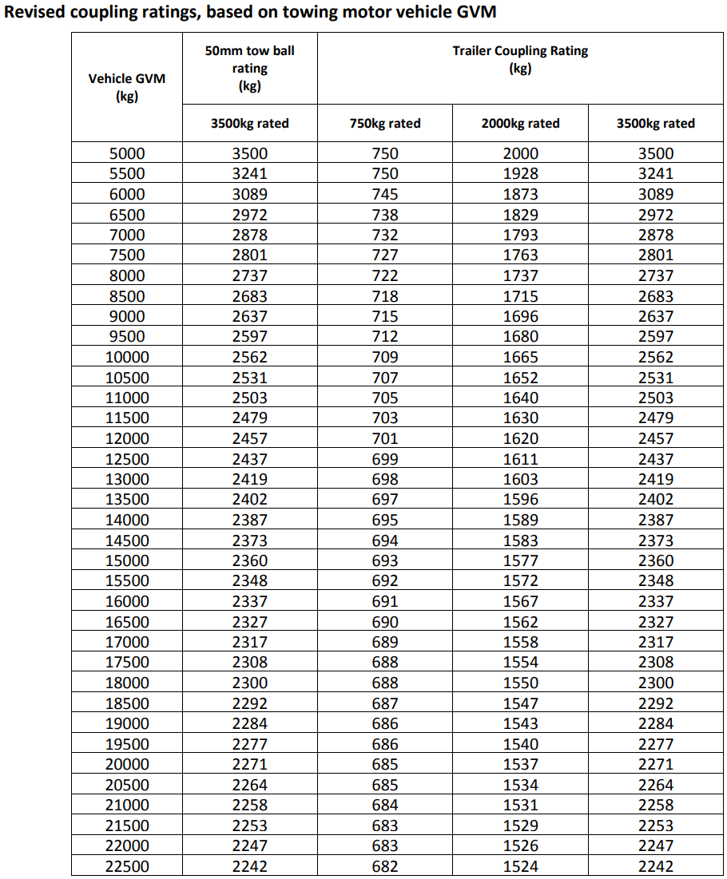
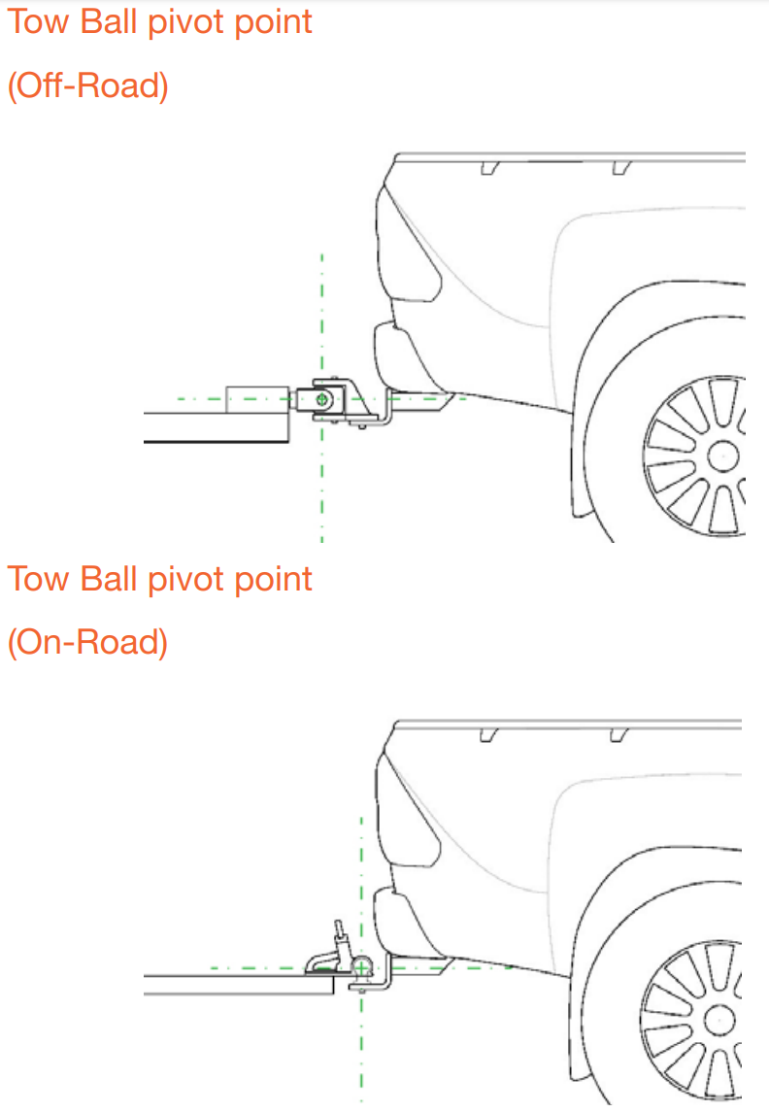

Caution

High articulation couplings when used with a weight distribution system should only be used for highway driving. Do not use for articulated off-road driving.
The levelness of the trailer may be adjusted on some tow bars by inverting the tow ball tongue to more appropriately suit the trailer.

Note:
• Some tow bar tongues are in the inverted position as standard. • Some tow bar tongues cannot be inverted. Tow ball position can only be changed to allowable tow bar designed positions. The load rating may change with a different orientation of the tow bar tongue.
• A tow bar that can be inverted will have a plaque fitted to the tow bar showing the position that it can be changed to and the load rating in the changed position.

Tow Hitch Down loads Trailer cargo load should be distributed so the tow hitch down load is within the specification shown in the vehicle owner’s manual and tow bar ID plate. The tow hitch download is measured in kilograms carried by the tow bar and must not exceed the maximum load for the vehicle/tow bar design. Tow hitch download as a guide should be 8-10% of the ATM, up to the tow bar load limit. Variation above or below tow hitch download reduces stability of the combination. It should be noted that some trailers/caravans may require a lower tow hitch download due to the design, for example European style systems. Trailer tow hitch download weight can be determined by weighing the trailer at the coupling point. Always have the trailer coupling at the same height as it is when coupled to the vehicle in the loaded condition.

Trailer tow hitch download weight must be included as part of the tow vehicle GVM. The Tow Hitch/Ball Based on ADRs and Australian Standards, tow hitches and balls suitable for ATM weights up to 4,500 kg must have the manufacturer’s name, or CRN, stamped on the tow ball. If using a 50 mm tow ball, with the tow vehicle in its as-used state, the towbar on the towing vehicle must be capable of being mounted (adjusted) to any one height within the range of 350 mm to 460 mm (from the ground to the centre of the tow ball). There are no height restrictions on other types of couplings. The most commonly used 50 mm diameter tow balls are not rated beyond.
3,500 kg. Towing 3,500 kgs to 4,500 kgs requires the use of a 70 mm tow ball or other coupling rated to the ATM of the trailer.

Proper hitching and unhitching procedures:

Guide to Correct Use Of 50mm Hitches
Attaching your trailer is a crucial step before hitting the road. Properly attaching your trailer ensures safe and stable towing, preventing accidents and damage to both the towing vehicle and trailer. The steps below provide a general guideline for attaching a trailer, but it is important to follow the specific instructions provided by the trailer and towing vehicle manufacturers.

If you are using a 50mm tow ball, follow these steps:

- Make sure that the trailer's parking brake is engaged to prevent it from moving while you are attaching it to the towing vehicle.
- Check that the coupling lock is raised in the release position. This is typically a lever or handle that needs to be lifted or pulled back to release the coupling mechanism.
- Reverse the towing vehicle so that the 50mm tow ball is directly underneath the trailer coupling.
- Lower the coupling mechanism so that it engulfs the tow ball. Ensure that the tow ball is securely in the coupling.
- Lower the coupling lock fully and install the R pin or optional padlock into the coupling lock. This ensures that the coupling remains securely locked onto the tow ball.
- Attach the safety chain/s. If two safety chains are in use, it is recommended that they cross underneath the tow ball to prevent the trailer from coming loose in case of a coupling failure.
- Shorten the chains to allow the trailer hitch to be held above the road surface should the trailer become uncoupled. However, do not shorten the chain to the extent that it comes under any strain load while turning the trailer to the extremities. Allowances must be made for approach and departing angles.
- Check the D shackles for any damage or wear and replace them immediately if necessary.
- Connect the trailer electrical connector. Ensure that the plug is compatible with the towing vehicle socket and that the wiring is correctly connected. Secure the connector by locking the cover of the towing vehicle connector over the trailer plug. Check secure attachment by applying light force on the lead.
- Check the function of all lights and brake activation. Make sure that all the lights, including brake and indicator lights, are working correctly.
- Install the parking jack in its transport position to prevent it from dragging on the road while towing.
- Release the parking brake on the trailer.

If you are using a trailer with other style couplings, follow these steps:

- Make sure that the trailer's parking brake is engaged to prevent it from moving while you are attaching it to the towing vehicle.

- Check that the coupling lock is raised in the release position.

- Position the towing vehicle and trailer so that they are aligned.

- Lower the trailer onto the tow ball and engage the coupling mechanism, following the manufacturer's instructions.

- Secure the coupling mechanism with any locking devices provided, such as locking pins or padlocks.

- Attach the safety chain/s. If two safety chains are in use, it is recommended that they cross underneath the tow bar to prevent the trailer from coming loose in case of a coupling failure.

- Shorten the chains to allow the trailer hitch to be held above the road surface should the trailer become uncoupled. However, do not shorten the chain to the extent that it comes under any strain load while turning the trailer to the extremities. Allowances must be made for approach and departing angles.

- Check the D shackles for any damage or wear and replace them immediately if necessary.

- Connect the trailer electrical connector. Ensure that the plug is compatible with the towing vehicle socket and that the wiring is correctly connected. Secure the connector by locking the cover of the towing vehicle connector over the trailer plug. Check secure attachment by applying light force on the lead.

- Attach the cable from the Breakaway Switch to a secure anchor point at the rear of the tow vehicle. Do not attach the cable to the tow ball or safety chain anchor.

- Check the function of all lights and brake activation. With the trailer properly attached to the towing vehicle, turn on all of the trailer lights (including brake lights, indicators, and taillights) and check that they are working properly. You can have someone stand at the back of the trailer to help with this step.

- Install the parking jack in its transport position. The parking jack is a device used to support the trailer when it is not connected to a towing vehicle. When the trailer is connected, the parking jack must be stowed in its proper position, which varies depending on the type of trailer and parking jack. Follow the manufacturer's instructions for guidance.

- Release the park brake. Once the trailer is properly attached to the towing vehicle, the trailer's parking brake can be released. This will allow the trailer to move freely when the towing vehicle moves. It is important to ensure that the parking brake is released before driving off with the trailer.

.

Guide to Correct Use of Cruisemaster's DO35 Hitch

The Cruisemaster DO35 Hitch is designed to provide a secure connection between your towing vehicle and trailer while allowing for smooth off-road articulation. To ensure the proper use of your DO35 Hitch, follow the steps outlined in this guide:

- Preparation
Ensure your towing vehicle has a suitable rated tow bar and a 50 mm (2-inch) tow ball.
Verify that both the towing vehicle and the trailer have the appropriate towing capacity for the load you plan to tow.

- Hitching the Trailer
Park your towing vehicle on a level surface and align the tow ball directly under the DO35 Hitch on the trailer.
Lower the trailer's jockey wheel to raise the hitch until it is high enough to clear the tow ball.
Reverse your towing vehicle so that the tow ball is positioned under the DO35 Hitch.
Release the DO35 Hitch locking mechanism by pulling out the red locking pin and rotating the latch handle to the open position.
Lower the jockey wheel to guide the DO35 Hitch onto the tow ball until the hitch is fully seated and the latch handle clicks into the closed position.
Ensure that the red locking pin has re-engaged by checking that it has sprung back into position. This indicates that the hitch is locked securely onto the tow ball.
Raise the jockey wheel and secure it in its stowed position.
Connect the trailer's safety chains to the towing vehicle and attach the breakaway cable to a secure point on the towing vehicle.
Connect the trailer's electrical connections to the towing vehicle, and test all lights for proper operation.

- Unhitching the Trailer
Park your towing vehicle and trailer on a level surface and apply the towing vehicle's parking brake.
Disconnect the trailer's electrical connections and release the safety chains and breakaway cable from the towing vehicle.
Lower the jockey wheel and ensure it is secure before raising the trailer hitch.
Pull out the red locking pin and rotate the latch handle to the open position, releasing the DO35 Hitch from the tow ball.
Carefully raise the trailer hitch using the jockey wheel until it clears the tow ball, and then move the towing vehicle away from the trailer.


- Maintenance and Inspection
Regularly lubricate the DO35 Hitch's moving parts, such as the latch handle and locking pin, using a high-quality lubricant.
Periodically inspect the DO35 Hitch for signs of wear, damage, or corrosion. If any issues are discovered, consult an authorized Cruisemaster service provider for assistance.
Keep the tow ball and DO35 Hitch clean and free of dirt or debris to ensure proper hitching and unhitching.

Guide to Using the DO45 Plus Hitch

The DO45 Plus Hitch from Cruisemaster is designed to offer a secure connection between your towing vehicle and trailer, while providing excellent off-road articulation. To use your DO45 Plus Hitch correctly, follow these simple steps:
Step 1: Preparation
- Ensure your towing vehicle has a compatible rated tow bar and a 50 mm (2-inch) tow pin.
- Verify that both the towing vehicle and the trailer have the appropriate towing capacity for the load you plan to tow.
Step 2: Hitching the Trailer
- Remove the tow pin cap from the tow pin on your towing vehicle.
- Clean the tow pin and universal coupling surfaces, removing any sand, dirt, or foreign objects. Apply a light layer of lubricant to prevent premature wear.
- Set the coupling to the unlocked position by pressing the red locking button and pushing the locking plate toward the button. The viewing port in the center of the locking mechanism should be clear.
- Raise the trailer's height by adjusting the jockey wheel or stand, ensuring the coupling is above the tow pin height.
- Align the coupling over the tow pin by moving either the vehicle or trailer, and lower the coupling onto the tow pin using the jockey wheel or stand. Make sure the universal coupling is fully seated on the tow pin, which should be visible through the viewing port.
- Press the red locking button to reset the locking plate into the locked position. The locking plate will slide forward simultaneously with the button press.

- Secure the checklock cap by snapping in the back edge of the cap first, followed by pushing down on the front of the cap. The cap will emit an audible snap when secured correctly.

Step 3: Unhitching the Trailer

- Park your towing vehicle and trailer on a level surface and apply the towing vehicle's parking brake.
- Disconnect the trailer's electrical connections, safety chains, and breakaway cable from the towing vehicle.
- Lower the jockey wheel and ensure it is secure before raising the trailer hitch.
- Press the red locking button and push the locking plate back to release the DO45 Plus Hitch from the tow pin.
- Carefully raise the trailer hitch using the jockey wheel until it clears the tow pin and then move the towing vehicle away from the trailer.


Step 4: Maintenance and Inspection

- Keep the tow pin and universal coupling surfaces clean and lightly lubricated at all times.
- Check the condition of the tow pin O-ring and replace it if necessary (Part No. 18D-DO45-101).
- Regularly lubricate grease points with multi-purpose grease.
- Periodically adjust the slotted nut and pin if the coupling head becomes excessively loose. This adjustment should be performed by a competent person.
- Flush the locking mechanism with clean water if it does not fully open due to dirt ingress.

Guide for Handbrake Use

Using the handbrake on your trailer is essential for ensuring the vehicle remains stationary when parked or disconnected from the towing vehicle. Here's a guide on how to use and maintain the handbrake effectively:

Operation of the Handbrake
- To engage the handbrake, pull the handle until the cable is tight, and the handbrake locks into the ratchet.
- To release the handbrake, pull the lever slightly and depress the handbrake button to ensure the pawl is free from the ratchet plate. Then, return the lever to its resting position.
Safety Measure
As an additional safety measure, you can use a padlock to secure the ratchet padlock hole, preventing the handbrake from being accidentally released.

Factors Affecting Handbrake Efficiency

Several factors can impact handbrake efficiency. Keep these factors in mind when configuring your handbrake system:
- Wheel and tire diameter: larger diameters may require more force to engage the handbrake effectively.
- Handbrake cable routing: Ensure the cable is routed correctly and free from obstructions.
- Brake condition or "bedding in": New brakes may require a "bedding-in" period to reach optimal performance.
- Road surface: Slippery or uneven surfaces can affect handbrake efficiency.
- Selected hole position in the lever: Adjust the lever's hole position to suit your specific setup.
- Pull force exerted on the handbrake lever: Apply adequate force to ensure the handbrake engages correctly.
- Brake type and size: Different brakes may require specific adjustments for optimal handbrake performance.
- Angle of surface: Steeper surfaces may require more force or additional support, such as wheel chocks, to ensure the trailer remains stationary.

Handbrake Maintenance and Safety Guide

To ensure the proper function and longevity of your handbrake, follow this maintenance and safety guide:
- Keep hands and fingers clear of the ratchet when operating the handbrake to prevent injury.
- Regularly inspect the handbrake cables to ensure they maintain the appropriate tension when the handbrake is engaged.
- Use wheel chocks as an additional safety mechanism to help keep the trailer stationary, particularly on uneven or inclined surfaces.
- As brakes wear and cables stretch over time, you will need to adjust the handbrake cable to maintain its effectiveness.
- Check all bolts and roll pins regularly to ensure they are correctly tightened and located, preventing any unexpected failures.
- Trailer safety chains should remain connected until the trailer is fully secured with the handbrake and any additional support, such as wheel chocks.

- Make sure the handbrake is correctly installed and provides adequate park braking efficiency for your specific trailer or van. Ideally, the handbrake should be able to hold the trailer or caravan on a minimum incline of 18% (10 degrees).

By following this maintenance and safety guide, you can ensure the proper operation of your handbrake and maintain the safety of your trailer or caravan when parked or disconnected from the towing vehicle. Regular inspection and maintenance will also help extend the lifespan of your handbrake components.

CRUISEMASTER™ Electric Brakes Operator's Manual

- Introduction This manual provides guidance on the operation and maintenance of CRUISEMASTER™ electric brakes installed on your trailer or caravan. Please familiarize yourself with the following sections to ensure safe and efficient usage of your electric braking system.
- Service Brake Specifications Refer to the manufacturer's documentation for brake pattern, bolt, nut torque, and other specifications related to your specific CRUISEMASTER™ brake model.
- Drum Size To maintain safe brake operation, ensure brake drums stay within the recommended internal diameter limits. Replace brake drums if they exceed the specified dimensions.
- Brake Ratings Refer to the manufacturer's documentation for brake capacity based on your suspension type, axle type, and tire diameter.
- Park Brake Operation A cable is attached to the designated lever arm on the outside of the backing plate, which operates the brakes without the need for constant electricity supply.
- How to Use Your Electric Brakes Properly Your trailer brakes are designed to work in synchronization with your tow vehicle brakes. Never use your tow vehicle or trailer brakes alone to stop the combined load. Proper synchronization can only be accomplished through road testing.
- Synchronization Follow the brake controller manufacturer's instructions to synchronize your tow vehicle with your trailer braking system.
- General Brake Maintenance Brakes should be adjusted and checked at specified service intervals or as use and performance require. Brake service, including cleaning and inspection, should be performed yearly or more often as needed.
- Brake Adjustment & Check Follow the specified procedure for adjusting the brakes at recommended intervals.
- Brake Service - Cleaning and Inspection Inspect and replace worn or damaged parts as needed, and clean the backing plate, magnet arm, magnet, and brake shoes. Ensure all removed parts are replaced in the same brake and drum assembly.
- Brake Service - Magnets Inspect and replace magnets if worn unevenly or abnormally. Replace magnets in pairs and use only genuine replacement parts.

- Brake Service - Shoes Inspect and replace brake shoes if the lining is worn, contaminated, or abnormally scored or gouged. Replace both shoes on each brake and both brakes of the same axle.
- Troubleshooting Refer to the troubleshooting section to identify and resolve common issues related to electric brakes.
For detailed specifications, part numbers, and maintenance procedures, refer to the manufacturer's documentation included with your CRUISEMASTER™ electric brakes system.

CRUISEMASTER™ ATX Air Suspension User Guide

Introduction: Thank you for choosing the CRUISEMASTER™ ATX Air Suspension for your trailer or caravan. This user guide will help you understand the features, operation, and maintenance of the ATX Air Suspension system. Please read this guide thoroughly to ensure safe and efficient use of your air suspension.
Table of Contents:
- System Components
- Features and Benefits
- Installation
- Operation
- Maintenance and Troubleshooting

- System Components: The CRUISEMASTER™ ATX Air Suspension system includes the following components:

- Airbags
- Air Compressor
- Air Manifold
- Air Tanks
- Height Control Valve
- Pressure Switch
- Air Lines and Fittings
- Wiring Harness and Connectors
- Features and Benefits: The ATX Air Suspension system offers several advantages over traditional leaf spring or coil spring suspensions:
- Improved ride quality and comfort
- Reduced road noise and vibration
- Enhanced load carrying capacity.
- Automatic height control for level towing
- Better handling and stability
- Easier and quicker hitching/unhitching

- Installation:
Installation of the CRUISEMASTER™ ATX Air Suspension system should be carried out by a qualified professional. Please refer to the installation guide provided with your air suspension kit and follow the steps outlined. The installer should verify the suspension alignment, air pressure settings, and electrical connections to ensure proper function and performance.

- Operation:
- Before towing, ensure the airbags are inflated to the correct pressure as specified in the installation guide or owner's manual.
- The height control valve will automatically adjust the airbag pressure to maintain a level ride height, regardless of the load.
- The air compressor and air tank system provide a reserve of compressed air for quick adjustments.
- The pressure switch ensures the air compressor operates within a safe pressure range, preventing over- or under-inflation of the airbags.
- In the event of an air leak or puncture, the air suspension system will automatically adjust the pressure in the remaining airbags to maintain a level ride height and safe towing conditions.

- Maintenance and Troubleshooting: Regular inspection and maintenance are essential for the safe and reliable operation of your CRUISEMASTER™ ATX Air Suspension system. Some recommended maintenance tasks include:
- Inspect airbags, air lines, and fittings for signs of wear or damage.
- Check the air compressor and air tank for leaks or corrosion.
- Test the height control valve and pressure switch for proper operation.
- Lubricate moving parts such as valve linkages and pivots as needed.
- Monitor air pressure and adjust as necessary for optimal performance.
For troubleshooting assistance or technical support, please consult the CRUISEMASTER™ website or contact the manufacturer's customer service team.




ATX User Guide XT User Guide

Redline Trailers Load Sharing Suspension

Thank you for choosing Redline Trailers! This User Service Guide is designed to help you maintain and service your Redline Trailers Load Sharing Suspension system, ensuring optimal performance and longevity for your trailer.

The Redline Trailers Load Sharing Suspension system provides superior handling and a smooth ride by distributing weight evenly across the trailer axles. To make sure your suspension system operates at peak performance, it's essential to follow the recommended maintenance schedule and procedures detailed in this guide.

- Greasing the Grease Nipples:
For the best performance, it is crucial to grease the grease nipples on the front and rear of each suspension spring weekly. This will ensure your suspension system remains well-lubricated and functions smoothly.

Follow these steps to grease the grease nipples properly:

- Locate the grease nipples: You can find these at the front and rear of each suspension spring.
- Clean the area around the nipples: Use a clean cloth or brush to remove any dirt or debris, ensuring a proper connection between the grease gun and the nipples.
- c. Attach the grease gun: Connect the grease gun to the nipple and ensure a tight seal.
- d. Pump the grease: Apply pressure on the grease gun handle, pumping grease into the nipple until a slight overflow is visible.
- e. Repeat the process: Complete these steps for all grease nipples located at the front and rear of each suspension spring.

- Replacing the Centre Rocker Units:

Centre Rocker Unit Replacement: RL210-HD
It is advised to replace the centre rocker units every 5 years or after 250,000 km, whichever occurs first. These crucial components maintain even weight distribution across the axles, and their timely replacement is essential for the ongoing smooth operation of your suspension system.
To replace the centre rocker units, follow the steps below:
- Position your trailer on a flat surface and secure the wheels with chocks to avoid any movement.
- Detach the trailer from the towing vehicle.
- Utilize a suitable jack to elevate the trailer, allowing access to the suspension system.
- Stabilize the axles and suspension springs.
- Remove the existing centre rocker units by punching out the centre eye pins on the rocker.

- Install new centre rocker units, making sure they are properly aligned.
- Carefully lower the trailer back onto its wheels by slowly releasing the jack.
- Remove the chocks from the wheels and make sure all tools and equipment are cleared from the area.
- Reconnect the trailer to the towing vehicle, ensuring all safety chains, electrical connections, and hitch components are properly secured.
- Perform a brief inspection of the newly installed centre rocker units to confirm they are correctly installed and functioning as intended.
- Conduct a test tow by driving the towing vehicle and trailer over various road conditions, such as smooth roads, bumps, and turns, to verify the suspension system's performance. Listen for any unusual noises or vibrations and monitor the trailer's stability during the test tow.
- If the trailer performs as expected during the test tow and no issues are observed, the centre rocker unit replacement process is complete. If any problems are detected, consult a professional mechanic or trailer service centre for further assistance.

Loading and unloading cargo:
  - Ensure the trailer is level and properly supported before loading and unloading.
  - Distribute the weight of the cargo evenly over the trailer, with heavier items placed near the centre and lighter items towards the front and rear.
  - Avoid overloading the trailer or exceeding its cargo capacity.

Securing cargo using tie-downs, straps, or other means:
  - Use appropriate tie-downs, straps, or other securing devices to keep the cargo in place during transit.
  - Periodically check the security of the cargo during your journey.

Balancing the load to ensure proper weight distribution:
  - Adjust the cargo distribution to maintain a balanced load, which helps to ensure proper weight distribution and prevent swaying or instability during towing.

Connecting trailer lights and verifying proper function:
  - Connect the trailer lights to your towing vehicle using the provided wiring harness.
  - Check the operation of all lights, including brake lights, turn signals, and running lights, before each use.

Safe towing practices, including speed limits, braking, and turning:
  - Observe posted speed limits and reduce your speed in adverse weather conditions or on rough terrain.
  - Allow for additional braking distance when towing a trailer, as the combined weight of the trailer and towing vehicle will require more time to stop.
  - Take wider turns to ensure the trailer clears curbs, obstacles, and other vehicles during turns.

By adhering to these safety precautions and operational procedures, you will ensure a secure and enjoyable towing experience with your Redline Trailer.

Maintenance and Inspections
Regular maintenance and inspections are crucial to keep your Redline Trailer in good working condition and to ensure safe operation. Follow the guidance provided below to maintain your trailer:

Routine Maintenance:
- Lubricating hinges and locks: Apply a high-quality lubricant to all hinges, locks, and other moving parts to prevent rust and ensure smooth operation. Perform this maintenance at least once every six months or more frequently in harsh environments.
- Checking tire pressure: Inspect and adjust the tire pressure on your trailer according to the manufacturer's specifications, found in the tire and wheel specifications section. Check tire pressure before each trip and monthly when the trailer is not in use.
- Cleaning electrical connections: Regularly clean and inspect all electrical connections, including the wiring harness, plug, and lights. Remove any corrosion, dirt, or debris, and ensure all connections are secure.
Periodic Inspections:
- Frame, axles, and suspension: Examine the trailer frame, axles, and suspension components for signs of wear, damage, or corrosion. Inspect welds and fasteners for cracks, loose connections, or other issues that may compromise the integrity of the trailer.
- Tires, brakes, and lights: Check the tires for uneven wear, damage, or punctures. Inspect the brakes for proper function and replace worn or damaged components as necessary. Verify that all lights are working correctly and replace any burnt-out bulbs or damaged fixtures.
Replacement of Worn or Damaged Parts:
- Always use genuine Redline Trailer replacement parts for any repairs or maintenance to ensure optimal performance and compatibility.
- Replace any worn or damaged components, such as tires, brakes, or lights as soon as they are discovered to prevent further damage or potential accidents.

Troubleshooting
The troubleshooting section is designed to help you identify and resolve common issues that may arise with your Redline Trailer. For each issue, possible causes and recommended solutions are provided:
Issue: Trailer lights not working Possible causes:
- Loose or disconnected wiring harness
- Blown fuse in the towing vehicle.
- Burnt-out bulbs or damaged light fixtures Solutions:
- Check and secure all wiring connections.
- Inspect and replace any blown fuses in the towing vehicle.
- Replace burnt-out bulbs or damaged light fixtures.
Issue: Trailer swaying during towing Possible causes:
- Uneven or improperly distributed load
- Insufficient tire pressure Solutions:
- Re-distribute the load evenly over the trailer, ensuring heavier items are placed near the centre
- Check and adjust tire pressure according to the manufacturer's specifications.
Issue: Difficulty hitching or unhitching the trailer Possible causes:
- Misaligned hitch and trailer coupler
- Dirty or damaged hitch ball or coupler Solutions:
- Ensure the towing vehicle and trailer are aligned properly before attempting to hitch or unhitch.
- Clean and lubricate the hitch ball and coupler, and inspect for damage.

For issues not covered in this section, consult the Redline Trailers support team or an authorized service provider for assistance.

Maintenance of Your Trailer

Using the information provided as a guide, follow this maintenance schedule to ensure your trailer remains in good working condition and performs optimally:
After First Trip:
- Check axle U-bolt torque. Re-torque to 141 ft/lbs. Re-torque after each trip until torque is maintained.
- Check wheel nuts. Tighten if necessary. Tighten after each trip until torque is maintained.
Weekly:
- Lubricate all suspension points, more often in wet or dirty conditions.
- Check tire pressure. Adjust to the specifications on the tire pressure/load for your tires and load capacity.
Tyre Pressure/Load

refer Manufacturers trailer plate or table on page 7 of this manual

Monthly:
- Adjust anti-rattle bolt on the ball. Contact the ball only, do not apply downward pressure onto the ball.
- Adjust wheel bearings.
- Adjust brakes.
- Check axle U-bolt torque. Re-torque to 141 ft/lbs.
Half Yearly:
- Check and repack wheel bearings.
- Check brake shoe conditions. Brake shoes should be replaced if brake linings are below 2 mm.
- Check the condition of suspension components.
- Check the general tightness of all bolts and hardware, battery terminals for corrosion, and the condition of warning signs and placards. Replace any missing or defective items.
By following this maintenance schedule, you can help ensure the longevity and reliability of your trailer, providing you with a safe and enjoyable towing experience. Remember that this is a general guide, and your specific trailer model may have additional maintenance requirements. Always consult your Redline Trailer Operator's Manual for any model-specific maintenance needs.

Warranty and Support

Redline Trailers is committed to providing a reliable and high-quality product for our customers. To ensure your satisfaction, we offer a 12-month warranty coverage for your Redline Trailer, which includes the following:
12-Month Warranty Coverage:
- The warranty period begins on the date of purchase and lasts for 12 months.
- The warranty covers defects in materials and workmanship under normal use and service. This includes, but is not limited to, issues with the trailer's frame, axles, suspension, and other integral components.
- The warranty does not cover damage resulting from accidents, misuse, abuse, neglect, improper maintenance, unauthorized modifications, or normal wear and tear.
- To claim warranty service, you must provide proof of purchase, such as the original sales receipt or a copy of the purchase invoice.
- Warranty repairs or replacements will be performed by authorized Redline Trailer service providers.
Please note that the warranty coverage is subject to the terms and conditions outlined in the Redline Trailers Terms Of Trade It is important to follow the maintenance schedule and guidelines provided in the manual to maintain your warranty coverage.
Customer Support:
Redline Trailers is dedicated to offering exceptional customer support throughout the life of your trailer. If you have any questions, concerns, or need assistance, please do not hesitate to contact us using the information below:
Phone Number: 026382 5210 Email: Workshop@redlinetrailers.com.au
Our knowledgeable and friendly support team is ready to assist you with any issues you may encounter, provide guidance on maintenance, and help ensure you have the best possible experience with your Redline Trailer.

General safety

- Read and understand the Operator’s Manual and all safety signs before operating, maintaining, or adjusting the tipper trailer.

- Only trained competent persons shall operate the tipper trailer. An untrained person is not qualified to operate the machine.

- Have a first aid kit available for use should the need arise and know how to use it.

- Place all controls in neutral, wait for all moving parts to stop before servicing, adjusting or repairing.

- Review safety related items annually.

Warning
Ensure Electric Brake Control Unit conforming to statutory requirements is fitted to tow vehicle before attaching to and towing this trailer

Warning
While installing any safety strut never position yourself or others under the body, should tray unexpectedly drop serious injury or death may result. Position yourself to the side

Warning
Never move trailer while safety strut is supporting tray, as structural damage, serious injury or death may result.

Warning
Never position yourself or others under a raised body. Serious injury or death may result.

Warning
Do not attempt to operate this tipping trailer without first receiving full instruction and reading the operator’s manual.

Caution
Raised height 4.20m

Checks during a trip
Soon after starting each day’s travelling with the trailer, stop and check:

- The coupling and safety chains, to make sure they are properly fastened.
- The tyres, to make sure they are still inflated correctly and are not rubbing the mudguards, suspension, trailer body, etc.
- Make one or two test stops from low speed to confirm that the trailer brakes operate properly.

Loading your trailer

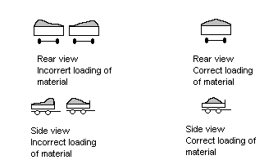

Loading your Redline tipping trailer requires some important considerations to ensure safe and efficient transport of your cargo. Here are some additional tips to keep in mind:

- Centre load laterally and longitudinally within the tipping body to maintain balance and prevent tipping. This will also allow for a 5% increased loading of the tow vehicle. Do not exceed D = 250kg load on 50mm ball coupling to avoid exceeding the maximum weight capacity of your trailer.
- Avoid loading products of different densities or moisture contents in the same load. This can lead to different flow characteristics and cause the load to shift during transport.
- When loading your trailer, be mindful of the weight of your cargo to ensure that it does not exceed the payload capacity of the trailer. The payload capacity is approximately the ATM weight minus the tare weight.
- Note that the standard floor of your trailer is not designed to withstand the impact of coarse materials or those with a density greater than 1.8. Therefore, only load free-flowing solid products such as soil, sand, and gravel.
- Similarly, avoid loading corrosive substances that can damage the powder-coated surface of your trailer. The powder-coated surface has superior adhesion and abrasion resistance, but it is not impervious to all substances.
- Cover your load with a tarp or other suitable cover to prevent debris from escaping during transport. This will also protect your cargo from moisture and dust.


Scan This Code for the National Transport Commission’s load restraint guide
By following these guidelines when loading your Redline tipping trailer, you can ensure a safe and successful transport of your cargo.

How your tipper works
The power pack in the stainless-steel box, under the tray, in the chassis of your Redline Trailer is responsible for powering the trailer's tipping function. Here's how it works:
- The deep cycle battery provides the power for the system. It's designed to be discharged and recharged many times, making it ideal for portable power needs like those of a trailer.
- The HE2000 Power Unit uses the power from the battery to create hydraulic pressure, which is used to activate the trailer's tipping function.
- The 12V 15L HD switch to control the system i is controlled by a 2-button control unit connected by a 3m cable.
- The 12L hydraulic oil tank holds the hydraulic fluid used by the Power Unit to generate pressure.
- 12L of ISO-68 Hydraulic Oil.
Overall, the power pack uses a combination of a deep cycle battery and hydraulic power to provide the energy needed to activate the tipping function of your Redline Trailer.
A bit about batteries:
Deep cycle batteries are designed to be used repeatedly, unlike car batteries which are made for short bursts of power to start engines.
Deep cycle batteries are great for portable power sources like the Redline Tipping Trailer.
It's important to avoid running a deep cycle battery to flat, which can damage the battery and shorten its lifespan. Ideally, you should recharge the battery before it reaches a state of complete discharge.
Three great options for charging the battery in your Redline Tipping Trailer.
- Trickle Charge (to be ordered with trailer at time of purchase)
The Redarc BC DC 1212T is a charger that can charge a deep cycle battery from a vehicle's alternator while driving. Connected to both the battery and alternator, it will adjust charging speed to keep the battery safe and efficient. It can also be used with a solar panel to charge and monitor the battery.
The Redarc BCDC1212T charger monitors battery voltage and adjusts charging speed to prevent overcharging or undercharging, which can damage the battery. It also has safety features like temperature protection, short-circuit protection, and reverse polarity protection to keep the battery safe.
The Redline On-Board Charge system is supplied with a wireless remote control and the push button controller on a 3m cable.

- Solar charger: (to be ordered with trailer at time of purchase)
These chargers use solar panels to convert sunlight into electricity, which is then used to charge the battery. Solar chargers can be used to maintain and charge batteries in Redline Tipping Trailers. The Redarc BC DC 1225T can charge a deep cycle battery from a Solar Panel & will deliver all the monitoring and control features outlined in the Trickle Charge info above.
- Smart chargers: These chargers use microprocessors to monitor and control the charging process, adjusting the charge rate and voltage as needed to avoid overcharging and prolong the life of the battery.
You will need to connect your battery to a charger at least every 15 to 20 tips, more often in hot weather or times of heavy use.

Safe Tipping Procedures
Introduction:
The following safe tipping procedures are based on health and safety best practices. Adherence to these guidelines is essential to prevent accidents, ensure operator safety, and maintain operational efficiency.
Before commencing any tipping operation, make certain that the trailer is securely connected to a suitable towing vehicle. This helps to prevent unexpected trailer movement and maintain stability during the tipping process.
Select a level and firm surface for tipping operations. This will minimize the risk of trailer rollover and enhance the stability of the towing vehicle and trailer during the procedure.
Carefully inspect the surrounding area for power lines, overhead structures, or other potential obstructions that may interfere with the tipping process. This is crucial to ensure safe clearance and avoid contact with hazardous elements.

Under no circumstances should tipping occur beneath power lines, as this may result in severe injuries or fatalities due to electrocution.

Do not tip across a slope, as this increases the risk of rollover and compromises stability. If it is absolutely necessary to tip on a slope, position the trailer combination facing uphill to reduce risks.
Back view of incorrect
position on slope

Thoroughly examine the hydraulic circuit for signs of damage, leakage, or wear. If any issues are identified, arrange for immediate repairs and do not proceed with tipping operations until the problem is resolved.
Correct tipping
Positioning

Remove any transport coverings, such as tarps or protective sheets, from the trailer to prevent entanglement or obstruction during tipping.
Incorrect tipping position

Detach the rear tailgate to allow for the smooth discharge of materials.

Properly connect the tip control unit, ensuring that all connections are secure and functional.

Stand at a safe distance from the trailer, using the 3-meter radius of the control cable as a guide (refer to Figure 10). This helps to maintain a safe zone and minimize the risk of injury in case of unexpected trailer movement.
Never position yourself, other personnel, or bystanders beneath a raised body. Serious injury or death may result from the body dropping unexpectedly due to mechanical failure or other unforeseen circumstances.
Correct position when
Tipping on a slope
Initiate the tipping process, closely monitoring the lifting and lowering of the trailer body to ensure smooth operation.While achieving a smooth flow of material may not be possible with all material types, avoid continuing to raise the body if the material is only discharging from one side of the trailer. In such cases, lower the body and manually redistribute or remove the material to prevent uneven loads and potential hazards.

After completing the safe discharge of materials, lower the body fully, reinstall the tailgate, disconnect and stow the control unit, and release the parking brakes. Perform a final inspection of the trailer and surrounding area to ensure that all equipment is in proper working order and that the site is free of hazards.
By following these comprehensive safe tipping procedures, operators can uphold health and safety best practices, reduce the risk of accidents, and maintain a safe working environment.
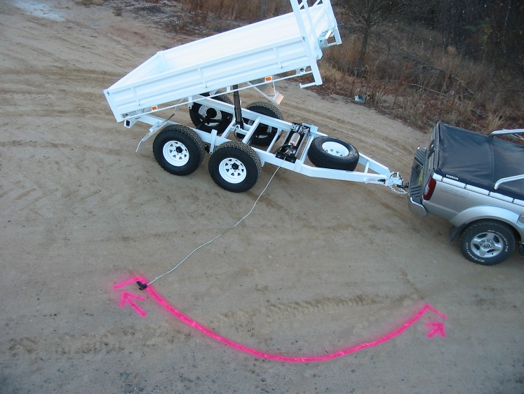

Top view of safe standing tip zone
Hitch
3m

Maintenance of your trailer
Weekly
- Lubricate all suspension points, more often in wet or dirty conditions.
- Check tyre pressure. Adjust to specifications on tyre pressure/load for your tyres and load kg.
Monthly
- Adjust anti rattle Bolt on ball. Contact ball only, do not apply downward pressure onto ball.
- Adjust wheel bearings.
- Adjust brakes then adjust parking brake.
- Check condition of hydraulic circuit.
- Check Axle U bolt torque. Torque to 141 ft/lbs.
- Lubricate hinge pins, ram rocker bushes, and ram rod ball.
- After 20 tips or monthly (whichever occurs first) charge battery. Use a 6 amps or greater charger, making sure not to overcharge.

The next steps in maintenance necessitate that the safety strut to be installed.

Servicing your tipper unit

Repair/Removal of inoperative unit

1. Should your tipper require service Redline recommends removal of the tipper body (preferred).

Another option is using a suitable approved lifting device. After the removal of the circlip holding ram ball in place and raising the tip body in a conventional manor, prop the body using the safety strut before working on the tipper unit.

2. Removal of the tipper power pack is achieved by removing the 4 -3/8” bolts.

3. Removal of the ram is achieved by removing the 4-1/2” ram trunnion bolts. It is not necessary to break the hydraulic circuit if both units are removed together. If required to break hydraulic circuit, first check for pressure in the circuit by installing the control switch and engage downward only, place container under ram break seal at ram end of hose and allow excess oil to be gathered in container.

4. Plug hose and ram to prevent loss of fluid or contamination.


There are no owner serviceable parts in ram or power pack. Contact a qualified auto electrician or hydraulics expert for service, or return to Redline Trailers for servicing.

https://www.whitelawhydraulics.com.au/wp/wp- content/uploads/2021/03/HE1000_2000-Power-Packs.pdf
scan this for a full And comprehensive manual for the power pack

Safe installation of the safety strut
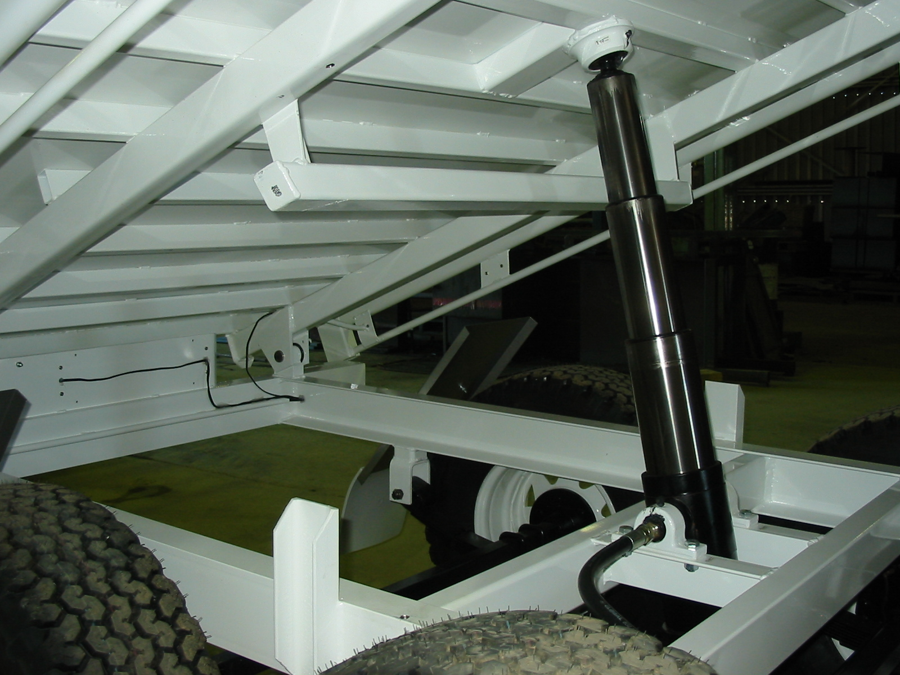
Figure 1a
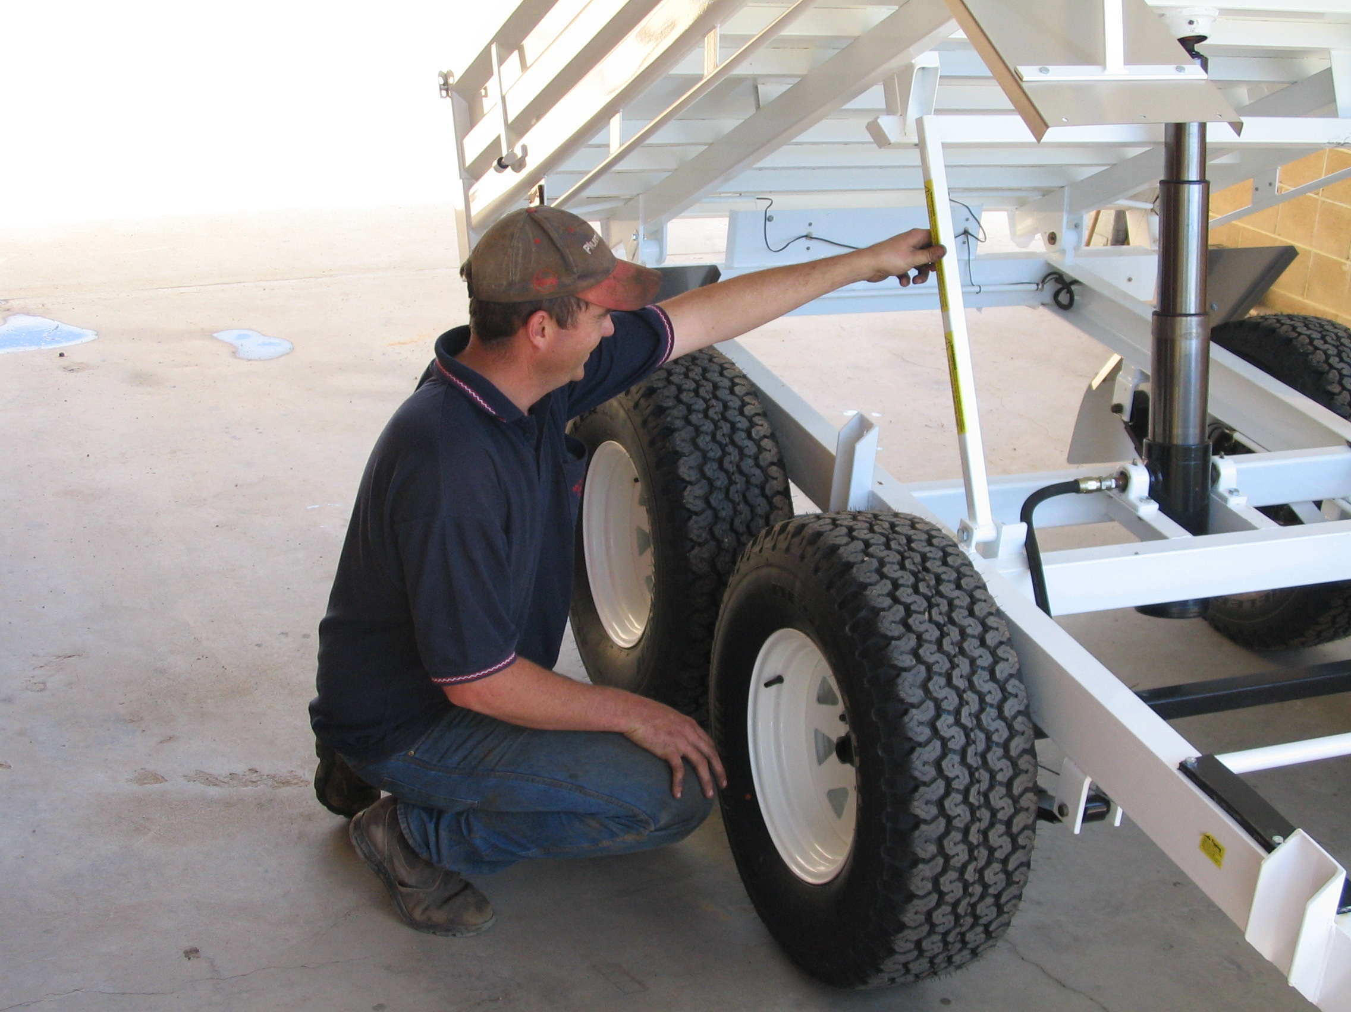
Figure 2a

A) Raise unladen trailer bed to the third ram stage. (Figure 1a)

WARNING- While installing the safety strut never position yourself under the body should tray unexpectedly drop serious injury or death could result. Position yourself to the side. (Figure 2a)

B) Lift Pivot Strut. (See figure 2a)

C) Locate in retainer socket ( See Figure 3a)

D) Lower hydraulic ram and observe that the strut is located correctly as the weight of the tray is taken by the strut. (Figure 4a)

WARNING- Never move trailer while the tray is being supported by the strut, as structural damage and collapse of the tray may result. Warrantee does not cover such damage.

- Check Battery electrolyte level.
- Check hydraulic level with clean dipstick. At the third ram stage the level should be between half and 2/3 of a full tank.
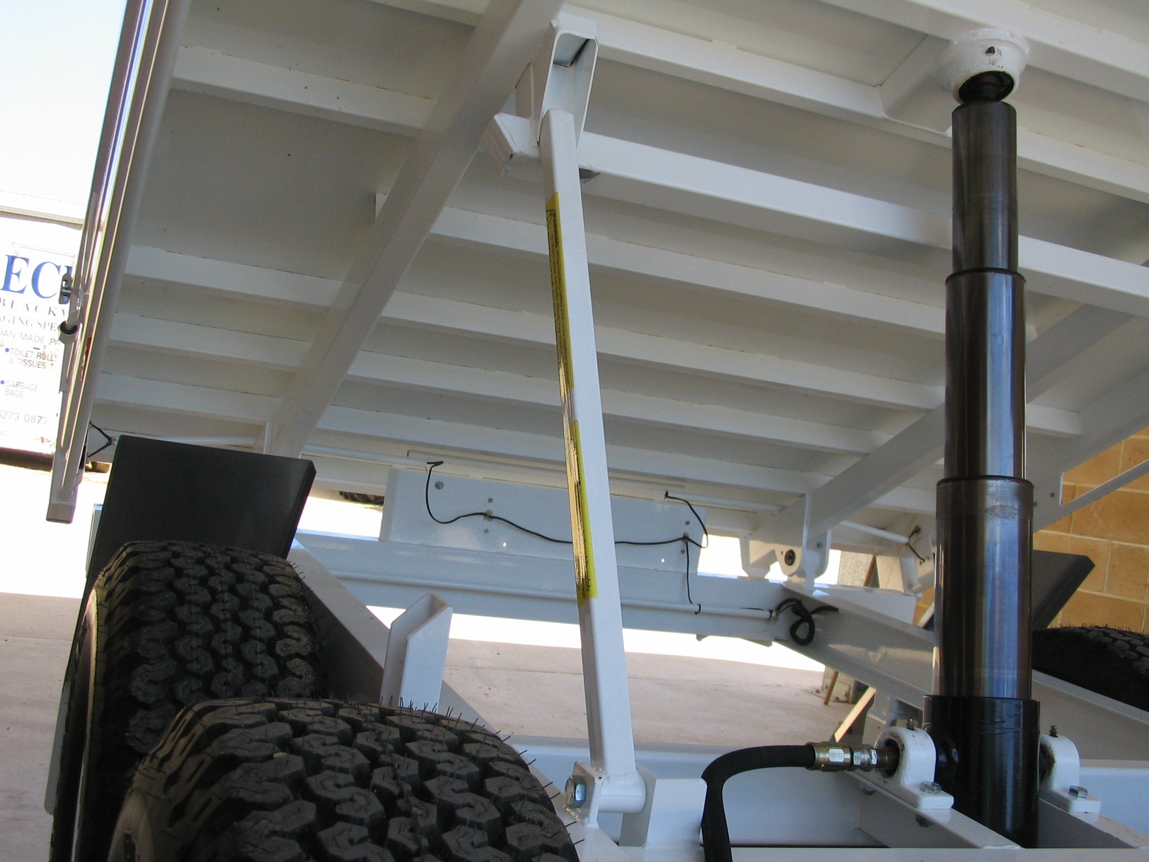
Figure 3a
Figure 4a

Half yearly

Check and repack wheel bearings.
- Check brake shoe conditions. Brake shoes should be replaced if brake linings below 4 mm.
- Check condition of suspension components.
- Check general tightness of all bolts and hardware, battery terminals for corrosion and condition of warning signs and placards. Replace any missing or defective items.

Spare Parts
When ordering spare parts Quote VIN number and model of trailer and manufacture date.

Towing Vehicle
Requirements for towing vehicles, parts, and tools involve strict rules and standards to ensure the safety and efficiency of the towing process. These rules encompass various aspects, including the towing vehicle, towbar, load equalizers, trailer, towing ratio, braking systems, towing couplings, safety chains, and proper trailer loading.

Towing Vehicle Requirements:
- Vehicles must be suited to the trailer and adhere to manufacturer guidelines regarding maximum weight and other features.
- All vehicles must comply with relevant standards for registration and roadworthiness.
- Rear number plates and lights must remain visible when no trailer is connected.
- Towing vehicles must be equipped with suitable towbars, couplings, electrical sockets, brake connections, and potentially extra mirrors or transmission oil coolers, depending on the size of the trailer and type of transmission.
- Some vehicles may require structural reinforcement, special suspension, transmission options, or load-distributing devices for towing heavier trailers.

Towbar Requirements:
- Towbars must be properly designed, fitted, and rated for capacity, and should be marked with maximum rated capacity, make and model of the vehicle or manufacturer's part number, and manufacturer's name or trademark.
- Towbars must not protrude dangerously when no trailer is connected.

Load Equalizer Requirements:
- Load equalizers can be used for towing large caravans to maintain normal suspension height and effective steering control, and to distribute weight across the towing vehicle's suspension.
- Consult the towbar manufacturer before using load equalizers to avoid overloading towbars and components.

Trailer Requirements:
- Trailers must be a suitable size and type, and built to meet registration standards.
- The loaded mass of the trailer must not exceed the lesser of the towbar, towing vehicle, or trailer capacity, or the tire carrying capacity.
- The braking system for a trailer depends on its weight and type, ranging from no brakes required for trailers up to 750 kg ATM to efficient braking systems on all wheels for trailers between 2001-4500 kg ATM.
- Towing couplings must be strong, marked with manufacturer information and rated capacity, and equipped with a positive locking mechanism.
- Safety chains must comply with Australian Standards, with one chain required for trailers under 2500 kg when loaded, and two chains for trailers over 2500 kg when loaded.
Loading Trailer Requirements:
- Do not overload trailers, and properly secure loads within the trailer.
- Loads must not project more than 150mm beyond the trailer's width or exceed 2.5m overall width.
- Loads projecting more than 1.2m behind the trailer must have a red flag, red light, or red reflectors for visibility.
- The overall length of the vehicle and trailer combination, including the load, must not exceed 19m.
- Heavy loads should be concentrated toward the centre of the trailer to reduce sway, and loads should be low and close to the axle(s) for stability.
- Loads must be covered to secure and contain all materials within the vehicle and trailer.

Your vehicles performance
All trailers reduce the performance of the towing vehicle. They increase fuel consumption and decrease acceleration, braking ability, general control and manoeuvrability.
These effects worsen as trailer size and weight increase relative to that of the towing vehicle.

How towing a trailer affects your driving
Driving while towing a trailer is a different experience to normal driving; it requires heightened spatial awareness of both your vehicle and trailer, a need for greater stopping distances and careful consideration of environmental factors such as high winds, wet roads and uneven surfaces.
All these factors can make the driving experience challenging and increase driver fatigue. It is important to make sure you don’t drive when you are tired, and always plan for plenty of rest breaks on your trip.
Our Trailer Safety (PDF, 508Kb) brochure has information on safe loading, towing practices and a handy checklist.
You can also find more information about towing a trailer on the NSW Government website.
Driving tips for towing a trailer You need to allow for the extra length and width of your trailer when entering traffic or changing lanes and allow for the extra road space required on corners and curves Apply the accelerator, brakes and steering smoothly and gently to avoid sway – particularly in wet or slippery conditions Leave a longer stopping distance from the vehicle ahead than when you are not towing a trailer and increase this gap further for longer and heavier trailers. Allow even more distance in poor driving conditions Use a lower gear when travelling downhill to maintain vehicle control and reduce the risk of brake failure When reversing, have someone watch the rear of the trailer from a safe location – reversing a trailer is difficult and takes practice Be aware of the increased effects of cross winds, passing heavy vehicles and uneven road surfaces that can cause your trailer to sway.
Towing a trailer can be more stressful than normal driving. To make your trip safer and more pleasant:
Plan to spend fewer hours on the road each day when taking long trips and take more rest breaks. There are several designated rest areas in NSW. Note that these rest areas are not designated trailer sites and you cannot stay overnight in these areas. Keep left unless overtaking and don’t hold up traffic behind you unnecessarily Look further ahead on the road than usual to anticipate changes in traffic or road conditions to give you more time to react, especially when merging with traffic, responding to hazards, or stopping at traffic lights. Remember that fuel consumption increases for most light vehicles when towing a trailer, particularly at speeds over 90km/h so you may need to plan to refuel more often.

Warrantee
Redline will repair or replace, at its opinion, without charge for parts or labour to the retail purchaser, any defective part of the equipment for a period of twelve months delivery to the first retail customer.

Exceptions to the warrantee
- In no event shall the owner be entitled to recover for incidental, special or consequential damages such as, but not limited to, loss of load, loss of profit or revenue, other commercial losses, inconvenience, or cost of rental of replacement equipment.
- Repair, Maintenance, and service items not related to defects:
- Loss or damage during shipment
- Failure resulting from or improper maintenance.
- Damage caused by operator abuse, negligence, or improper operation.
- Non- defective items replaced due to customers demand unless authorised by the Redline Trailers Service Department.
- Non reimbursable maintenance items including but not limited to oil.
- Any and all costs for repairs or replacement of parts not shown to be defective.
- Damage due to accidents.
- Original Equipment Batteries are warranted for full replacement for the first three months and on a prorated replacement cost basis for the next three months.
- Tyres are warranted directly by the tyre manufacturer’s agents only, and not by REDLINE TRAILERS.
  - Paint / Coating warrantee is void if the damage has been caused by corrosive substance, heat or abrasion.
  - Replacement Parts will be warranted for three months or for the balance of the warrantee, which ever is greater, providing the bill of sale is attached to the warrantee claim.
  - The terms of this warrantee are subject to Commonwealth and state legislation. REDLINE TRAILERS reserves the right to make changes in accordance with these Acts ay any time without notification or obligation. The stated warrantee contained in the REDLINE TRAILERS Warrantee Policy applies in all situations, unless the law provides a greater warrantee in the jurisdiction of the retail customer.
  - REDLINE TRAILERS reserves the right to continually improve its equipment, and reserves the right to change products or specifications at any time without notice or obligation.

Owner’s Warranty Obligation
Warranty commences on the date of purchase.

Date of purchase ___________________________________

Trailer type ___________________________________

VIN number of trailer ___________________________________

Purchaser’s name and address ___________________________________

___________________________________

___________________________________

Dealer’s name ___________________________________

Dealer’s agent ___________________________________

It is the responsibility of the owner, at the owner’s expense, to transport the equipment to the service shop of an authorised REDLINE TRAILERS dealer (place of purchase) or alternately to reimburse the dealer for any travel or transportation costs involved in fulfilling this warranty.
It is the responsibility of the owner to read, understand and practise the maintenance, safety, and operational guidelines set out in the operator’s manual furnished with the equipment.
It is the owner’s responsibility to ensure that the Pre-delivery Inspection Sheet, which must be signed by the owner, is completed, and returned to REDLINE TRAILERS by the dealer. The completed and signed Pre-delivery Inspection Sheet is required to register a new unit for warranty.

