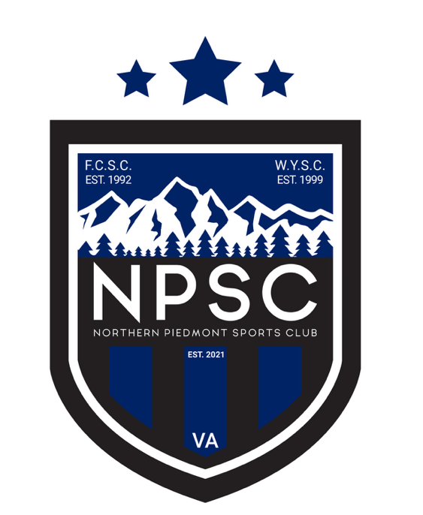
Recreational Volleyball Program Structure
This document outlines the structure, offerings, and key details of NPSC’s Recreational Volleyball Program. Designed to provide a positive and developmentally appropriate volleyball experience for players of all ages and skill levels in multiple tiers, including a pre-travel tryout program to offer additional training and recognition for standout athletes potentially looking to advance into NPSC’s competitive program. This document also details seasonal planning timelines, coaching expectations, and support resources, including equipment distribution, training opportunities, and communication tools. Whether you're a parent, coach, or program partner, this guide provides a comprehensive overview of how NPSC will deliver a fun, organized, and community-centered volleyballexperience.

Offerings
Elementary Division
- 3rd through 5th grade
- Uniforms through www.431Sports.com
- 1 1-hour weekly practice
- Game on Saturdays
- 7-8 week seasons
- Volunteer coaches
- Fall, Winter, and Spring seasons

Middle School Division
- 6th through 8th grade
- Uniforms through www.431Sports.com
- 1 1-hour weekly practice
- Game on Saturdays
- Final Saturday of the season is a tournament
- 7-8 week seasons
- Volunteer coaches
- Fall, Winter, and Spring seasons

High School Division
- 9th through 12th grade
- Uniforms through www.431Sports.com
- 1 1-hour weekly practice
- Game on Saturdays
- Final Saturday of the season is a tournament
- 7-8 week seasons
- Volunteer coaches
- Fall, Winter, and Spring seasons

Pre-Travel Camps
- 6th through 12th graders
- No specific uniform
- One week in early- to mid-October
- Led by professional NPSC Travel Coaches

Private Lessons
- 1:1 ratio
- 5th through 12th graders
- No specific uniform
- 1-hour duration
- At the outdoor volleyball courts
- Led by professional NPSC Travel Coaches

Small Group Lessons
- 3-5 athletes per coach
- 5th through 12th graders
- No specific uniform
- 1-hour duration
- At the outdoor volleyball courts
- Let by professional NPSC Travel Coaches

Recreational Volleyball Summer Camps
- 20 campers maximum
- Rising 3rd through rising 8th graders
- No specific uniform
- 3-hour duration, 5 days per week
- At the outdoor volleyball courts
- Led by senior travel athlete camp counselors with adult supervision

Overall Outline
For the Fall and Spring seasons, each season includes 2 weeks of pre-game practices plus 7 weekends of games.
- Spring season counts backwards from the first weekend in June. The weekend of Easter has no games. NPSC tries to avoid scheduling activities during both weekends of Spring Break if possible.
- Fall season counts backwards from mid-October.
- 1 rain dates per season will be scheduled and publicized at the beginning of the season. Practices are generally not made up for weather cancellations, up to two weekends of games are made up for weather cancellations.

