
Engagement Lead
Dear Applicant
Thank you for your interest in the post of Engagement Lead. Please find attached a Job Description and Equal Opportunities Monitoring form. Please return both to russ@chapelartsstudios.co.uk if you would like to apply for the position.
Chapel Arts Studios is a small dynamic organisation operating in the heart of Andover, with a gallery space (The Chapel), a network of Associate Artists and a growing community programme. If you are passionate about the impact the visual arts can have on communities that, and are equally passionate about supporting artists to create exceptional work, then we would love to hear from you. We are an Arts Council England National Portfolio Organisation (www.artscouncil.org.uk/npo-investment-programme) and work closely with other Stakeholders to deliver our programmes.
Please visit our website before applying to get more information www.chapelartsstudios.co.uk and if you would like an informal conversation before applying contact Russ Tunney russ@chapelartsstudios.co.uk.
We look forward to hearing from you

Russ Tunney
Director
Chapel Arts Studios
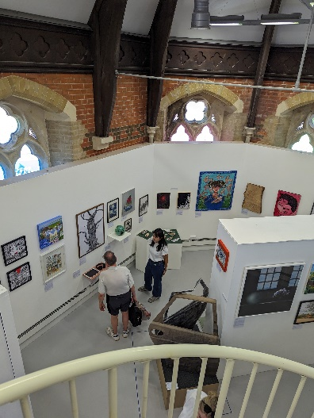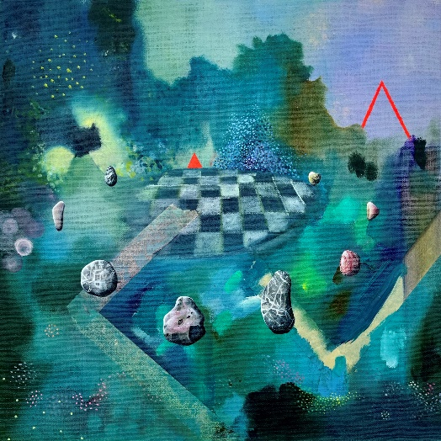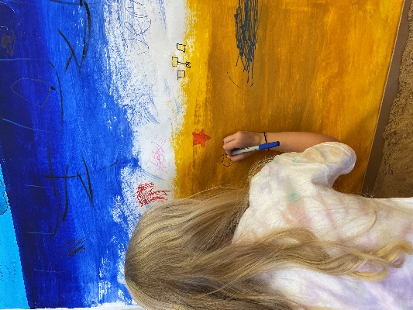
JOB DESCRIPTION
Job Title: Engagement Lead
Responsible to: Director
Responsible for: Events Assistant, Project Artists
External stakeholders: Associate Artists, Cultural Peer Organisations & artists, Arts Council England, Test Valley Borough Council, Hampshire Council, Andover College, Winchester School of Art, Community Partners and Youth Organisations. Media, Press, and Influencers. Social Media Agencies.
ABOUT CAS
Chapel Arts Studios (CAS) is a socially engaged contemporary visual arts charity based in Andover, Hampshire. We are a gallery, artist support and community arts organisation.
We are one of Arts Council England's National Portfolio Organisations (NPO).
This is an exciting moment for the evolution of the organisation which makes it an ideal time to join the team. Under new leadership and seeking to deepen our impact, both for artists and our community, we aim to make extraordinary things happen through creativity, and to make connections for the communities we serve. By being part of the cultural transformation of Andover and championing inclusion and creative potential in the wider region, we inspire our communities and nurture creatives, thus transforming lives.
It is our mission to work with our local communities and give a sense of belonging to everyone engaging with us. We develop and nurture artists of all ages to maximise their potential and inspire our communities by sharing high quality art with them.
We aim to become an exemplar model of sustainable practice, placing Environmental Responsibility at the heart of all of our planning and delivery.
ROLE SUMMARY
The Engagement Lead will work with the Director and the Curator & Programme Manager to create an inspiring and impactful participation programme for our communities.
The postholder will have their eye on the latest developments in the sector and possess the enthusiasm to develop our presence in the arts ecology of the region. Working closely with the Director and the rest of our small, dedicated team, the role will ensure that our work is socially engaged with, and accessible to, the region we serve.
The postholder will deliver some projects and manage others. The role also has an operational element, providing excellent administration of the programme and ensuring that our beautiful exhibition space runs smoothly and is accessible to all. We are an organisation which achieves more by actively seeking positive collaborations with stakeholders to inform ongoing organic social strategies.

CAS STAFF STRUCTURE

Creative Learning Programme Lead
Working Hours: | Part Time - 3 days per week  Some evening and weekend work will be required according to business needs We operate a TOIL system in instances where staff exceed normal weekly working hours.
Annual leave: | The annual leave period runs from April to March, and you will be entitled to 33 days holiday (Pro Rata) per year (including Bank Holidays).
Salary | £26,000 to £27,500 pro rata (dependant on experience)
Notice Period: | 2 Months

MAIN DUTIES & RESPONSIBILITIES
The Engagement Lead will oversee and develop our thriving creative learning programme. This role offers the opportunity to step into a growing programme, delivering inclusive, high-quality creative learning opportunities for adults, families, young people, schools, and community groups.
Reporting to the Director, the Engagement Lead will ensure impactful, inspiring programme delivery, outreach and partnerships, freelance tutor management, budgeting, and marketing support, while line-managing the Events Assistant. The role is available on a part-time basis, with flexible working patterns considered, and includes some evening and weekend work.
This position is ideal for a confident creative learning professional with strong programme management experience who is passionate about accessibility, community engagement, and the power of the arts to inspire and connect people.
Engagement
- Inspiring the community through our targeted engagement programme, helping audiences access high quality contemporary art and reflect on how it challenges, represents and inspires their life experience. The current programme includes regular groups such as CAS Kids, Life Drawing and National Saturday Club.
- Deepen engagement with communities we work with. To devise and deliver projects and activities to embed the company's work, build new audiences and participants, and reach people of least engagement.
- Collaborate with the Director and the Curator & Programme Manager in identifying and engaging with communities of place and interest for new projects and ideas.
- Forge and maintain relationships with community and special interest groups in order to create engagement activities linked to the exhibition programme.
- Lead, schedule and manage comprehensive engagement initiatives aimed at broadening our reach and growing participants for each project and future work.
- Co-ordinate and execute engagement wrap-around events, talks and workshops in line with our Arts Council targets.
- Maintain and build on current relationships with stakeholders, and creative partners and seek new partnerships.
To achieve these aims, you will
  - In collaboration with other CAS staff, design engaging and exciting events and workshops around the exhibition theme, bringing together all the different aspects of CAS and its programmes.
  - Host events in line with exhibitions and be responsible for developing, planning and executing these.
  - Manage budgets.
  - Working with the Director, apply for funding from available sources to enable projects to take place
General
- As appropriate, work with volunteers, contractors and interns.
- Work to budgets, keeping accurate and timely records.
- Working with Marketing Lead to manage communications for the programme.
- Working with the Director on reporting to key stakeholders. This includes keeping accurate records of engagement in all activity.
- Assisting at and attending Private Views for Exhibitions
- Being part of the invigilation rota when we are staging exhibitions.
- As part of the CAS team, helping to ensure that our space is kept in a suitable condition for public events.
- To be committed to putting artists and community needs at the heart of everything we do.
- To act as Deputy Safeguarding Lead, ensuring that excellent safeguarding is in place for all delivery.
- To promote and comply with current legislation and the CAS policies on Equality, Diversity, Child and Data Protection, Health & Safety and financial compliance, both in the delivery of services and the treatment of others.
- To promote, develop and comply with our policies and practices regarding sustainability and lessen the environmental impact of CAS.
- To be responsible for identifying and undertaking training and personal development to meet business needs.
- Be an advocate for CAS, as opportunity arises.
- To be committed to putting artists and community needs at the heart of everything we do.
- To undertake any other reasonable duties, commensurate with the level of the post so as to ensure the smooth running of CAS.

REVIEW ARRANGEMENTS
This job information cannot be all-encompassing. It is inevitable over time that the emphasis of the job will change without changing the general character of the job or the level of duties and responsibilities entailed. Consequently, this information will be periodically reviewed, revised and updated in consultation with the post holder to reflect appropriate changes.

PERSON SPECIFICATION
Essential
- A passion and enthusiasm for visual arts, as well as a strong understanding of wider creative industries.
- Proven ability to collaborate with diverse internal teams, to gather information and align on content requirements.
- Engagement experience.
- Educated to degree level in a relevant field, or equivalent work experience.
- Experience working with internal and external stakeholders to achieve agreed objectives.
- Excellent project management skills.
- Experience in managing or coordinating projects, with an emphasis on inclusivity and collaboration.
- Experience of managing project budgets, timelines and reporting processes.
- An adept communicator, particularly with regards presenting curatorial content to stakeholders.
- An understanding of Safeguarding
Desirable
- Ability to influence others and liaise effectively with colleagues and external contacts within a museum/gallery environment.
- Commitment to community action and the arts and education, with a passion for community empowerment.
- A proactive, solution-oriented mindset with a hands-on approach to problem-solving
- Ability to work under pressure, meet deadlines and retain good attention to detail.
- A mutually supportive and collaborative team working style.
- Experience of working in Canva, PowerPoint, Word and Excel.

TO APPLY:

To apply please send a PDF to russ@chapelartsstudios.co.uk including:
- A brief CV highlighting relevant experience
- A statement outlining your approach to developing the programme for CAS , plus examples of organising, delivering and budgeting - maximum 2 sides of A4.
- Details of two referees
We want to provide an equal and inclusive application process. If you are unable to apply in this format, we are happy to accept other formats of application. Please contact russ@chapelartsstudios.co.uk to discuss.

Closing date: 31/03/2026 14:00pm

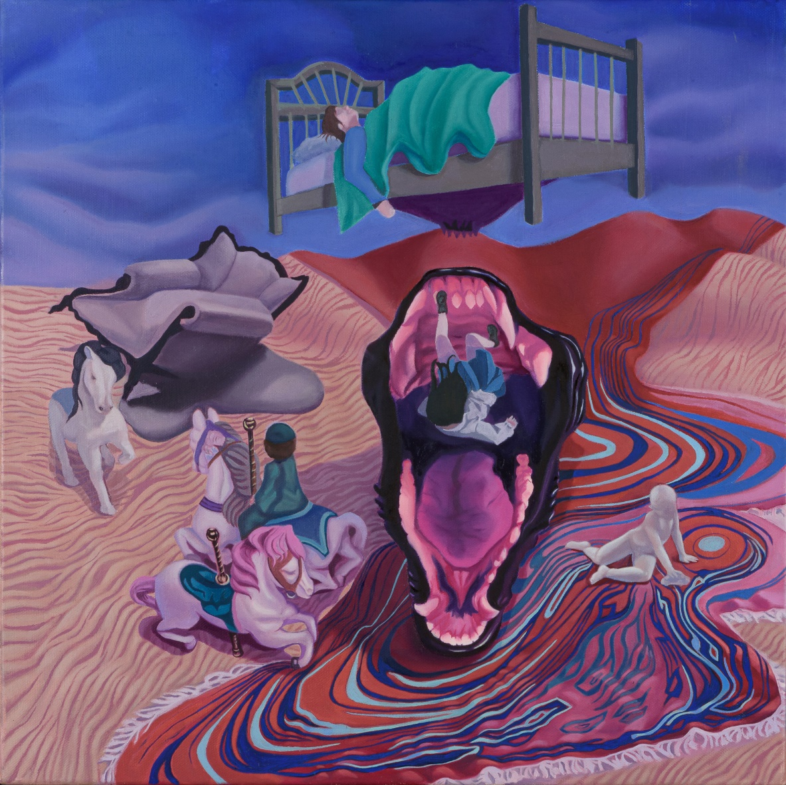
Faye Theocharous

