
Curator & Programme Manager
Dear Applicant
Thank you for your interest in the post of Curator and Programme Manager. Please find attached a Job Description and Equal Opportunities Monitoring form. Please return both to me if you would like to apply for the position.
Chapel Arts Studios is a small dynamic organisation operating in the heart of Andover, with a gallery space (The Chapel), a network of Associate Artists and a growing community programme. If you are passionate about the impact the visual arts can have on the communities that engage and are equally passionate about supporting artists to create exceptional work then we would love to hear from you. We are an Arts Council England National Portfolio Organisation (www.artscouncil.org.uk/npo-investment-programme) and work closely with other Stakeholders to delive our programmes.
Please visit our website before applying to get more information www.chapelartsstudios.co.uk and if you would like an informal conversation before applying contact Russ Tunney russ@chapelartsstudios.co.uk.
We look forward to hearing from you

Russ Tunney
Director
Chapel Arts Studios
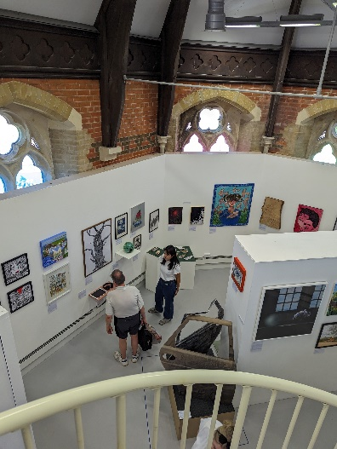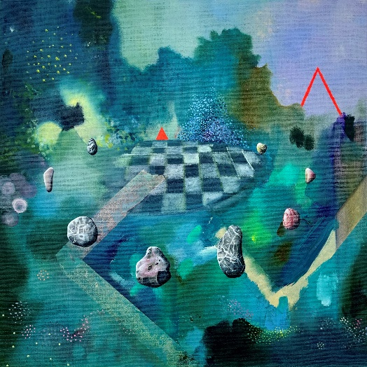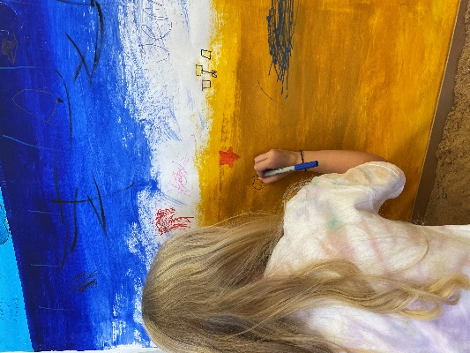
JOB DESCRIPTION
Job Title: Curator & Programme Manager
Responsible to: Director
Responsible for: N/A
Internal stakeholders: Creative Programme Coordinator, Marketing Lead, Office Manager, Events Assistant.
External stakeholders: Associate Artists, Cultural Peer Organisations & artists, Arts Council England, Test Valley Borough Council, Hampshire Council, Andover College, Winchester School of Art, Community Partners and Youth Organisations. Media, Press, and Influencers. Social Media Agencies.
ABOUT CAS
Chapel Arts Studios (CAS) is a socially engaged contemporary visual arts charity based in Andover, Hampshire. We are a gallery, artist support and community arts organisation.
We are one of Arts Council England's National Portfolio Organisations (NPO).
We believe that in a disconnected community with lack of access to cultural opportunities for all, we create a home of connections and possibilities through art. By being part of the cultural transformation of Andover and championing inclusion and creative potential in the wider region, we inspire our communities and nurture creatives, thus transforming lives.
It is our mission to work with our local communities and give a sense of belonging to everyone engaging with us. We develop and nurture artists of all ages to maximise their potential and inspire our communities by sharing high quality art with them.
ROLE SUMMARY
The Curator & Programme Manager will play a key role in shaping the work that we present to our communities and the support that we offer to artists. The Curator and |Programme Manager will have their eye on the latest developments in the sector and possess the enthusiasm to develop our presence in the arts ecology of the region. Working closely with the director and the rest of our small, dedicated team, the role will ensure continuity through the varied elements of our offer.
The role also has an operational element, providing excellent administration of the programme and ensuring that our beautiful exhibition space is runs smoothly and is accessible to all. We are an organisation which achieves more by actively seeking positive collaborations with stakeholders across the business to inform ongoing organic social strategies.
With a busy programme of exhibitions, as well as an expanding and ambitious participation programme, the Curator and Programme Manager will work alongside other members of the team to ensure that our impact is profound within our communities.
CAS STAFF STRUCTURE

CURATOR & PROGRAMME MANAGER
Working Hours: | Part Time - 2/3 days per week  Some occasional evening and weekend work may be required according to business needs, which can be accrued and claimed back as TOIL.
Annual leave: | The annual leave period runs from April to March, and you will be entitled to 28 days holiday (Pro Rata) per year (including Bank Holidays).
Salary | £31,000 pro rata
Notice Period: | 2 Months

MAIN DUTIES & RESPONSIBILITIES
Collaborating closely with the Director, you will create and manage a high quality, accessible, creative and impactful exhibitions in our spaces, and seek opportunities to build our profile in the arts ecology of the region. This includes artist development opportunities, nurturing creative talent. The postholder will seek innovative opportunities to create project work which positively impacts our communities and the role will play a key role in ensuring that all of our activity is connected and effectively delivered.
Curation
- Bringing exciting, varied and innovative contemporary art to the region (min 6 main exhibitions in the Chapel including the Associates' Exhibition)
- Inspiring the community through our targeted engagement programme, helping audiences access high quality contemporary art and reflect on how it challenges, represents and inspires their life experience
- Bringing audiences from further afield to Andover, raising the profile of CAS & Andover reinforcing its place on the cultural map.
To achieve these aims, you will
  - Be aware and engaged with the world of contemporary art and the various current movements, trends and themes. Coordinate all exhibitions, liaise with artists, engage with arts orgs, art universities and stakeholders to recognise opportunities for collaboration etc
  - In collaboration with other CAS staff, design engaging and exciting events and workshops around the exhibition theme, bringing together all the different aspects of CAS and its programmes.
  - Host events in line with exhibitions and be responsible for developing, planning and executing these.
  - Select and approach artists for exhibitions, working with them to develop their work/plan the exhibition. This includes:
    - Leading planning meetings.
    - Writing specs for commissions.
    - Running selection panels.
    - Organising transport where appropriate.
    - Creating contracts.
  - Managing budgets.
  - Working with artists and CAS staff to design all marketing and print material to include posters, flyers, handouts, catalogues.
  - Managing volunteers and staff for invigilation.
  - Managing the practical tasks for exhibition.
  - Designing and overseeing construction of elements for the space.
  - Organising and overseeing painting and preparation of space.
  - Hanging the work (with technician support which may be paid or volunteer).
  - Understanding and operating/planning basic digital technology (screens, projection, sound).
Artist Support
- Associate Artists:
  - Working with other CAS staff to help design a creative professional development programme for CAS Associate Artists.
  - Lead the planning and execution of our annual Associates exhibition.
  - Support CAS staff in planning for our Associate away days and outings and play a leadership role on the day.
  - Lead or participate in our Associate development events and meetings.
  - Support the Associates Programme through mentoring for Associate Artists, e.g. supporting them in writing funding applications, proposals, etc.
- Seek other opportunities to support artists as appropriate e.g. collaborations with peer organisations, schemes etc.
Programme
- Working with the Director and Creative Programme Coordinator, create and manage projects which impact our community.
- Proactively make connections between the strands of our programme.
- Create and maintain meaningful relationships with potential partners and stakeholders
General
- Recruiting and managing volunteers, contractors and interns.
- Work to budgets, keeping accurate and timely records.
- Working with Marketing Lead to manage communications for the programme.
- Working with the Director on reporting to key stakeholders.
- Working with Office Manager as appropriate.
- Managing our Chapters Collection.
- Supporting the fundraising effort for the charity.
- To be committed to putting artists and community needs’ at the heart of everything we do.
- To promote and comply with current legislation and the CAS policies on Equality, Diversity, Child and Data Protection, Health & Safety and financial compliance, both in the delivery of services and the treatment of others .
- To promote, develop and comply with our policies and practices regarding sustainability and lessen the environmental impact of CAS.
- To be responsible for identifying and undertaking training and personal development to meet business needs.
- Be an advocate for CAS, as opportunity arises.
- To be committed to putting artists and community needs at the heart of everything we do.
- To undertake any other reasonable duties, commensurate with the level of the post so as to ensure the smooth running of CAS.

REVIEW ARRANGEMENTS
This job information cannot be all-encompassing. It is inevitable over time that the emphasis of the job will change without changing the general character of the job or the level of duties and responsibilities entailed. Consequently, this information will be periodically reviewed, revised and updated in consultation with the post holder to reflect appropriate changes.
PERSON SPECIFICATION
Essential
- A passion and enthusiasm for visual arts, as well as a strong understanding of wider creative industries.
- Proven ability to collaborate with diverse internal teams, to gather information and align on content requirements.
- Curatorial experience.
- Educated to degree level in a relevant field, or equivalent work experience.
- Experience working with internal and external stakeholders to achieve agreed objectives.
- Excellent project management skills.
- Experience in managing or coordinating projects, with an emphasis on inclusivity and collaboration.
- Experience of managing project budgets, timelines and reporting processes.
- An adept communicator, particularly with regards presenting curatorial content to stakeholders.
Desirable
- Ability to influence others and liaise effectively with colleagues and external contacts within a museum/gallery environment.
- Commitment to community action and the arts and education, with a passion for community empowerment.
- A proactive, solution-oriented mindset with a hands-on approach to problem-solving
- Ability to work under pressure, meet deadlines and retain good attention to detail.
- A mutually supportive and collaborative team working style.
- Experience of working in Canva, PowerPoint, Word and Excel.

TO APPLY:

To apply please send a PDF to russ@chapelartsstudios.co.uk including:
- A brief CV highlighting relevant experience
- A statement outlining your approach to developing the programme for CAS (exhibitions and other work), plus examples of curating, organising, delivering and budgeting - maximum one side of A4 max.
- Details of two referees
We want to provide an equal and inclusive application process. If you are unable to apply in this format, we are happy to accept other formats of application. Please contact russ@chapelartsstudios.co.uk to discuss.

Closing date: 26/01/2025 14:00pm

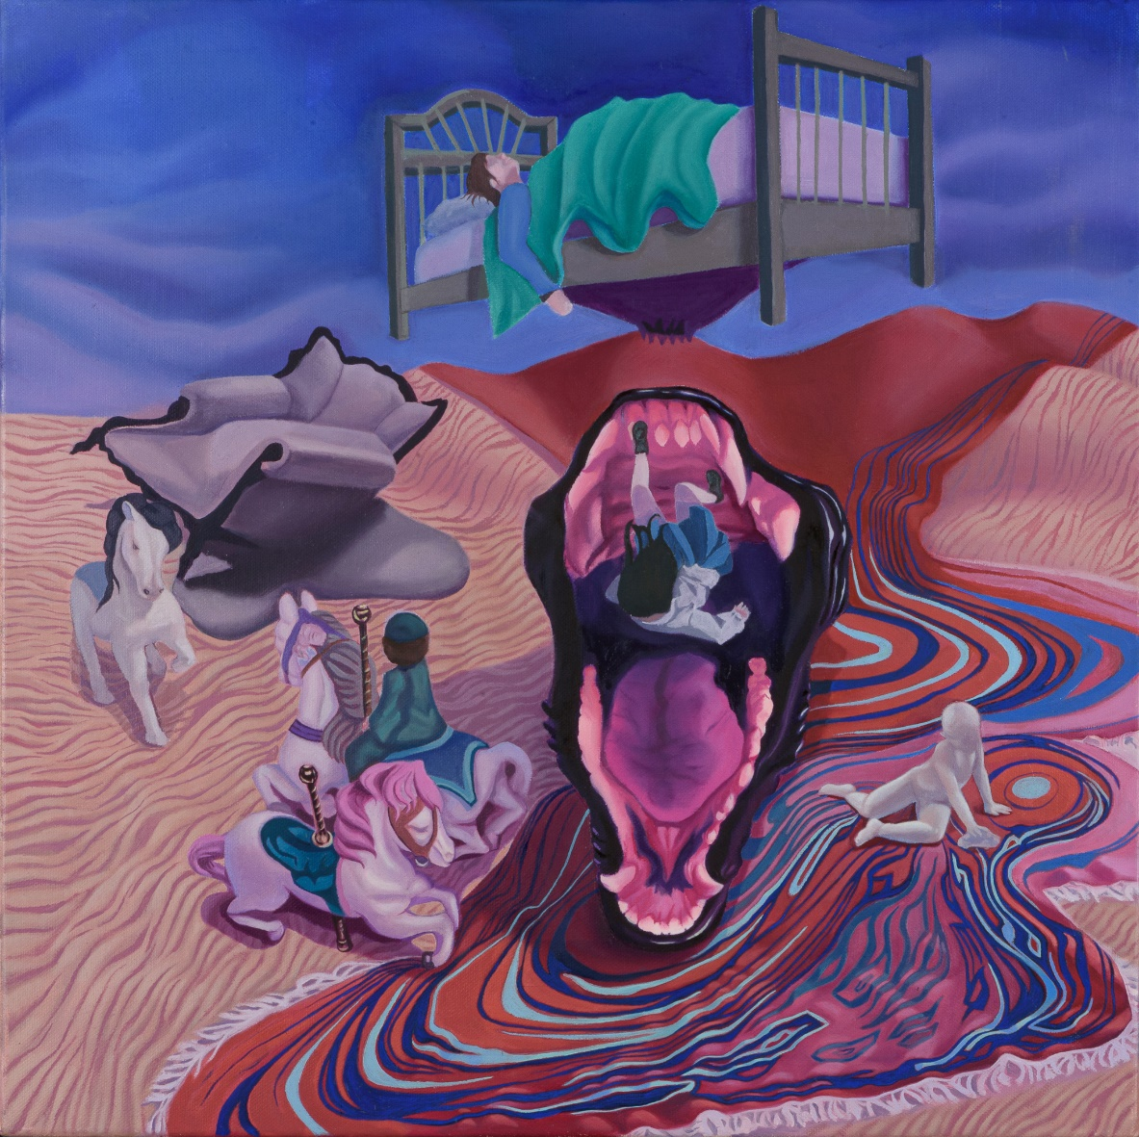
Faye Theocharous

