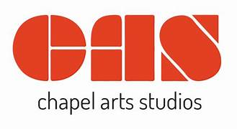
CAS Graduate Educational Programme - 2026

Chapel Arts Studios are excited to offer a tremendous opportunity for emerging graduate artists who wish to develop their skills and experience working in the field of education.
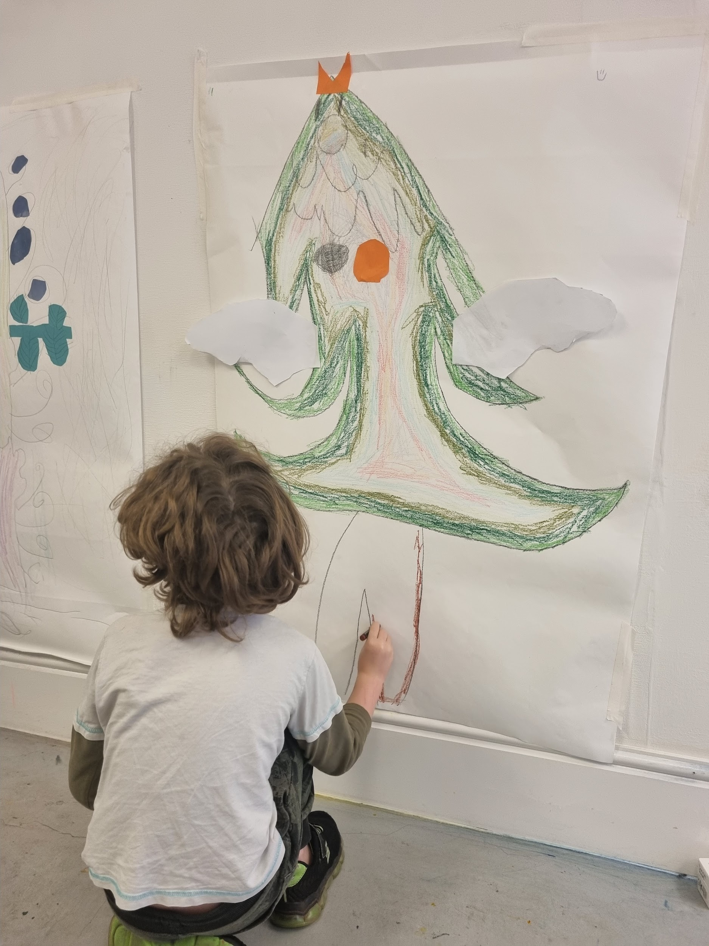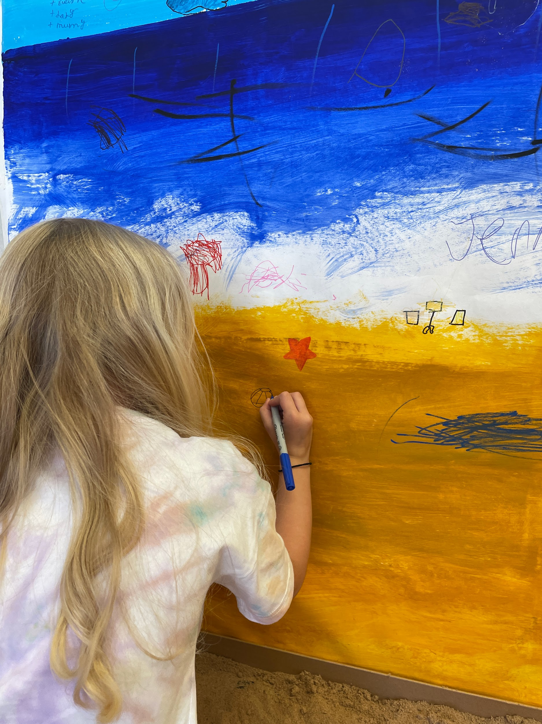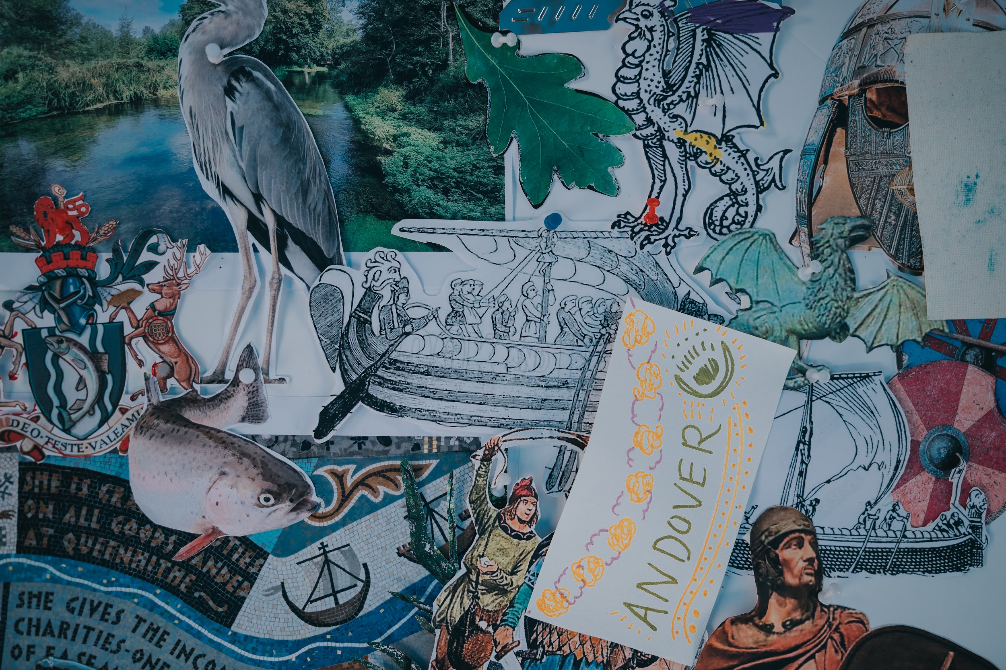
During the residency the selected artist will receive:
- A school placement in Andover to explore and develop your educational skills and experience, working with teachers to provide weekly sessions.
- An opportunity to develop and run adult or family workshops at Chapel Arts Studios (CAS)
- Mentoring throughout the residency from CAS staff/artists
- Enhanced DBS certification (worth £50)
- CAS Associate Artist professional development membership for 1 year, giving access to all opportunities, facilities and events (worth £126)
- A fee of £1000 to deliver the residency.
- Exhibition opportunity at the Chapel Gallery.

This is a valuable opportunity to gain hands-on experience, develop skills in planning, delivering and evaluating art projects, as well as installing an exhibition, networking and learning from other artists.
This opportunity will be an excellent chance for any recent graduate artist considering a career in art education. We welcome expressions of interest from both recent undergraduates and post graduates within one to three years of graduation from an art school.
To register your interest, please send an email to russ@chapelartsstudios.co.uk with the following;
- CV
- Portfolio / Images / or Video
- Statement - explaining your interest and why you believe you are a suitable candidate.

DEADLINE FOR APPLICATIONS IS MONDAY 2rd MARCH 2PM.

