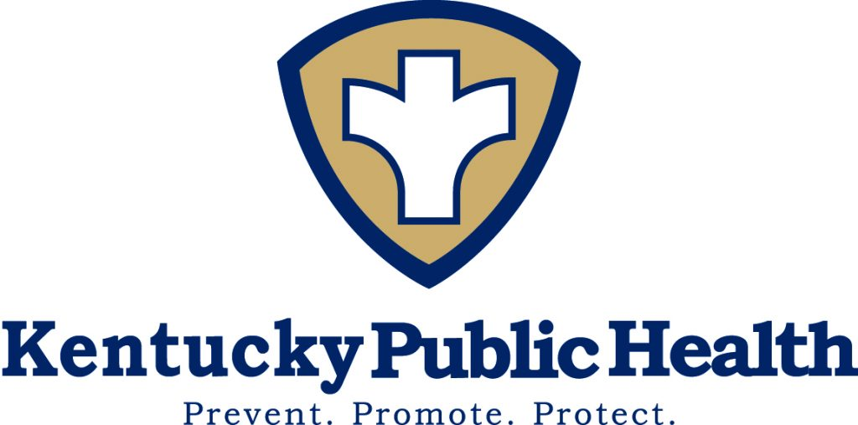

2018 FDA Central Region Retail Food Protection Seminar
August 28 – 30, 2018

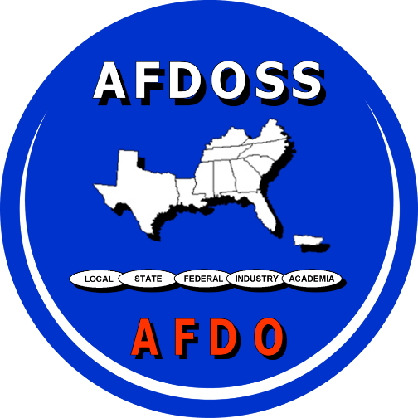

The Brown Hotel
Louisville, KY

Hosted by:
The Kentucky Department for Public Health’s Food Safety Branch, AFDOSS and the FDA

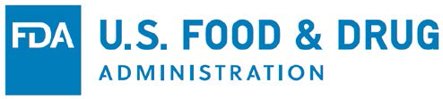



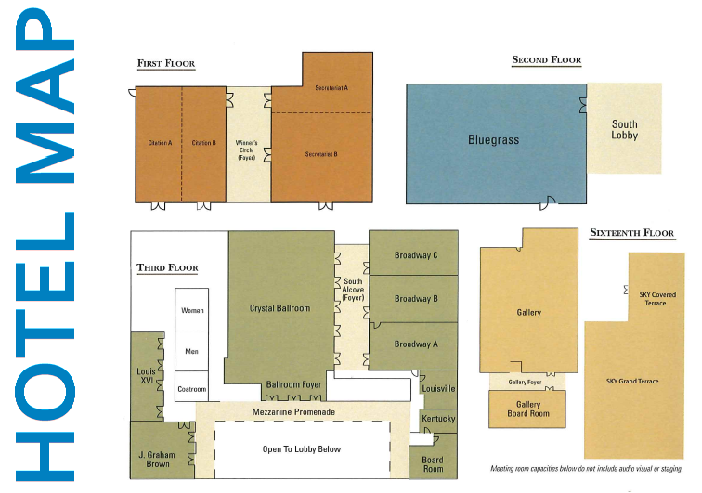

Did you know? KY State Symbols

- Cheeseburgers were first served in 1934 at Kaolin’s restaurant in Louisville.

- Mammoth Cave is the world’s longest cave and was first promoted in 1816, making it the second oldest tourist attraction in the United States.

- The public saw an electric light for the first time in Louisville. Thomas Edison introduced his incandescent light bulb to crowds at the Southern Exposition in 1883.

- Starters in the Kentucky Derby, the oldest continuously held horse race, have had names beginning with every letter of the alphabet except for “X”.

- Kentucky has more miles of running water than any other state except Alaska. The numerous rivers and water impoundments provide 1,100 commercially navigable miles.
- Bird: Cardinal
- Fruit: Blackberry
- Flower: Goldenrod
- Tree: Tulip Poplar
- Gemstone: Freshwater Pearl
- Musical Instrument: Appalachian Dulcimer
- Motto: “United We Stand, Divided We Fall”
- Wild Animal: Gray Squirrel
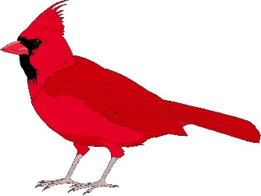
- Soft Drink: Ale-8-1
- Car: Corvette

Welcome
From the Mayor of Louisville

Text text text text text text text text text text text text text text text text text text text
Text text text text text text text text text text text text text text text text text text text
Text text text text text text text text text text text text text text text text text text tex
Text text text text text text text text text text text text text text text text text text text
Text text text text text text text text text text text text text text text text text text text

Text text text text text text text text text text text text text text text text text text text
Text text text text text text text text text text text text text text text text text text text
Text text text text text text text text text text text text text text text text text text text

Text text text text text text text text text text text text text text text text text text text
Text text text text text text text text text text text text text text text text text text text
Signed,
XXXXXXX
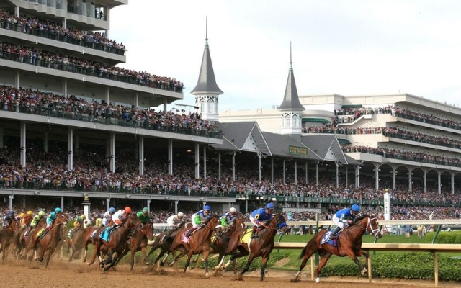

Churchill Downs Racetrack

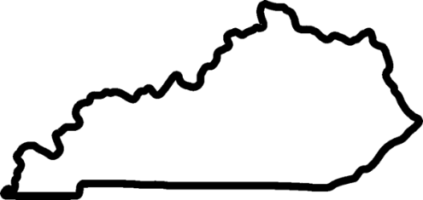
Welcome to
Louisville, Kentucky
Yes, Bourbon is a spirit that comes in a glass, but it’s also a spirit that defines our culture and compassion, our arts and parks, our creative energy. It’s this same spirit that continued and created Louisville itself - a city that combines heritage with innovation, authenticity with originality, quirkiness with friendliness in a way that’s completely unique to our region.
We’re an entirely different type of Southern. From boundary pushing twists on Southern cuisine that have made us one of the “10 Best New Food Cities” in America to our one and only Urban Bourbon Experience™, featuring the world’s only, city-wide trail filled with award-winning micro-distilleries, exhibits and craft cocktail destinations. Then discover one-of-a-kind attractions like the legendary Churchill Downs, Louisville Slugger Museum & Factory, and the Muhammad Ali Center. And that’s just your first day here.
Courtesy of Louisville Convention & Visitors Bureau
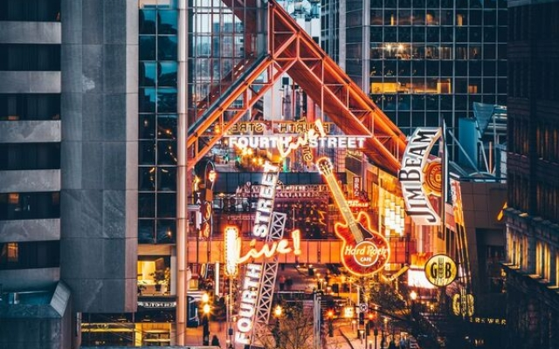
https://www.gotolouisville.com
What’s That Now?

Say it with us – Louisville!

Not sure how? Join the great Kentucky debate of what to call Derby City!

LOOEY-VILLE
LOUIS-VILLE
Did you know? LOO-A-VILLE
LUL-VUL
Kentucky is the birthplace of bourbon, and crafts 95 percent of the world’s supply. We like it so much, there are now more barrels of bourbon in Kentucky than people!

LOO-UH-VUL

Join us
at the Welcome Reception
Tuesday, August 28
5-6 pm on the Rooftop Garden

Now nearing its centennial, The Brown Hotel is considered Louisville’s landmark hotel, reflecting the rich heritage and Southern gentility that have made Louisville a hot spot destination. In 2017, Condé Nast Traveler magazine named The Brown Hotel one of the top 10 hotels in the South. Be sure to make time to attend the FDA Retail Food Protection Seminar’s official “Welcome Reception” on Tues., Aug. 28 from 5-6 p.m. at The Brown Hotel’s Rooftop Garden, with one of the best skyline views in the city!

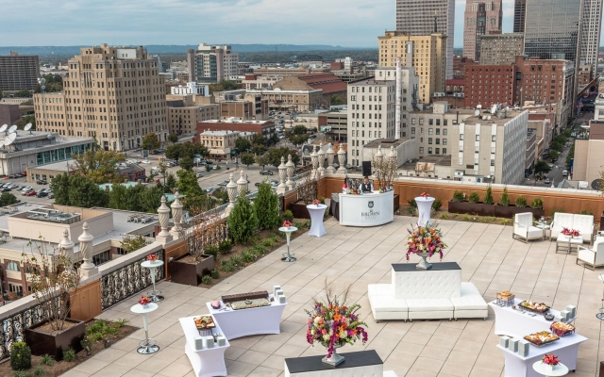
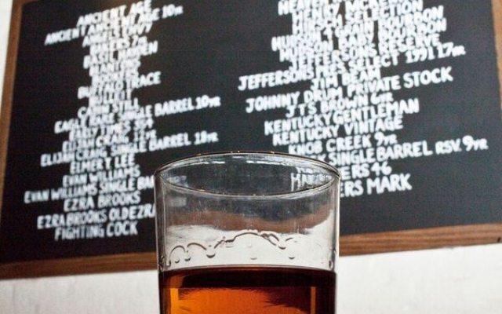
Featuring
The Whiskey .. Bent Valley .. Boys
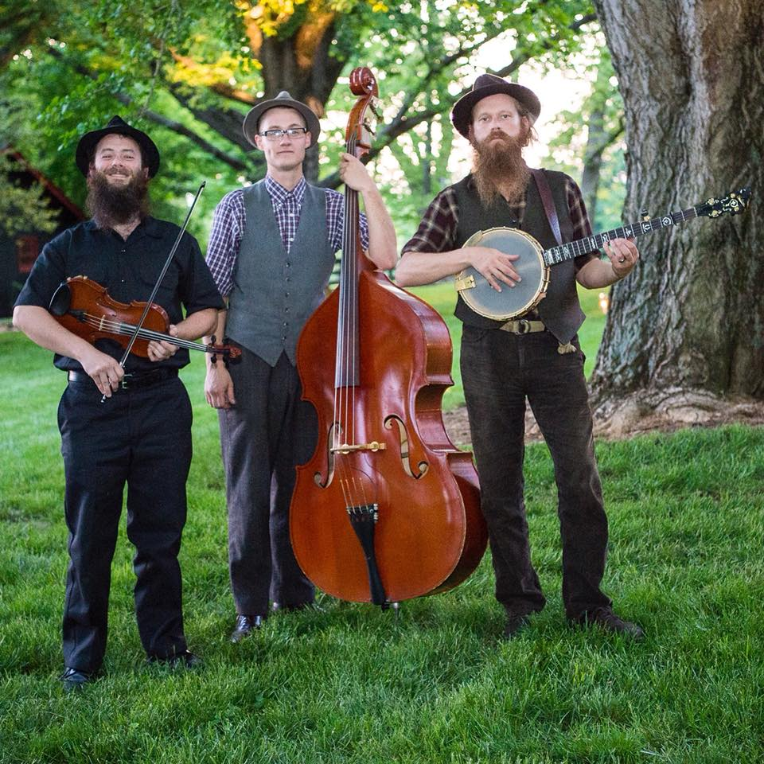

Did you know?
Kentucky bluegrass (more than just a pretty lawn)
Is said to originate with Bill Monroe, Father of
Bluegrass Music. Bill first played with his “Bluegrass
Boys” in 1939 – and they didn’t even have a banjo!

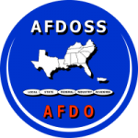 |  | 2018 FDA Central Region    Retail Food Protection Seminar  August 28-30, 2018  The Brown Hotel, Louisville, KY
Monday, August 27th
2018 FDA Central Region Retail Food Protection Seminar
12:30 –  4:30 pm | REGISTRATION  Near Hotel Check-In – 2nd floor
Tuesday, August 28th
2018 FDA Central Region Retail Food Protection Seminar
7:15 – | REGISTRATION & NETWORKING  Crystal Ballroom Foyer – 3rd floor
8:00 am
8:00 –  8:25 am | Welcome on behalf of Mayor Fischer  Vincent James, Chief of Community Building, Louisville Metro Government  Crystal Ballroom – 3rd floor
8:30 –  8: | FDA Welcome  Chris Smith, Retail Food Branch Director, FDA Office of State Cooperative Programs
8:55 am
9:00 –  10:00 am | CFSAN Yearly Update:  2017 Food Code; CFP Update  Robert Sudler, Jr., FDA
10:00 – | BREAK
10:30 am
10:30 – | Office of Partnerships Update  Maribeth Niesen, Consumer Safety Officer, FDA
10:50 am
11:00 –  11: 15 am | AFDO  Michael Turner, AFDO
11:20 –  11:45 am | Office of Training, Education and Development Updates  Kimberly Destromp, Consumer Safety Officer, FDA
11:45 – | LUNCH  Bluegrass Room – 2nd floor
1:00 pm
1:00 – | Tracking Standardization Data  Carrie Pohjola, EH Technical Specialist-Wisconsin Dept. of Ag., Trade and Consumer Protection
1:50 pm
2:00 – | Menu Nutritional Labeling  Felicia Billingslea, Director, FDA Division of Food Labeling and Standards
2:50 pm
3:00 – | BREAK
3:30 pm
3:30 – | Charcuterie  Dr. Gregg Rentfrow, University of Kentucky
4:30 pm
5:00 –  6:00 pm | RECEPTION  Entertainment – Whiskey Bent Valley Boys  Rooftop Garden – 16th floor
Wednesday, August 29th
2018 FDA Central Region Retail Food Protection Seminar
7:15 – 8:00 am | REGISTRATION & NETWORKING  Crystal Ballroom Foyer – 3rd floor
8:00 – 8:10 am | Welcome & Announcements  Matt Colson, AFDOSS Vice-President  Crystal Ballroom – 3rd floor
8:10 – 9:00 am | Active Managerial Control  Shannon McKeon, Senior Environmental Health Specialist, Fairfax County Health Dept.  Crystal Ballroom – 3rd floor
9:10 –  9: 35 am | NACCHO  Funding for Local Health Departments in Retail Food Program Standards  Amy Chang, Program Analyst, Env. Health Program, National Association of County and City  Mentor/ Mentee Program  Robert Sudler, FDA  Crystal Ballroom – 3rd floor
9:35 –
10:00 am
10:00 – 10:30 am | BREAK
10:30 – 11:15 am | Overcoming Challenges of HEP A Outbreak  Connie Mendel, Deputy Director, Louisville Metro Public Health & Wellness  Rui Zhao, Communicable Disease Supervisor, Louisville Metro Public Health & Wellness  Crystal Ballroom – 3rd floor  Crystal Ballroom – 3rd floor
11:15 – 12:45 pm | LUNCH  Bluegrass Room – 2nd floor
12:45 – 1:30 pm | Motivational Speaker  Daro Mott, Chief of Performance Improvement, Louisville Metro Government  Crystal Ballroom – 3rd floor
1:30 – 1:40 pm | TEN MINUTE STRETCH BREAK
1:40 – 2:30 pm | FBI WMD Program Overview and Threats to the Food Sector  Michael Russo, FBI Louisville Division  Chris Hubbuch, FBI Louisville Division  Crystal Ballroom – 3rd floor
2:30 – 3:00 pm | BREAK
3:00 – 3:50 pm | Environmental Sampling at Retail Food Establishments  Matt Colson, Chief, Bureau of Food Inspection  Florida Department of Agriculture and Consumer Services  Crystal Ballroom – 3rd floor
4:00 – 4:50 pm | Food Code Interpretations  Questions and Answers  Greg Abel, Retail Food Specialist, FDA  Broadway B – 3rd floor | 4:00 – 4:50 pm | Kroger Temperature Monitoring System  Jeff Lanter, Sr. Food Safety Manager  Shana Davis, Food Safety Manager  Kroger  Crystal Ballroom – 3rd floor
Thursday, August 30th
2018 FDA Central Region Retail Food Protection Seminar
7:15 – 8:00 am | REGISTRATION & NETWORKING  Crystal Ballroom Foyer – 3rd floor
8:00 – 8:50 am | 2014 FDA Risk Factor Study  Kenya Moon, FDA Office of State Cooperative Programs  Crystal Ballroom – 3rd floor
9:00 –  9:50 am | Keeping Food Out of the Landfill: Policy Ideas for States and Localities  Katie Sandson, Clinical Fellow, Harvard Law School Food Law & Policy Clinic  Crystal Ballroom – 3rd floor
9:50 – 10:20 am | BREAK
10:20 –  11:20 am | Use of Social Media for Foodborne Illness Surveillance  Kara Sewalk, Boston Children’s Hospital  Crystal Ballroom – 3rd floor
11:30 – 12:00 pm | BUSINESS MEETING / SEMINAR ADJOURNS  Becky Gillis, Director, Kentucky Division of Public Health Protection and Safety  Kris Moore, Retail Food Specialist, FDA

Thank you to our generous sponsors!

