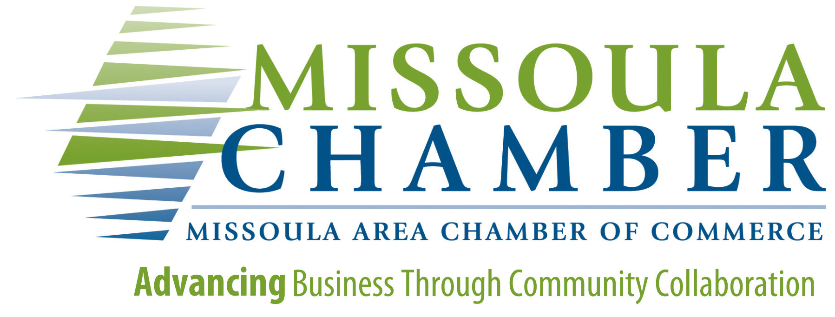

**Nonprofit of the Year Award**

Missoula Chamber of Commerce

Award Nomination Guidelines:

*The Missoula Area Chamber of Commerce will recognize top-performing nonprofits who have a significant presence and are making our community a great place to work, play and live. Nonprofits who are nominated for this award should encompass some or all of the following attributes:*

- Provides outstanding programs and services that make a profound difference in the Missoula area

- Embodies a spirit of volunteerism, altruism and respect

- Supports and demonstrates a collaborative spirit through creative community partnerships

- Inspires others by their example

- Displays strong fiscal management with diversified revenue sources

- Maintains a team of professional staff and leadership

- Shown stability or growth in services or expanded programs and services

- Demonstrated commitment to ethical business practices and employee support and development

Eligibility Criteria:

*Organizations may receive nominations year-after-year if they are not selected for an award. Nominations are only valid for the year they are submitted.*

*To be eligible for the Nonprofit of the Year Award, organizations must:*

- Be a Chamber member in good-standing

- Be a registered 501c organization or service group as defined by the IRS

- Possess attributes as listed above

Application & Judging Process:

Nonprofit organizations that meet award eligibility criteria and receive a complete nomination will be considered for this award. The winner will be determined by the Missoula Chamber Board of Directors.

Nomination Process Timeline:

**August 9 - September 2nd Nominations Accepted**

**September - Nominations Reviewed, Recipient Notified**

**Wednesday, October 23 - Annual Banquet, Recipient Honored**

The Nonprofit of the Year will receive two complimentary tickets to the Annual Banquet where they will be announced as the award recipient. Award recipient information for this category will not be released publicly until after the Award night.

NOMINATION FORM

*Forms must be received by September 2nd, 2025 for consideration.*

Name of organization you are nominating:

Website of org:

Address of org:

Phone number of org:

Name of person submitting this nomination:

Your contact phone:

Your contact email:

*Please answer each of the following questions. Only complete nominations will be considered. The more information you offer, the stronger the nomination will be.*

1.Briefly describe the mission of this organization:

2.Briefly describe reasons why you feel this organization is deserving of this award:

3. Describe how the organization has made a positive impact on the local community. Cite any major accomplishments the organization has seen in meeting their goal:

4. Provide any additional comments on how the organization contributes to the overall well-being of the community (contributions of time, money or resources, service and volunteer activity, leadership roles, partnerships with other nonprofits, etc.):

5. Please provide any additional information you find relevant for this nomination. Helpful information includes: data to support your nomination, newspaper/online articles recognizing the organization or additional details about what makes this organization the top award candidate in your opinion. Additional narrative may be provided by way of attachments or links.

#### *Submission Information:*

* **Submit all application materials (email, mail, or drop off) by September 9th, 2025 to:** Missoula Area Chamber of Commerce  
  Attn: Debbie Erbacher / Small Business of the Year Nomination

MAIL: P.O Box 7577 Missoula, MT 59807-7577

DROP OFF: 825 E Front St, Missoula, MT 59802  
EMAIL: debbiee@missoulachamber.com