Introduction
Welcome to Start with Awareness: A Pre-Coaching Curiosity Guide, a quick, thoughtful tool designed to help you explore your goals, values, and self-awareness before beginning your coaching journey. Whether you’re just curious about coaching or ready to take the next step, this guide will help you uncover what matters most and what’s shaping your current situation.
In about 15 minutes, you’ll engage in honest reflections that spark curiosity and open the door to clarity and meaningful change. Remember, there are no right or wrong answers here, just your unique perspective.
To get the most from this guide, here are a few tips on how to approach the reflection process:
- Set aside dedicated time and a quiet space. Plan for about 15–20 minutes where you won’t be interrupted, so you can reflect fully without distraction.
- Approach the exercises with curiosity and openness. This is a chance to explore your thoughts honestly, without judgment or pressure.
- Write your reflections down. Using a journal or digital device helps deepen your awareness and creates a record you can revisit or share with your coach.
- Be gentle with yourself. Some questions might bring up unexpected feelings or insights. That’s okay, reflection is a process, not a destination.
- Revisit the guide as your journey evolves. Self-awareness grows over time, so feel free to return to these reflections as new challenges or goals emerge.
- If you decide to explore coaching, these reflections can be a powerful starting point for your conversations.
By taking this time for self-discovery, you are laying a strong foundation for your coaching experience or any meaningful change you wish to make.

1. Life Quality: A Holistic View
Understanding the different aspects of your life can help you identify areas of satisfaction and those needing improvement.
Describe your quality of life from four key perspectives: work, spare time, health, and family/relationships.
Work:
___________________________________________________________________
___________________________________________________________________
___________________________________________________________________
Spare Time:
___________________________________________________________________
___________________________________________________________________
___________________________________________________________________
Health:
___________________________________________________________________
___________________________________________________________________
___________________________________________________________________
Family/Relationships:
___________________________________________________________________
___________________________________________________________________
___________________________________________________________________

2. Existential Reflection
Reflecting on your life journey and current situation can provide insights into your values, motivations, and dreams.
How did I end up where I am today?
___________________________________________________________________
___________________________________________________________________
___________________________________________________________________
What am I doing today?
___________________________________________________________________
___________________________________________________________________
___________________________________________________________________
How do I live my life?
___________________________________________________________________
___________________________________________________________________
___________________________________________________________________
What is good?
___________________________________________________________________
___________________________________________________________________
___________________________________________________________________
What are my needs?
___________________________________________________________________
___________________________________________________________________
___________________________________________________________________
What is important to me?
___________________________________________________________________
___________________________________________________________________
___________________________________________________________________
What motivates me?
___________________________________________________________________
___________________________________________________________________
___________________________________________________________________
What are my credentials?
___________________________________________________________________
___________________________________________________________________
___________________________________________________________________
What kind of life quality do I want?
___________________________________________________________________
___________________________________________________________________
___________________________________________________________________
What is my innermost dream?
___________________________________________________________________
___________________________________________________________________
___________________________________________________________________

4. Goal Setting
Setting clear goals can provide direction and motivation for your personal and professional growth.
What are my short-term goals (next 1-2 years)?
___________________________________________________________________
___________________________________________________________________
___________________________________________________________________
What are my long-term goals (next 5-10 years)?
___________________________________________________________________
___________________________________________________________________
___________________________________________________________________

5. SWOT Analysis
Identifying your strengths, weaknesses, opportunities, and threats can help you make informed decisions and strategic plans.
Strengths: What are my key strengths?
___________________________________________________________________
___________________________________________________________________
___________________________________________________________________
Weaknesses: What areas do I need to improve?
___________________________________________________________________
___________________________________________________________________
___________________________________________________________________
Opportunities: What opportunities are available to me?
___________________________________________________________________
___________________________________________________________________
___________________________________________________________________
Threats: What challenges or threats might I face?
___________________________________________________________________
___________________________________________________________________
___________________________________________________________________

6. Action Plan
Creating a detailed action plan can help you turn your goals into achievable steps.
What specific steps do I need to take to achieve my goals?
___________________________________________________________________
___________________________________________________________________
___________________________________________________________________
What resources or support do I need?
___________________________________________________________________
___________________________________________________________________
___________________________________________________________________
What is my timeline for achieving these steps?
___________________________________________________________________
___________________________________________________________________
___________________________________________________________________

7. Reflection on Past Experiences
Reflecting on past experiences can provide valuable insights into your personal growth and development.
What past experiences have been most influential in shaping who I am today?
___________________________________________________________________
___________________________________________________________________
___________________________________________________________________
What have I learned from these experiences?
___________________________________________________________________
___________________________________________________________________
___________________________________________________________________

8. Feedback Section
Considering feedback from others can help you see yourself from different perspectives and identify areas for improvement.
What feedback have I received from others that I should take into consideration?
___________________________________________________________________
___________________________________________________________________
___________________________________________________________________
How can this feedback help me improve and grow?
___________________________________________________________________
___________________________________________________________________
___________________________________________________________________

12. Scale of Commitment
Assessing your level of commitment can help you understand your dedication to achieving your goals and identify areas where you may need additional support.
Reflect on your level of commitment to achieving the goals and changes you've identified in this workbook. Use the following scale to rate your commitment:
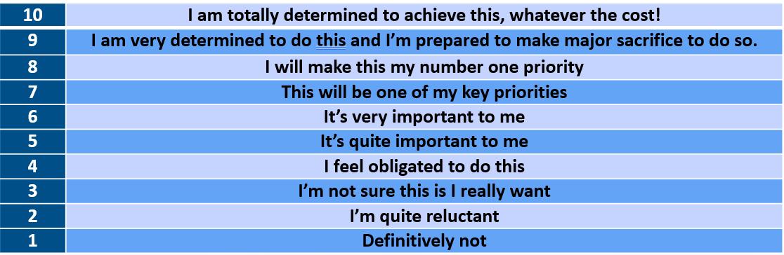
For each of the goals or changes you've identified, rate your level of commitment:
Goal/Change: [Describe the goal or change]
- Commitment Level: [Rate from 1 to 10]
Goal/Change: [Describe the goal or change]
- Commitment Level: [Rate from 1 to 10]
Goal/Change: [Describe the goal or change]
- Commitment Level: [Rate from 1 to 10]

13. Reflection on Commitment
What factors influence your level of commitment to each goal or change?
___________________________________________________________________
___________________________________________________________________
___________________________________________________________________
Are there any goals or changes where your commitment level is lower than you'd like? What might be causing this?
___________________________________________________________________
___________________________________________________________________
___________________________________________________________________
What steps can you take to increase your commitment to these goals or changes?
___________________________________________________________________
___________________________________________________________________
___________________________________________________________________
How can you maintain a high level of commitment over time?
___________________________________________________________________
___________________________________________________________________
___________________________________________________________________

If this guide has sparked new insights or questions, let’s explore them together.
You’re invited to book a free discovery call, a relaxed, no-pressure conversation where we can reflect on what’s emerging for you, explore possibilities, and see how coaching might support your next steps.

