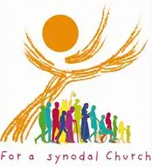
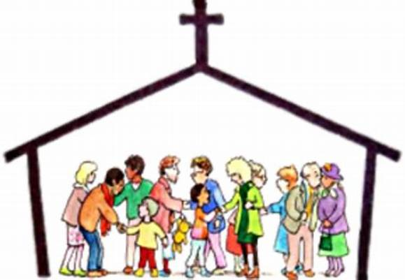

Sacred Heart Anchored in Faith:
Whole Community Formation 2026-2027
Adults, Children, Teens, and Youth
2026-2026 Calendar

Anchored in Faith
Faith Formation is a life-long process. As Catholic Christians we never stop learning about and growing in our faith. For children it is especially important that they are surrounded by people of faith who are not only good role models but who are able to be companions on the faith journey. Sacred Heart is pleased to support all generations coming together to learn and share their faith, in keeping with +Pope Francis and the USCCB.
…all believers need and are called to build vibrant parish communities of faith and service. Such communities cannot exist without a strong, complete and systemic catechesis for all its members…that nurtures a profound, lifelong conversion of the whole person and will help adults to experience the transforming power of grace… USCCB, “Our Hearts Were Burning Within Us.”

August, 2026
16th Parent Orientation 10:15am-11:15am
30th Parish Picnic & Formation Registration

September, 2026 January, 2027
13th -Welcome & Student Orientation 3rd -Epiphany, King’s Gifts to Jesus
20th -God Our Creator & Father, (Unit 1) 10th -Baptism of Jesus, Baptism, (Unit 4)
27th -Guardian Angels 17th -Jesus, Lord & Savior, (Unit 2)
24th -Sacraments of Service, (Unit 4)
31st -Holy Cross Heritage Month
October
4th -Prayers, Petitions, Thanksgiving February
11th -Safe Environment 7th -Celebrating Lent, (Unit 4)
18th -Virgin Mary & Rosary 14th -1st Sunday of Lent, Temptation & Sin
25th – Loving Our Family, (Unit 5) 21st -2nd Sunday of Lent, Jesus Calls Us to Love 28th -3rd Sunday of Lent, 10 Commandments
November
1st - All Saints Day (Daylight Saving Time Ends) March
8th -Beatitudes, (Unit 2) 7th -4th Sunday of Lent, Reconciliation, (Unit 4)
15th -Serving God & Others, (Unit 3) 14th -5th Sunday of Lent, Walk Through Holy Week
22nd -Christ the King, Works of Mercy 21st Palm Sunday No Class
29th No Session-Thanksgiving 22nd -26th Spring Break 28th Easter Sunday No Class
December
6th -2nd Sunday in Advent-Celebrating Advent April
13th -3rd Sunday in Advent 4th-Divine Mercy Sunday, Praying the Chaplet
20th -4th Sunday in Advent 11th -Jesus Sends His Spirit, (Unit 2)
Winter Break December 21-31st 18th -Good Shepherd
25th Last Day of Formation
Tentative Sacramental Dates
1st Reconciliation Practice- 1st Reconciliation-

1st Eucharist Practice May 1, 2027 1st Eucharist Mass May 2, 2027

8th Grade Confirmation Retreat- 8th Grade Confirmation Mass –TBD

OCIA Fall Retreat OCIA Spring Retreat March 27, 2027 -Easter Vigil
October 17, 2026 March 20, 2027

