Saint Thomas Indian Mission
Very Reverend Antonio Morales, Father Jose Alfredo Moreno, Parish Life Director: Mr. Steven M. Taylor
P. O Box 1176, Winterhaven, CA 92283, Office: 760 572-0283, Cell: 928 941-5179
Website: www.stthomasindianmission.org, E-mail: parishdirector@outlook.com

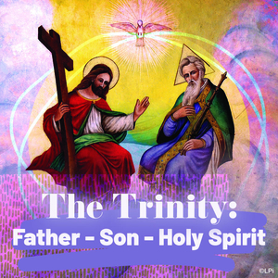

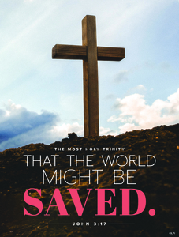

Trinity Prayer
O Divine Mystery, O Sacred Trinity!
Surround us with Your wisdom, love, power, and grace. Draw us to Yourself. Help us to rest in Your goodness. Amen.

Scripture Focus: Journeysongs #942
First Reading: Exodus 34:4b-6, 8-9
Responsorial Psalm: Daniel 3:52, 53, 54, 55
Second Reading: 2 Corinthians 13:11-13
Gospel Acclamation: cf. Revelation 1:8
Gospel Reading: John 3:16-18

Music
Entrance: #467 Holy, Holy, Holy
Offertory #615 Abba, Father
Communion: #802 One Bread, One Body
Recessional: #466 All Praise and Glad Thanksgiving

Catholic Trivia Question: What’s the official name for a person who is seeking to be baptized and initiated into the Catholic Church?

The Solemnity of the Most Holy Trinity– A

May 31, 2026
SUNDAY MASSES
4:00 AZ TIME
Join us next Sunday at 3pm to pray The Rosary.
Join us after Mass in the Parish Hall. Parishioner Stan Simala will present and lead the discussions on the third season of The Chosen.
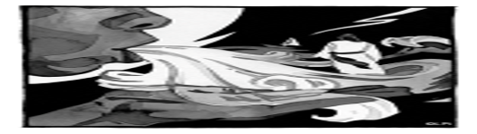
Second Reading
Brothers and sisters, rejoice. Mend your ways, encourage one another, agree with one another, live in peace, and the God of love and peace will be with you. Greet one another with a holy kiss. All the holy ones greet you.
The grace of the Lord Jesus Christ and the love of God and the fellowship of the Holy Spirit be with all of you.

First Reading
Early in the morning Moses went up Mount Sinai as the LORD had commanded him, taking along the two stone tablets.
Having come down in a cloud, the LORD stood with Moses there and proclaimed his name, “LORD.”
Thus the LORD passed before him and cried out, “The LORD, the LORD, a merciful and gracious God, slow to anger and rich in kindness and fidelity.”
Moses at once bowed down to the ground in worship. Then he said, “If I find favor with you, O LORD, do come along in our company. This is indeed a stiff-necked people; yet pardon our wickedness and sins, and receive us as your own.”

Gospel Reading
God so loved the world that he gave his only Son, so that everyone who believes in him might not perish but might have eternal life. For God did not send his Son into the world to condemn the world, but that the world might be saved through him. Whoever believes in him will not be condemned, but whoever does not believe has already been condemned, because he has not believed the in the name of the only Son of God.

Responsorial Psalm

Glory and praise forever!

Blessed are you, O Lord, the God of our fathers, praiseworthy and exalted above all forever; and blessed is your holy and glorious name, praiseworthy and exalted above all for all ages. R.

Blessed are you in the temple of your holy glory, praiseworthy and glorious above all forever. R.

Blessed are you on the throne of your kingdom, praiseworthy and exalted above all forever. R.

Blessed are you who look into the depths from your throne upon the cherubim, praiseworthy and exalted above all forever. R.

Gospel Acclamation
Alleluia, alleluia, alleluia.

Glory to the Father, the Son, and the Holy Spirit; to God who is, who was, and who is to come.

The Mystery of Faith

We proclaim your Death, O Lord, and profess your Resurrection until you come again.

Prayers of the Faithful
Celebrant: Through the grace of the Son, we learn of the love of the Father, and are drawn into the fellowship of the Holy Spirit. Through the Son, we come to the Father with prayers inspired by the Spirit.

R. Lord, hear our prayer.

For the holy Catholic Church, that we may be one in our faith in the Triune God, let us pray to the Lord. R.

For this world, that it may be saved though the Son sent by the Father, let us pray to the Lord. R.

For those who do not accept the true God, that they may come to the peace and love of the Father, Son, and Holy Spirit, let us pray to the Lord. R.

For ourselves celebrating this Eucharist, that we may help one another with the love which reflects the Trinity, let us pray to the Lord. R.

For our sick, bereaved, and our special projects or events, let us pray to the Lord. R.

For the dead, that they may rejoice for ever in the glorious life of the Father, Son, and Holy Spirit, let us pray to the Lord. R.

Celebrant: Eternal Father, receive the prayers of this people, filled with the Holy Spirit, and offering Christ, your only Son, who lives and reigns for ever and ever. R. – Amen.

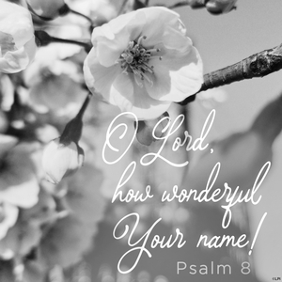

Observances for the week of May 31, 2026
Sunday: The Most Holy Trinity
Monday: St. Justin, Martyr
Tuesday: Saints. Marcellinus and Peter, Martyrs
Wednesday: St. Charles Lwanga and Companions, Martyrs
Thursday:
Friday: St. Boniface, Bishop and Martyr
Saturday: St. Norbert, Bishop
Next Sunday: The Most Holy Body and Blood of Christ

Prayer to the Holy Trinity
Glory be to God the Father, God the Son, and God the Holy Spirit, who calls us into communion with Him, a life of grace and mystery, reconciliation and unity. Amen.

Holy Tales
A Test of Love
Back when I was a student in the seminary, we would be tested in general areas of theology as well as in the specific course work we were taking. They would give us an extensive reading list for those “area” exams. One of them included the theology of the Holy Trinity.
At 4 a.m. the night before the exam, I reached a chapter in a thick textbook that was titled “The Filioque Issue.” Evidently at some point in church history theologians debated whether the Holy Spirit came from the Father though the Son or from the Father and the Son. I was too tired to wrap my mind around the issue, so I closed the book and went to sleep.
The next day there was a 30-percentage point question on the test, asking us to describe that very issue. I did not know what I said, but it was good enough to pass—barely.
It is good and important to leave those issues to the theologians. For most of us, it is enough to believe in our God who created us and who has lived with us in history and now in the church. It is enough to believe in the God whom we find animating the very depths of our being—one God experienced in such mysterious ways. That should be enough for us to respond to with love. And this may be even a little harder to do than to explain it all theologically.


Our faithfully departed,
and
Pray for all of our brothers and sisters in
Christ who are in need of comfort and healing:
Kissina Bay, Tanyia Burgess Carr, Michael Francisco Castaneda, Gloria Castillo, Gloria Derma, Bobby Derrick, Trini Dominguez, Veda Fraijo, Jeanne Hoffman, Gabriel Jim, Patricia Lumas, Jason and Anna Magdaleno, Charles “Gordie” Martinez, Evelyn McGee, Bill Mejia, Joann Montague, Asher Mullins, Emma Nelson, Margaret Patane, David Rico, Tara Roberson, Oscar Sevilla, Elva Shannon, Gloria Simala, Daphne Stone, and Elaine and Norman Weingart

CATHOLIC TRIVIA ANSWER: A Catechumen.

Prayer for the Sick
For those in pain and in sorrow, God be their comfort. For caretakers and medical staff, God give them grace. Surround those afflicted with Your love, care, and mercy, You who are our healing and hope. Amen.

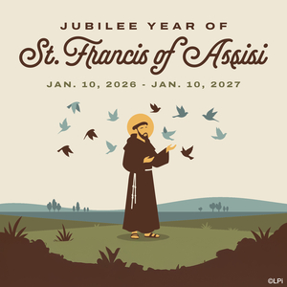
MASS COLLECTION
May 24, 2026: To be posted next Sunday.

