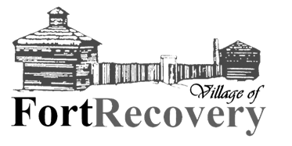
Application for Open Council Position
Thank you for your interest in serving on the Fort Recovery Village Council. Please complete the following application to be considered for the open council seat. Your responses will help the current council members evaluate your qualifications and commitment to the community.

Applicant Information
- Full Name: ____________________________________________________
- Address: ____________________________________________________
- Phone Number: ____________________________________________________
- Email Address: ____________________________________________________
- Years Residing in Fort Recovery: __________

Background & Experience
- Please describe your current and past involvement in the Fort Recovery community.

- What professional or personal experience do you have that would contribute to your role as a council member?

- Why are you interested in serving on the Fort Recovery Village Council?

- What do you believe are the most important issues currently facing Fort Recovery?

- What ideas or goals would you like to bring to the council if selected?

Availability & Commitment
- Are you available to attend regular council meetings (Held on 1st and 3rd Mondays every month)?
☐ Yes ☐ No ☐ Other (please explain): _______________________
- Are you willing to serve on additional committees or attend special meetings as needed?
☐ Yes ☐ No ☐ Maybe

Signature
I certify that the information provided in this application is true and complete to the best of my knowledge. I understand that this application will be reviewed by the current Village Council members and may be discussed in a public meeting.

Signature:___________________________ Date: __________________________

