About Us
The Village of Fort Recovery is a rural community located in southwest Mercer County near the Indiana state border. Incorporated as a village in 1858, Fort Recovery has been the location of a continuous settlement since 1793 when General Anthony Wayne constructed the original Fort on the banks of the Wabash River.
With a current population of 1,501, Fort Recovery remains a small, yet progressive village with deep ties to the agricultural business community. With a school system that continually receives high ratings from the State of Ohio, a strong business community, a strong faith-based community with religious diversity, a strong locally owned industrial base, and a passion about our historical significance in shaping this country --all characteristics that lead to the excellent quality of life enjoyed by our residents.

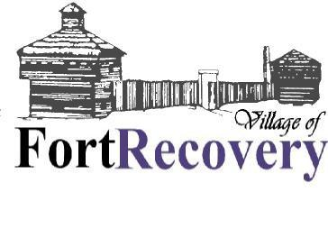
201 South Main Street
P.O. Box 340
Fort Recovery, Ohio 45846
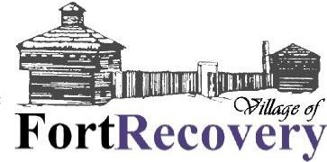
a proud past...
a promising future
Information Guide
for New Residents
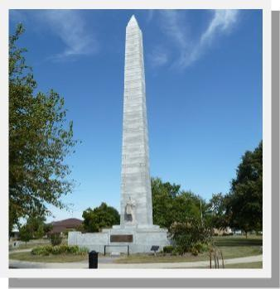
Village Offices
Fire Department* | (419)375-2726
Fiscal Officer/Mayor | (419)375-2530
Police Department* | (419)375-2662
Street Department | (419)375-8102
Tax Administrator | (419)375-4580
Village Administrator (419)375-1056
Water Plant (419)375-2555 *Non-Emergency Phone Number
MAIL & ADDRESS
Fort Recovery Post Office
206 St. Clair St.
Ft. Recovery, OH 45846
Phone: (419)375-2656
You will need to contact the Post Office to determine your mailing address. The majority of residents have Post Office Boxes. There is no carrier delivery in the village. If you do not know your street address, contact the fiscal officer at the town hall.
SCHOOLS
High School
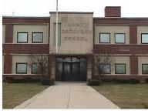
400 E. Butler St.
Ft. Recovery, OH 45846
(419)375-4111

Administration (419)375-4139
Elementary & Middle
School
865 Sharpsburg Rd.
Ft. Recovery, OH 45846
Phone: (419)375-4131 Preschool
(419)375-2768 Kindergarten
(419)375-2768 Elementary (Gr.1-5)
(419)375-2815 Middle (Gr.6-8)
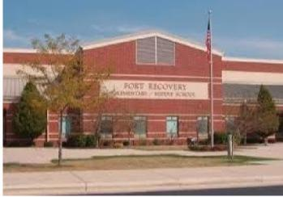
LOCAL TAX
- Ft Recovery Local Schools
Tax Rate is 1.5%
Phone (800)282-1780
*The school district income tax is administered by the State of Ohio.
- Village of Ft Recovery
Tax Rate is 1.5%
Phone (419)375-4580
*The Village has mandatory filing. This means each resident age 18 and older (including partial year residents) must file a return with the Village whether or not they have earned income
VOTING INFORMATION
Where to Register
Mercer County Board of Elections
Rm 101, Mercer County Courthouse
Celina, Ohio 45822
Phone: (419)586-2215
*Must register at least 30 days prior to election
Where to Vote
You may contact either the Village Hall (419) 375-2530 or the Election Board (419)5862215 to find out where to vote. The Village is divided into two townships, Gibson and Recovery. Gibson Township is south of Boundary Street and Recovery Township is north of Boundary Street.
"This institution is an equal opportunity provider and employer."

You can find more information about the Village on our website. FortRecovery.org

For Village events and information follow Village of Fort Recovery  page.

CABLE
- Comcast Cable
Phone: (800)439-9006
- Wabash Mutual Telephone Phone: (419)942-1111
INTERNET
- Comcast Cable
Phone: (800)439-9006
- Frontier Communications Phone: (877)462-8188
- Wabash Mutual Telephone Phone: (419)942-1111
ELECTRIC
- AES OHIO
- Company Phone: (800)433-8500
NATURAL GAS
- ENBRIDGE Gas Ohio
- Phone: (800)362-7557
TELEPHONE
- Frontier Communications Phone: (877)462-8188 *Installations
- Wabash Mutual Telephone Phone: (419)942-1111
WATER & SEWER
- Village of Fort Recovery Phone: (419)375-2530—Billing (419)375-2555—Plant
TRASH SERVICES
Residential Residents
Maharg Trash Service
Fort Recovery Resident Utility Aggregation

When you set up your electric and gas accounts you will be given a standard rate which changes each month. You have the option of contracting these rates with different suppliers. You will still receive your electric bill from AES (Formerly DP&L) and your gas bill from Enbridge (Formerly Dominion).

These contracts do not have a cancellation fee so if you decide you want to contract with another supplier you may do so at any time. When you call, tell them that you would like to join the Village of Fort Recovery Utility Aggregation Contract. Please have your bill in front of you as they will need your account number. The new rate will not take effect until the next billing cycle.
 Electric Contract 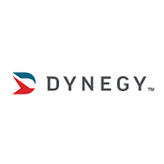
After you receive your first AES bill you may call Dynegy 1-888-682-2170 to have your account contracted at the rate of .0908¢ per KWh until May 2028.
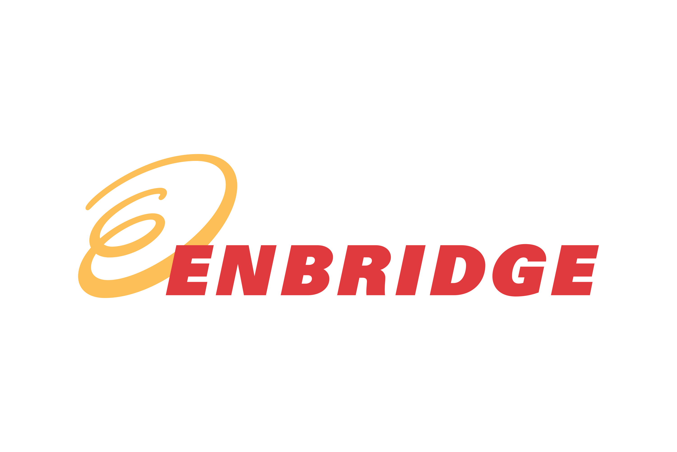Gas Contract 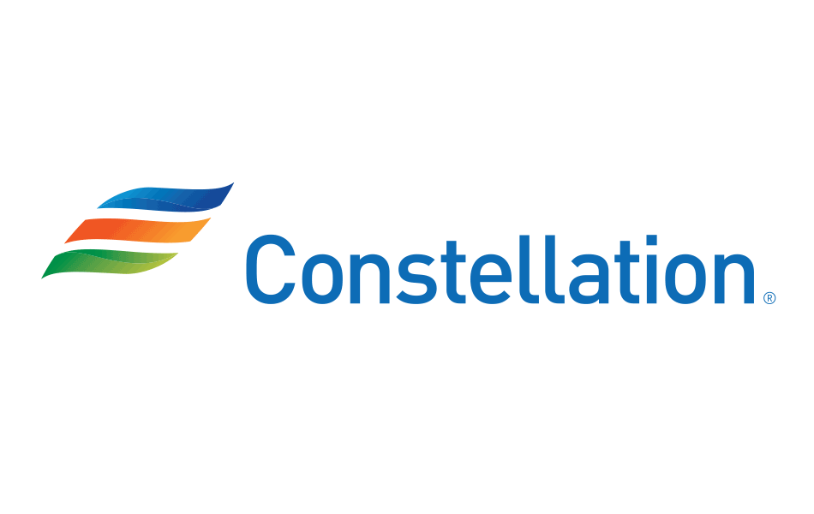

After you receive your first Enbridge (FKA Dominion) invoice you may call Constellation 1-844-916-0135 where you will obtain a variable standard rate per Mcf added to the NYMEX last day settlement price. until we are able to obtain a fixed rate contract again.


If you would like to see other electric or gas contracts that are available, you may go to http://www.energychoice.ohio.gov. This website is managed by the Ohio Public Utilities Commission to offer residents choices for gas and electric suppliers. This will allow you to manage your supplier.

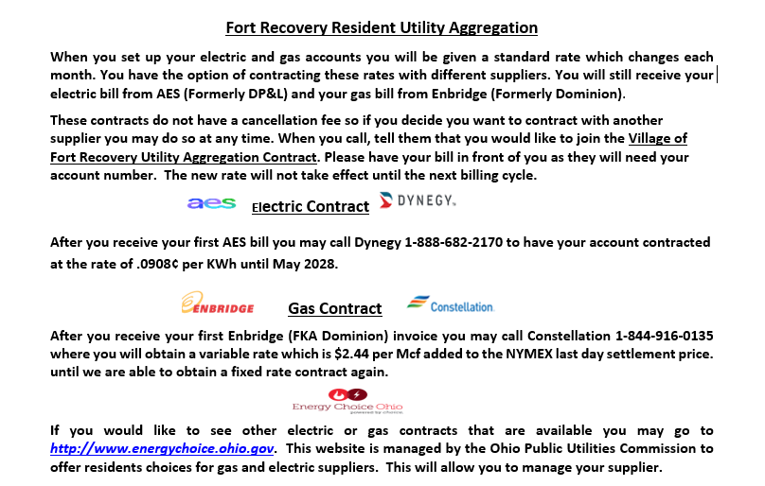
Phone: (419)586-3130
Garbage Pickup is 6:00AM on Tuesdays. You will
need to purchase specific garbage bags at Tobe’s Carryout, or Fort
Recovery Party Mart.
Recycling Pickup is 6:00AM on Wednesdays. You need to purchase specific recycling bags at the stores listed above.
Recycling is a Two-Bag System
Bag 1 = All acceptable paper/cardboard (Fibers)
Bag 2 = All acceptable plastic, tin & glass
Limb/Brush Pickup is the first Monday of each month; except during the winter. Place trimmed branches and brush along the road for a Village truck to dispose. April through November.
Clean-Up Day is in the month of May, usually on a Saturday. A truck will pick up household items. A tag must be purchased for larger items and there is a limit to amount placed curbside. Watch the schedule.
Commercial Businesses
Commercial users may subscribe to other sanitation companies.

