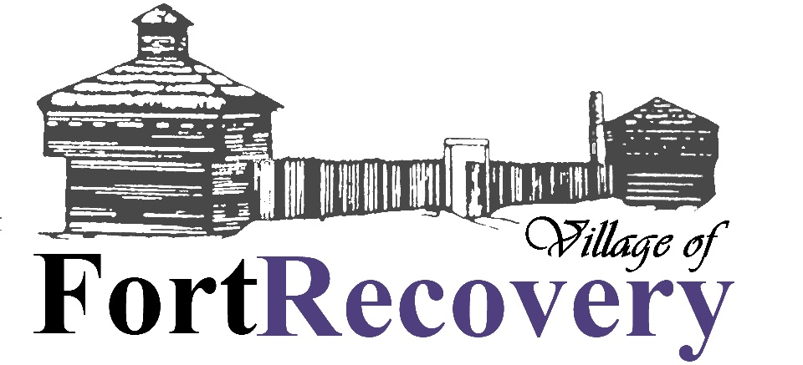
Legal Notice
In accordance with the Village of Fort Recovery, notice is hereby given that on or before the 21st day of April, 2026 the following resolutions were adopted and/or ordinances passed by the Council of the Village of Fort Recovery. Publication of which was directed to be made in a summary manner as provided therein; the subject of said legislation being expressed in the caption thereof:
RESOLUTION 2026-17 A RESOLUTION TO TRANSFER MONEY FROM ONE FUND TO ANOTHER FUND FOR THE VILLAGE OF FORT RECOVERY, OHIO; AND DECLARING AN EMERGENCY.
RESOLUTION 2026-18 A RESOLUTION TO AMEND APPROPRIATIONS FOR THE VILLAGE OF FORT RECOVERY, OHIO; AND DECLARING AN EMERGENCY.
The complete text of each such resolution or ordinance may be obtained or viewed at the office of the fiscal officer of the Village of Fort Recovery, located at 201 S Main Street, Fort Recovery, OH.

