Gaaf voor de Start

English

Brainstorming, talking and designing together.

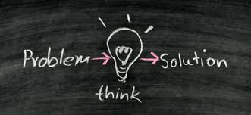

Name: …………………………..

Mrs Lykles
Hermann Wesselink College

PROBLEMS and SOLUTIONS
Vocabulary:
to wipe an apron to butter glue stick to spread dust foldable

Invention | What problem does it solve? What could it be handy for? | Exists for real Y/N?
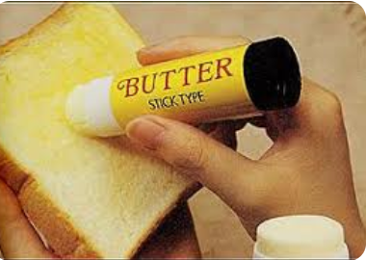
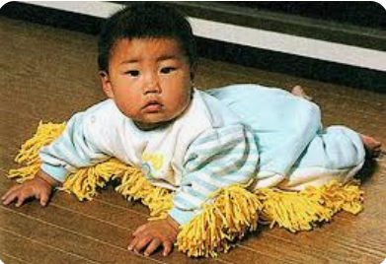
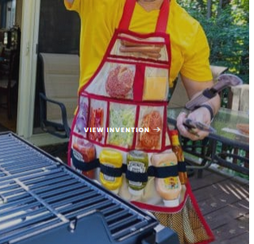


How to communicate and sell your ideas - Advertisements
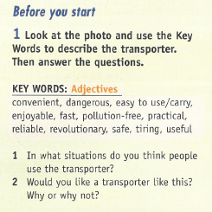
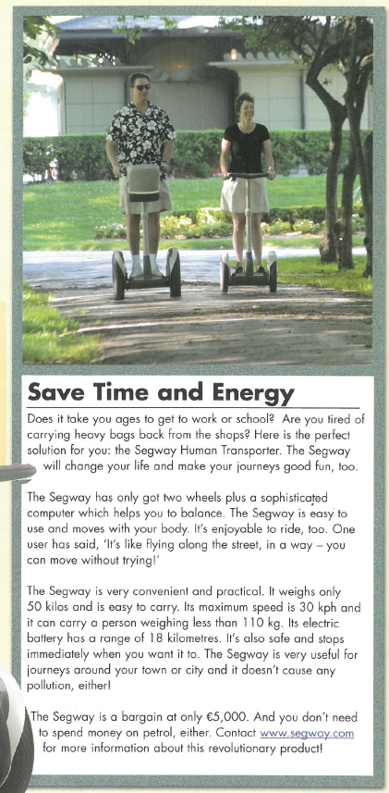

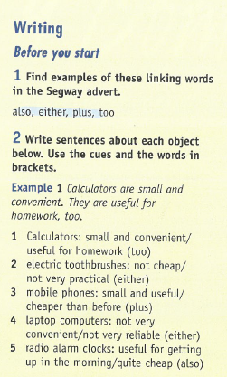
Assignment: Great inventions for common problems.
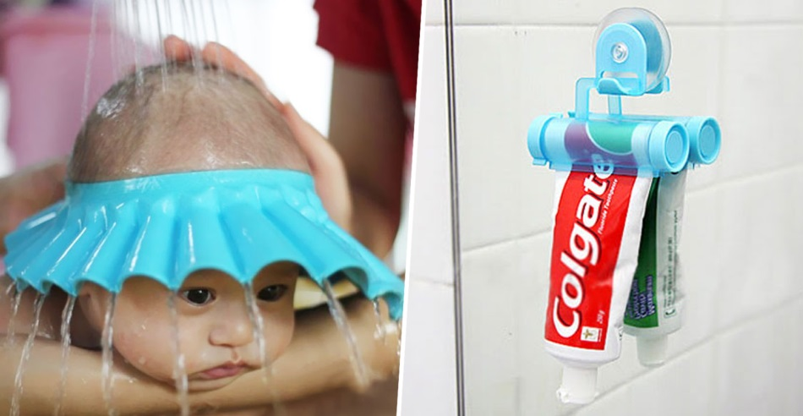

Do you remember those problems, shampoo stinging in your eyes when you were younger and your mum washed your hair for you? Or that annoying little bit of toothpaste that seems impossible to squeeze out of the tube? Some people thought of an ingenious solution!
For the inventor’s fair it is your turn (in pairs) to think up an invention as a solution to a (common) problem that you encounter in your daily lives. Think out of the box and don’t limit yourself. You don’t have to worry about how realistic your solution is.
Step 1: Problem. So, the first step is to decide what problem you encounter and you want to solve. First describe the problem.
Step 2: solution, product design Then you and your partner are going to talk about how to solve the problem, what kind of gadget to design to solve that problem. Talk about how it should work. It can be imaginary of course.
Step 3: takes notes on your product. Think up details that are important for you gadget, like name, how it works, what the advantages are, how much it could cost etc.
Step 4: Write an advert telling your reader about the problem that your invention tries to solve and saying what the advantages are.
Important: | For writing your advert you have to follow the layout and language tips in the appendix.
Step 5: Prepare to talk about the invention (It is not the same text as the advert)
Step 6: Show and tell about your invention on the HWC Inventor’s Fair (date: ………………………….…)

Step 1: Problem description.
Describe the problem and describe the feeling that you might get because of the problem. What are the consequences of the problem?
................................................................................................................................................................

...............................................................................................................................................................

..............................................................................................................................................................

...............................................................................................................................................................

...............................................................................................................................................................

...............................................................................................................................................................

...............................................................................................................................................................

...............................................................................................................................................................

...............................................................................................................................................................

...............................................................................................................................................................

...............................................................................................................................................................

...............................................................................................................................................................

...............................................................................................................................................................

...............................................................................................................................................................

...............................................................................................................................................................

Step 2: Brainstorming a solution to the problem.
You do the brainstorming on scrap paper. Make a sketch of your product if necessary.

Appendix

