**Application**

**Form**

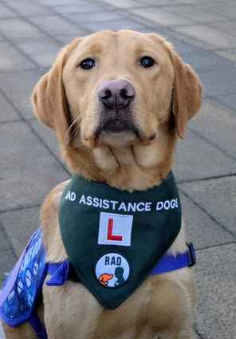

| **Personal details:** | | | | |
| --- | --- | --- | --- | --- |
| Preferred title: | |  | | |
| Forename(s): | |  | | |
| Surname: | |  | | |
| Known as (if different): | |  | | |
| Preferred pronouns: | |  | | |
| Home address: | |  | | |
| Postcode: | |  | | |
| **Contact details:** | | | | |
| Daytime telephone number: |  | | Evening telephone number: |  |
| Mobile number: |  | | Preferred contact time: |  |
| Email address: |  | | | |
|  |  |  |  |  |

| **Summary of qualifications relevant to this role:** | |
| --- | --- |
| Date | Awarding body / Qualification / Level |
|  |  |
|  |  |
|  |  |
|  |  |
|  |  |
|  |  |
| **Current and previous relevant voluntary work and employment** | |
| Dates  From - To | Organisation, Position held,  Summary of responsibilities |
|  |  |
|  |  |
|  |  |

| **Position applied for:** |  |
| --- | --- |
| **Times you are available:** **(On a weekly basis)** |  |
| **Reason for applying and personal skills and qualities:** Please tell us why you wish to undertake this role with RAD and the skills and qualities you have to fulfil this role. | |
|  | |

| **References** Please supply the contact details for two people who have known you for at least 5 years (but are not related to you) who have a good knowledge of you whom we can contact for a reference. If applicable these should include your current or most recent employer in a paid or volunteer role. At least one referee should hold a professional position. Please ensure that you have obtained their consent before giving us their details. Thank you. | |
| --- | --- |
| Name: | Name: |
| Address: | Address: |
|  |  |
|  |  |
|  |  |
| Postcode: | Postcode: |
| Daytime telephone number: | Daytime telephone number: |
| Evening telephone number: | Evening telephone number: |
| How is this person known to you? | How is this person known to you? |
| **Please sign and date this application form:** | |
| Signature: | Date: |

**Self-Disclosure Form**

RAD Assistance Dogs aims to promote equality of opportunity for and welcomes applications from a wide range of individuals, including those with prior criminal records. The position/role for which you have applied is an exempted occupation for the purpose of the Rehabilitation of Offenders Act 1974 (as amended by the Rehabilitation of Offenders Act 1975), requiring an enhanced DBS disclosure. All ‘spent’ and ‘unspent’ convictions must be declared. Having an ‘unspent’ conviction will not necessarily impede your appointment, this will depend on the circumstances and background to your offence(s). If you fail to disclose an offence and RAD Assistance Dogs is later informed of any previously undisclosed criminal matter, you may be subject to disciplinary action. Any information you provide will be held on a strictly confidential basis and dealt with the utmost discretion. In addition, should you subsequently be investigated for or convicted of any offences these should be disclosed to the your line manager or the Chair of the charity at the earliest opportunity.

| **Previous convictions**  Have you ever received a conviction/caution/reprimand or final warning for any criminal offences?  **Yes / No** (Please delete as appropriate) | |
| --- | --- |
| If Yes, give details: | |
| Date | Offence and outcome |
|  |  |
|  |  |
|  |  |
|  |  |

| Are you a person known to any Social Services department/statutory agency as being an actual or potential risk to adults at risk?  **Yes / No** (Please delete as appropriate) |
| --- |
| Have you ever been the subject of disciplinary sanction in any paid or unpaid employment in relation to adults at risk?  **Yes / No** (Please delete as appropriate) |
| If yes, give details: |

| **Please sign and date the self-disclosure form:** | |
| --- | --- |
| Signature: | Date: |