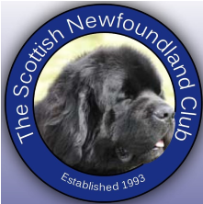
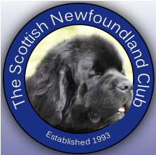
THE SCOTTISH NEWFOUNDLAND CLUB
APPLICATION FOR MEMBERSHIP
Please complete this form in full and send it together with the appropriate cheque or P.O. made payable to:
THE SCOTTISH NEWFOUNDLAND CLUB
Membership Secretary 9 Tynwald Avenue Burnside G73 4RN
OR
email scotnewfmembership@gmail.com
OR
Bank transfer The Scottish newfoundland club Account No, 00213600, sort code 800219

Standard membership -applicant and partner children under18 at same address - £20

Working group membership -as above and participation in water training and draft work -£35

Applicant Name: __________________________________________________________

Applicant Name: __________________________________________________________

Landline Number:

Email: _______________________________________________________

Address: ____________________________________________________
____________________________________________________
Please tick preferred method of contact from Club

Newfoundland’s Owned (Please attach another sheet if more Newfoundland’s owned)
Breeder |  | Breeder
Kennel Name (Affix) |  | Kennel Name (Affix)
Pet Name |  | Pet Name
Colour |  | Colour
Male / Female |  | Male / Female
Neutered / Spayed |  | Neutered / Spayed
Age |  | Age
Welfare Yes/No |  | Welfare Yes/No

I/We have read the enclosed Code of Ethics and Rules and Regulations and agree to abide by them.

I/We have enclosed a cheque or postal order for £ _________ in respect of the annual subscription fees. (leave blank if you have paid online)

I/We understand that if, for any reason my/our application is rejected, the above sum will be reimbursed in full.
Please tick if you have paid Bank transfer
The Scottish Newfoundland Club does not use data for marketing purposes and all details of our members are held securely and purely for the purpose of keeping you informed and for keeping our memberships up to date.

The data we hold about our members is only kept on private computers, not on cloud systems and it isn't transferred outside the UK / EU nor is it transferred to another company. Only the membership Secretary and the Club Secretary have access to your data for the purpose stated below. We do not produce statistics based on the data that you have provided us with.

We will only share this data if lawfully required and we will only keep this data on file for the length of time we are legally required to do so. You have the right to be forgotten and to request to be removed from our database.

We need to gain consent from our members to obtain, retain and use their personal information in our Club membership database.

We need evidence that we are complying with the principles of the General Data Protection Regulation, which includes evidencing that members provide their consent for their data to be processed and retained by us.

Please read the Privacy Statement below before giving consent for your data to be held by the Scottish Newfoundland Club.

Please tick the box below to give us permission to use the information you have supplied on your membership form.

- To store your name, the name of your dog, your postal address, telephone number, and email address securely and solely for membership purposes.

- To communicate with you as an SNC member, to send you membership and AGM documentation, Club magazines, and email messages relating solely to the Club business.

I consent to my data being used for membership purposes as detailed above.
Applicant Signature:

Date:

