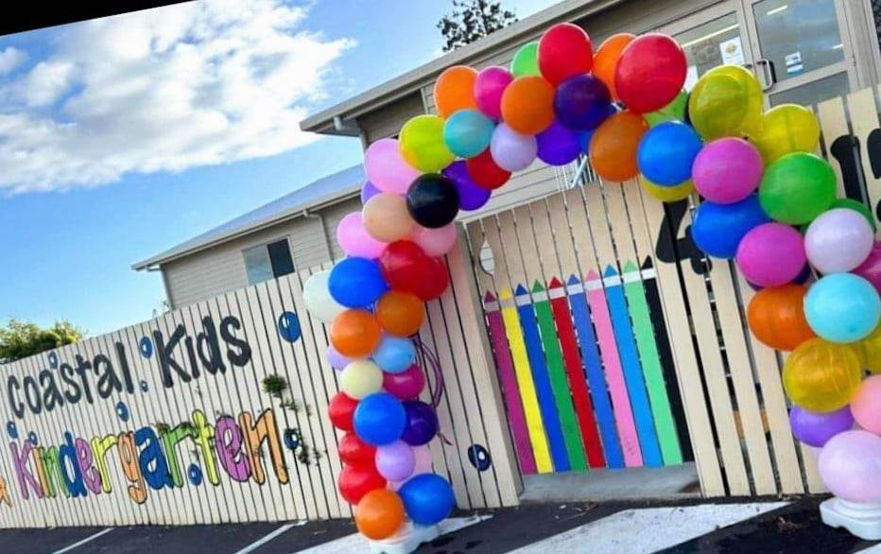

A Place Where Kids Become Friends and Friends Become Family …
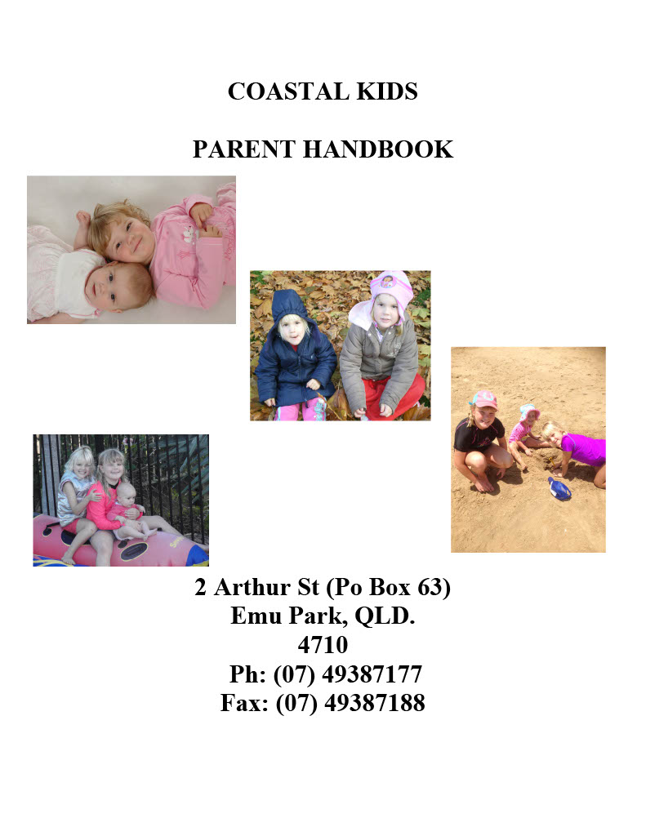
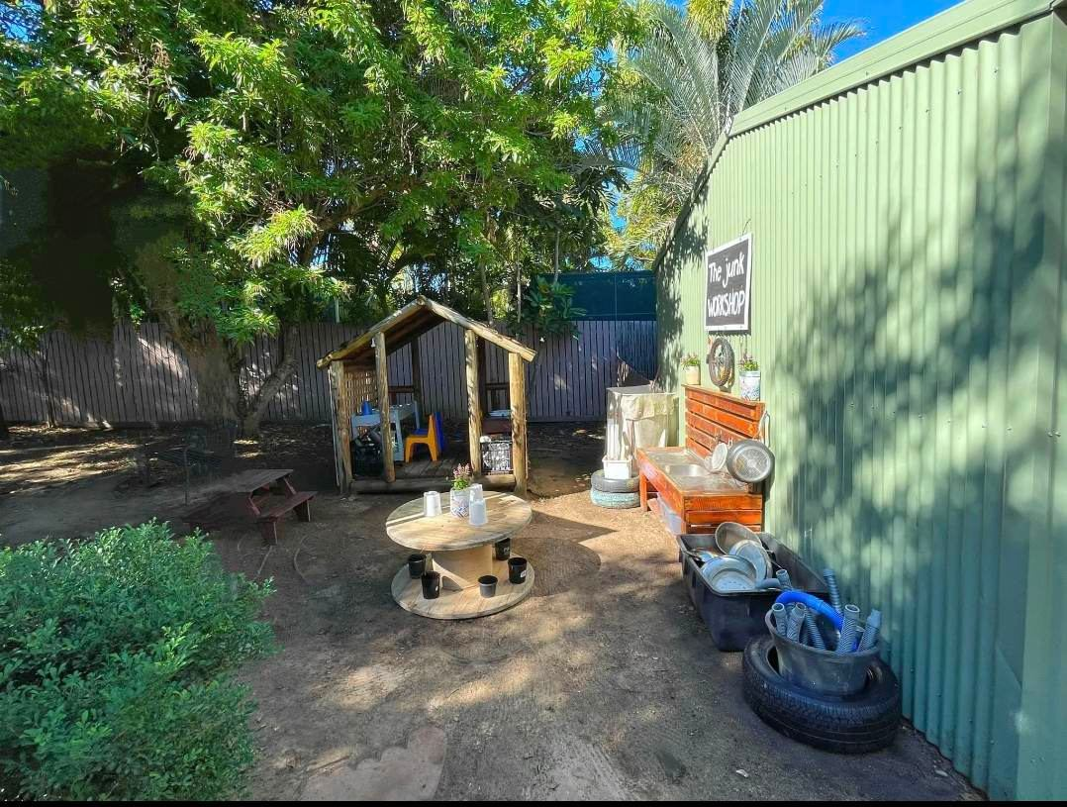
Family Owned Since 2006
Kindergarten
Parent Handbook

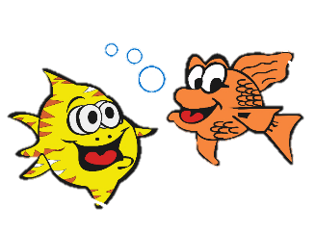
ABOUT COASTAL KIDS
KINDERGARTEN
Coastal Kids is privately owned and operated by Kerrie and Shaun Corrigan. We have three daughters (Molly, Paris and Olivia), and understand the needs of families who are working, studying and commuting each day. We purchased Coastal Kids in August 2006. Previously I (Kerrie) taught at Yeppoon Primary school for five years and Directed Long Day Care centres prior to teaching. Shaun worked in the mines, but once we had our children, he wanted to be closer, so we purchased the business and for many years we all came to work together each day. Here at Coastal Kids, we are highly experienced and committed to providing the highest level of care for your child. Our emphasis is "Early Learning” in a loving, caring environment. Please do not hesitate to approach us if you have any questions regarding our centre.
In October 2011 the Federal Government introduced the Education and Care Services National Law and the Education and Care Services National Regulations. A new national body jointly governed by the Australian Government and state and territory governments – the Australian Children’s Education and Care Quality Authority (ACECQA) to oversee the new system. The National Quality Framework took effect on 1 January 2012. Our overall rating and individual standards are display at the entrance of the building.
Department of Early Education and Care: Telephone: 49324022
We are licensed under the Education and Care Services National Regulations and Education and Care Services National Law Act 2010 and must comply with requirements in the National Quality Standard to provide continual improvement through our activities, experiences and programs, numbers of staff members to children and also Staff member’s qualifications.

Contents

About Coastal Kids ………………………………………………………………………… 2

Contents ………………………………………………………………………………………………………………3-4
Centre Philosophy and Curriculum……………………………………………………………………………5
Fee Information…….………………………………………………………………………………………………….6
Late Fees …………………………………………………………………………………………………………………6
Fee Relief………………………………………………………………………………………………………………….6
Hours of Operation…………………………………………………………………………………………………..7
Priority of Access……………………………………………………………………………………………………..7
Absent on Booked Days…………………………………………………………………………………………….7
Method of Payment………………………………………………………………………………………………….7
Arrival and Departure……………………………………………………………………………………..…….7-8
Allergy Alert……………………………………………………………………………………………………………..8
Safety in the Centre…………………………………………………………………………………………………8
Accident/Emergency………………………………………………………………………………………………8-9
Evacuation Procedure……………………………………………………………………………………………….9
Lost Property…………………………………………………………………………………………………………...9
Illness………………………………………………………………………………………………………………….9-10
Medication……………………………………………………………………………………………………………..10
Asthma…………………………………………………………………………………………………………………..10
Anaphylaxis……………………………………………………………………………………………………….10-11
Hygiene………………………………………………………………………………………………………………..…11
Animals and Pets at the Centre…………………………………………………………. ………………….11
Staffing of Centre………………………………………………………………………………………………11-12
Surveillance Camera……………………………………………………………………………………………….12
Students, Visitors & Volunteers………………………………………………………………………………12
Excursions………………………………………………………………………………………………………………12
Parent Involvement………………………………………………………………………………………………...13
Anti-Discrimination………………………………………………………………………………………………..13

Contents continued

Special Needs…………………………………………………………………………………………………….13-14
Non-Smoking Policy………………………………………………………………………………………………..14
Concerns/Complaints………………………………………………………………………………………………14
Information Requirements………………………………………………………………………………………14
Centre Policy Booklet and Child Care Regulations……………………………………………………14
Compliance History…………………………………………………………………………………………………15
Clothing………………………………………………………………………………………………………………….15
Sun Protection………………………………………………………………………………………………………..15
Admission and Enrolments………………………………………………………………………………….…..16
Sleep and Rest………………………………………………………………………………………………………16
Child Protection……………………………………………………………………………………………………..16
Toys………………………………………………………………………………………………………………………..16
Birthdays………………………………………………………………………………………………………………..16
Immunizations………………………………………………………………………………………………………..17
Child Behaviour Management & Guidance……………………………………………………………….17
Biting……………………………………………………………………………………………………………………..17
Food……………………………………………………………………………………………………………………….18
What to bring to Daycare…………………………………………………………………………………..18-19
Illness Poster ………………………………………………………………………………………………………..20

Philosophy and Curriculum

Philosophy
"Holistic approaches to teaching and learning recognize the connectedness of mind, body and spirit.”
At Coastal Kids, we embrace a holistic education philosophy that recognizes the interconnectedness of mind, body, and spirit in each child's journey. We believe that learning transcends academic achievement, and we focus on all aspects of a child's development: physical, personal, social, emotional, mental, and spiritual well-being. Recognising the importance of relationships, we value the connections between children, families, the community, and our educators. We strive to empower families by fostering their involvement and creating a welcoming atmosphere, ensuring they feel supported and connected throughout their child's educational journey. We believe in a holistic approach to teaching that emphasizes connections to the natural world. This fosters respect for the environment and highlights the interdependence between people, plants, animals, and land. It also encourages sustainability and responsibility in young learners to protect our planet for future generations.
Cultural responsiveness, diversity, and equity are central to our mission. We celebrate the diverse backgrounds of our children and families, integrating various cultural perspectives into our curriculum. Honouring each child’s heritage creates an inclusive environment where every child feels valued and understood. Our commitment to equity ensures that all voices are heard and that every child has equal opportunities to thrive. Additionally, we prioritise child safety and adhere to the highest child-safe standards. This ensures that every child in our care is protected from harm and feels secure within our environment. Our policies and practices are designed to promote a culture of safety, empowerment, and transparency. We provide ongoing training for our educators to recognize and respond to risks and foster an open environment where children can express their needs and concerns.
Ultimately, we envision Coastal Kids providing a joyful sanctuary where all children, including the youngest of babies, are valued as contributing members of society. We firmly believe that every child possesses the right to play, explore, and partake in decisions that impact their lives. Through our philosophy, we embrace their unique perspectives and celebrate their journeys, fostering a vibrant, nurturing, and inclusive community.

.

Opening Hours and Fee Information

Method of Payment
Fees will be made weekly or fortnightly in advance. You may choose either the NumeroPro Direct Debit System which debits the nominated amount from a bank account which you choose or a Centre pay deduction which is deducted from your nominated Centrelink payments before they enter your bank account. Upon enrolling your child, you will be asked to choose your preferred payment style and fill out the relevant forms. You will receive a statement for your fees at the start of each month.
FEES AS AT 1ST JULY 2025
Session Times | Fee Per Day (Kindy) | Fee Per Day (Pre Kindy)
12 Hour session | $130.00 | $130.00
10 Hour session | $130.00 | $130.00
9 Hour session | $130.00 | $130.00
8 Hour session | $130.00 | $130.00
The standard fees before fee relief are:

Please ask for the amount of your fees after fee relief.
Fees may be paid weekly, fortnightly, or monthly in advance. Statutory public holidays and days your child is absent from their booked days must be paid for.
Late Fees
There is a $15.00 late fee, which is applicable for each ten minutes or part thereof after 6.15pm. This fee is not subject to Childcare subsidy.
Fee Relief
Fee relief:
1. Child Care Subsidy (CCS) is available to all Parents/Guardians who meet the eligibility requirements. Parents/Guardians receive this as a deduction from fees; it cannot be claimed as a tax deduction at the end of the year. Application may be made through your MyGov account/Centrelink. Full fees will be charged until CCS is approved.
2. Absences: Under the Child Care Subsidy System (CCSS) CCS is strictly monitored. A child is allowed to have 42 absences in a financial year for any reason, but a fee must be charged to gain CCS. Once 42 absences have been reached documented proof is required for any additional absences, for continued CCS entitlement as assessed by DEPARTMENT OF HUMAN SERVICES. A fee is still required to be charged to claim CCS.

Hours of Operation
Coastal Kids Kindergarten is open from Monday to Friday from 6.15am to 6.15pm. The centre is closed on Statutory Public Holidays. All children must be picked up by 6.15pm. It is vital that you contact the centre by telephone should any unforeseen difficulties arise that will affect your child's collection by this time. Children can become very distressed should regular routines be upset. Therefore, it is vital that staff be adequately informed in order to keep these situations as stress free as possible.
Please be aware that like all centres we charge a late fee if your child is not collected by 6.15pm. Details of fees and charges are covered in the Fees section of this book.
Priority of Access
One of the main reasons the Australian Government funds childcare is to meet the childcare needs of the Australian Families. However, at times demand for childcare sometimes exceeds supply in some locations. If this happens it is important for services to allocate places to those families with the greatest need for care. The Australian Government has priority of access guidelines for allocating places in these circumstances. They set out the following three levels of priority, which childcare services must follow when filling vacant places.
- Priority 1 – a child is at risk of serious abuse or neglect.
- Priority 2 – a child of a single parent who satisfies or of parents who both satisfy the working/training/study test under section 14 of the A new tax system Act 1999.
- Priority 3 – any other child.
Absent on Booked Days
If your child will not be attending on any booked day due to illness, holidays or any other reason, please give us notice if possible. A record of all absences must be kept for the purpose of claiming the Childcare Subsidy, and parents may be asked to sign a register as proof of absence. Childcare Subsidy is paid for up to 40 absences for each child each financial year. You will be charged for the days your child is absent to a total of 40 per year. Absences due to illness do not count towards the 40 absences if you obtain a doctor’s certificate for your child. Absences for attendance at kindergarten, parent’s RDO and rotating shifts do not count towards the 40 days absence.
Coastal Kids do not offer make-up days or swap a day for these missed days.
Arrival and Departure
Arrival and departure time are a perfect opportunity to discuss your child with the staff. Each morning a staff member will greet you and your child, please pass on any information at this time that may be useful for the staff to provide the best care for your child e.g., he has had a very restless night so may need be tired and need an early sleep today etc.
At collection time a staff member will again greet you and discuss your child’s day if for any reason staff are busy and have not seen you please ensure you find a staff member get a report of your child’s day before leaving so that we are aware the child has been collected.

A responsible adult known to the Director and/or the Group Leader/Assistant must bring the child into the centre. Only authorized persons (as indicated on the enrolment form) will be allowed to collect children from the centre. Please notify the Director either verbally or with a written note of any changes regarding the adult who is collecting your child. An adult other than one known to the centre requires identification (preferably photographic). Parents with custody orders must provide a copy to the Director.
In case of a non-custodial parent arriving to collect the child, the Director will contact the police and provide the copy of the order to the police to enforce.
On no account will a child be allowed to go home with a parent/guardian in contravention of a custody/court order held at the centre. Such custody/court orders should be brought to the Director’s attention on enrolment. However, in the event of a non-custodial parent gaining access to a child, the Centre cannot be held liable.
Staff are always concerned about your child’s welfare, so if you are aware of any intending absence, could you please inform the Director/Staff.
Allergy Alert
The centre is a Nut and Mango free environment. This means that Mango, whole nuts and spreads such as peanut butter and Nutella are not acceptable on sandwiches, nuts of any kind are not to be included as a snack, and foods such as satay are not to be included as a lunch item. We have a child at risk of severe anaphylaxis.
Safety in the Centre
No child will be left unattended at any time. Each child will at all times be under the direct supervision of a qualified staff member. No staff member will spend time alone with children out of sight and hearing of other staff.
All staff in the centre is in possession of a current First Aid Certificate.
Students and Visitors will at no time take the place of an adult for supervision of children.
Equipment is checked daily for sharp edges and broken pieces.
Toys provided for the children will be appropriate for their age and maturational level.

Privacy and Confidentiality
We are committed to protecting the privacy and confidentiality of individuals by ensuring that sensitive information about individual children, families and team members. To guarantee confidentiality, photos of other children from our closed Storypark group are not to be shared without consent.

Accident/Emergency Procedure
Although accidents and other emergencies are rare occurrences it is vital that the centre be prepared to deal with them quickly and efficiently while respecting the parent’s preference for care.
All our staff is in possession of current First Aid Certificates and are qualified to provide care in the instance of sudden illness or accident.
In the event of an accident that requires treatment by the staff at the centre it will be recorded on an Accident Report Form. This form will detail the nature of the accident, where, when, the name of staff present and the treatment received. This will be reported to the Director or Assistant Director. When the child is collected the Director or person-in-charge will have the parent read and sign the report.

In the case of an accident or sudden illness of a more serious nature, and it is not possible to contact the parent, the Director, as agents for the parent shall have the discretionary power to seek medical attention as outlined below.
We will attempt to contact the child’s own doctor as listed on his/her enrolment form.
An ambulance will be called to transport the child to the nearest public hospital. The child will be accompanied by a staff member familiar to him/her, in an attempt to minimize stress to the child.
It is very important that we are able to contact parent/guardians immediately in the case of emergency. Please ensure that we have a contact phone number for you every day. This should be recorded on the attendance sheet when signing your child in each day.

Evacuation Procedures
Emergency evacuation procedures have been developed with the co-operation and guidance of the Fire Department. Evacuation procedures are practiced on a monthly basis. Your child will be involved in three different emergency drills ( Evacuation, Lockdown and Medical emergency) All staff are fully aware of these procedures and we ask that you co-operate with staff members should you be at the Centre in the unlikely event of a fire or emergency. Our service emergency policy and procedure is reviewed annually and available for you to view in our About section on Storypark.
Lost Property
Where possible we aim to ensure all mislaid items are returned to their owner. If this is not possible, these items will be kept in a basket in your child’s room. Please check these baskets regularly. After a period of time uncollected items will be donated to a local charity. To ensure items are returned please clearly name all your child’s belongings.
Illness
One of our goals is to minimize the risk of contraction or spread of illness, in a manner, which is safe and practical for all children and adults. (See appendix 1 Illness exclusion table).
The Director/Group Leader in charge of the centre will not accept a child into care if the child is too ill or is considered that the health of others will be jeopardized.
The basis of any such decision will be the book “Staying Healthy in Childcare, 5th edition”. This book is available at our reception desk for your perusal. Information regarding specific illnesses and associated exclusion times is available on request.
The attached “Timeout Poster” also gives you a guide as to when children should be kept home from care.
As a general guide, keep your child home if he/she has: -
Temperature -over 38 degrees Celsius.
Conjunctivitis –An eye infection where the eye is generally red with some associated burning and sometimes a thick yellowish discharge.
Rashes-that you cannot identify or that have not been diagnosed by a doctor as non-infectious,
Impetigo (school sores)-Initially shown as a red pimple like bump. These eventually become fluid filled surrounded by a reddened area. As blisters break the surface is raw and weeping. These lesions most commonly occur in moist areas of the body such as creases of the neck, groin, arms, face and hands.
Diarrhea-from any cause (known or unknown). Please keep your child at home until 24 hours has elapsed with no diarrhea.
Vomiting from any cause (known or unknown, please keep your child at home until 24 hours has Elapsed with no vomiting.
Severe Colds with fever, nasal drainage or coughing.
All infectious Diseases e.g., Measles, Mumps, chicken Pox, Whooping Cough, Rubella, Mite Infections of the skin or hair (i.e. head lice, scabies). If it is found that your child has any of these whilst at the Centre you will be called to collect him/her as soon as possible.
In some rare instances (at the discretion of the Director) if your child has had a contagious illness a doctor’s certificate may be requested for re-admission to the Centre.
Please remember these health standards are meant to protect your child as well as others. If you have any doubts in the morning whether or not your child should be coming to childcare on that day, then your instincts are telling you that you should keep them at home. Often a child who is sick in the morning repeats this during the day or becomes worse, and we need to contact you to collect your child and take them to the doctor. When children are sick, they need more attention, as well as quiet, rest and the comfort of their own home. In a group situation, it is impossible for staff to give appropriate care for ill children and still care for the remainder of the group.
Parents must be prepared for times when, because of ill health or an infection a child cannot be accepted at the centre. It is essential that parents think about this possibility in advance and plan alternative arrangements for their child’s care if this occurs.
If your child is ill, please do not bring them to childcare. Please consult the exclusion table at the back of this Handbook.
Please see our Infectious Diseases Policy and Procedure for more information.
Medication
If your child requires prescribed medication please notify the Director or authorized person. Prescription medication will only be administered once the Medication permission form has been completed. Medication permission forms require details of doctor’s instructions, child’s name, medication currency, dosage times of administration and condition for which medication has been prescribed.
No medication other than prescribed medication listed on the permission form will be administered to the child with the exception of one dose of Paracetamol in the case of a high fever, (at the discretion of the Director). Parents will be notified in this instance. All medication will be kept in the kitchen out of the children’s access.
NOTE: Please do not leave medication including nappy creams etc in your child’s bag or locker, as these areas are accessible by the children.
Asthma
Please provide a copy of your child’s asthma action plan (signed by your doctor), and demonstrate to staff, with the child, the procedure for administering the medication.
Nebulisers/Inhalers will only be administered with your doctors written consent. Medications will not be administered more often than 4 hourly. A risk minimization plan will need to be filled in by the parent regarding triggers and all staff will sign this form to ensure they are aware of the condition prior to us caring for this child.

Anaphylaxis
If your child has any food or insect allergies and suffers from any reactions to these allergies please have an appropriate Anaphylaxis Action Plan completed by your doctor and inform Coastal Kids staff on enrolment if any medications need to be kept at the centre for your child. Please discuss with staff the procedure for administering an Epi Pen (if allergies are severe enough to require one). All staff hold an Asthma and Anaphylaxis First Aid Certificate. A risk minimization plan will need to be filled in by the parent regarding triggers and all staff will sign this form to ensure they are aware of the condition prior to us caring for this child.
Intolerances and Parents Preferences
A risk minimization plan will need to be filled in by the parent regarding triggers and explaining preferences, all staff will sign this form to ensure they are aware of the condition prior to us caring for this child.
Hygiene Procedures
At Coastal Kids we aim to provide a clean hygienic environment, which promotes infection control and good hygiene practices for both staff and children.
In order to do this we will maintain the following practices at all times.
- Tissues & disposable gloves will be supplied in every room
- Hand blowers will be used to dry hands.
- Staff encourage and promotes good hand washing practices.
- All bins are emptied & disinfected daily and/or when full.
- Tables are to be wiped with disinfectant before children eat and when children
have finished playing or eating.
- Floors are to be mopped daily or when a spillage occurs.
- Carpets are to be vacuumed daily.
- Toilets are to be disinfected after each group toileting and when required.
- Toileting accidents will be cleaned up and the area disinfected immediately.
- All towels will be laundered daily.
- Disposable gloves will be worn at all times when dealing with any bodily fluids.
- Disposable gloves will be worn at times when directly handling food.
- Children will use separate cots and stretchers.
- All equipment will be checked and disinfected before it is replaced in the storage areas.
- All rooms are to be well presented, with clear access for children and adults to doorways and bathrooms to lessen the likelihood of falling over.
Please see our Health and Hygiene Policy and Procedure for more information.
Animals and Pets at the Centre
- We appreciate and want to foster the development of children’s bonds with animals. We ask if you would like to bring a pet to the centre that you speak with the senior educator of your room so that an appropriate time be organized. We also ask that the pet visits for a short period of time and that you remain with your pet at the centre whilst it is visiting.
- Due to guideline provided by Queensland Health it is advisable not to have Snakes, Lizards or wild animals in a centre environment, so we ask that you do not bring these animals for show and tell.

Staffing of Centre
- The staff consists of qualified childcare personnel and conforms with Education and Care. All staff work in shifts to ensure an adequate ratio of adults to children at all times. An emphasis on high quality early learning in a caring environment is maintained at all times.
- Coastal Kids encourages all staff to participate in staff development, as all staff are given the opportunity to broaden their knowledge. Each week Lead Educators are given 2 ½ hours pupil free time to plan and prepare the children’s program.
Surveillance Cameras
To ensure the safety and security of all children, staff, parents as well as security of our day care facility.
Coastal Kids Kindergarten is equipped with 24 hour video surveillance system and security cameras are installed in all classroom areas and outdoor play areas. Children in our kindergarten program and younger
have cameras installed in all toileting and Nappy change areas as incidents can occur in any section of our premises. School age children and adult bathrooms do not contain any surveillance.
The cameras are intended to help promote the safety and security of people and property and can assist Coastal Kids Kindergarten in reviewing an incident not seen by the highest quality of care.
Because we insist on protecting the privacy of all children, parents and staff our surveillance system/ security are for internal purposes only.
Security camera recording are periodically deleted by Coastal Kids as they are on a system with a limited amount of storage. Every parent must sign consent on your enrolment form, prior to commencing care.

Students, Visitors & Volunteers
From time to time, you will see new faces at the Centre. Relief staff and volunteers are screened before participating in our daily activities and must adhere to our philosophy whilst at the Centre.
At no stage will a student volunteer worker or visitor be left in charge of a group of children. However, they will interact with the children, giving help and attention as needed. All students, visitors and volunteers must have a Suitability Card.
Excursions
Excursions may be held periodically to enhance themes or programs being taught in the Centre at the time. In such cases parents will be notified of details well in advance. No child will be permitted to join any excursion without written parental consent for that specific excursion.
The Director or qualified Senior Educator will be in charge of all excursions.
Appropriate adult ratios in accordance with Education and Care National Law are always adhered to. All care will be taken to ensure children’s safety, children will be expected to wear seatbelts, hats and shoes and to listen to and follow directions from staff.
Parental Involvement
We operate an OPEN-DOOR POLICY, where parents and family are welcome into the Centre at ANYTIME. Parent participation sends strong positive messages to your child that you support them and are part of the child care environment. There are many levels of PARENT PARTICIPATION and we appreciate that time is of a premium for all parents, but we will be willing to accommodate any form of involvement you may desire to assist you and your child, which ultimately benefits the whole centre. The staff sincerely wish for you and your child to be happy and feel welcome at our centre. Communication between parents and the staff ensures a secure partnership and a consistency between home and centre.
Siblings are always welcome in our Centre when children are being dropped off or picked up, however the staff cannot assume responsibility for them.
Parents will have opportunity to discuss and have input into the Program through daily
conversations with educators and the office staff, also through communication diaries and information sessions. Coastal Kids Kindy conducts regular parent surveys as most parents find it difficult to find time to participate in general meetings. Coastal Kids Kindy also provides an area on our website for parents to update information in all the Quality Areas and to provide feedback on an ongoing basis. This will also assist the staff as we work towards the standards set by the National Quality Framework.
Some ways that parents can be involved in Coastal Kids Kindy are:
- Participate in excursions
- Attend functions at the Centre (e.g. Parent Nights, Morning Teas etc)
- Come along and share your talents with the children (crafts, music, cooking etc.)
- Suggest ideas for our program
- Read and offer suggestions on our Policies.
- Collect craft items from home such as cereal boxes, egg cartons, magazines, cotton reels, wool, lace, buttons, tinsel, soft wood off cuts, match boxes, material scraps, interesting hats, bags or capes for dress ups.

Anti-Discrimination
Coastal Kids Kindy is a non-discriminatory centre. No child will be refused admittance because of their race, colour, gender or religion. In general, our program will reflect the multi-cultural nature of Australian society at large. All reasonable efforts will be made to accommodate children’s specific ethnic, religious, cultural, special physical requirements due to any special need.
Special Needs
If your Child has special needs, then we will need your help to plan how they can best be accommodated into child care. We may need to consult extensively with you and possibly other professionals to make their inclusion as successful as possible. If your child requires a higher level of care than usual, you may need to apply for funding for your child so they receive an extra carer whilst they are at the centre. Details of funding programs can be obtained from the Director. Please note that there is a waiting period whilst your application is processed and your child may not be able to start at child care until these arrangements are in place.
Non-Smoking Policy
No staff, parents or visitors are permitted to smoke in the Centre or within the playgrounds.
Concerns/Complaints
Our policy of open communication between parents and staff will hopefully help to prevent misunderstandings from occurring. Should any problems arise that you feel need addressing please approach the Senior Educator of your child’s room as soon as is practical. The sooner any problems are rectified, the healthier the environment will remain for the children and all concerned. If after speaking with the Senior Educator , the issue is not resolved, please discuss this with the Director.
Please feel free to either speak directly with us or send an email to kindy@coastalkidsemupark.com.au. We pride ourselves on resolving any issue promptly. Your concern will be our priority and either the Director Kylie or our Approved Provider, Kerrie will respond to you promptly.
Should the matter not be concluded to your satisfaction you can contact:
Early Childhood Regulatory Authority on Contact Number: 49 324022 or email on centralqueenslandECRA@qed.qld.gov
Information Requirements
You need to keep us informed. All information on the enrolment form must be kept current. It is your responsibility to inform the office of any changes such as:
- Home telephone and address of parents/guardians.
- Work place and telephone number of parents/guardians.
- Name of child’s doctor, address and telephone number.
- Persons authorized to pick up your child and their telephone number.
- All medical information.
- Changes to family circumstances. E.g. custody orders etc.

Centre Policy and Childcare Regulations
Coastal Kids has a range of policies that guide our educators and families to ensure a safe environment for your child to grow. Our policies have a section informing families of their responsibilities in regards to the relating policy. You can find all updated policies on our Storypark platform by going into the About heading or in the app head to the ME section and click on Coastal Kids Childcare, which takes you to DOCS where you will find all of our current policies.
This is an opportunity for you to have input into our policies and gives us a chance to have some parent views on our policies.
Also available for loan is a copy of the Education and Care Services National Law and Education and Care National Regulations, which all centres must adhere to. Following links are provided
http://deta.qld.gov.au/earlychildhood/ and the www.acecqa.gov.au to access the National Regulations, National Law and the National Quality Framework. There is a lot other information on these sites for families.

Compliance History and Log Register
Coastal Kids is required under the National Education and Care Services Law 2010 to keep and maintain a compliance history log book to provide a local-level record of where services failed to meet legislated standards and that this register is available on request at Coastal Kids. If you wish to view our Log please ask the Director.
Clothing
Please ensure that your children wear practical clothing that allows them to actively participate in our daily programs. Please also ensure that your child’s clothing is easy for them to handle when it comes to toileting. Belts, braces and other complicated accessories often restrict children’s ability to be independent in this respect.
It is desirable that parents send along a change of clothing for each child in order to cater for any accidents that may occur.
N.B Please clearly label all articles of clothing, as the staff cannot be held responsible for lost items.
SUN PROTECTION- Coastal Kids is a Sun smart centre
Our centre prided itself on being an endorsed sunsafe kindergarten through the Cancer council of Australia. We have a policy and procedure around sunsafety which is available to view on Storypark in the About section. Please ensure that all children are dressed in clothes that afford good sun protection. All shirts and dresses should have sleeves. Please do not send children in singlet tops, halter neck dresses etc. We will supply sunscreen for each room, and supervise the application of sunscreen each afternoon before going outside to play. The application of sunscreen in the morning will be the responsibility of parents. Sunscreen stations are available at various points around the centre. Parents are asked to ensure their child already has their sunscreen on prior to coming out to play. If you drop your child off early (before 8.00am) then staff will apply sunscreen before we go outside to play.
All children must have a shady hat. Caps do not provide adequate sun protection in Queensland. If your child does not have a hat, they will be given a spare so they can play outside. On enrolment each child is given a free Sun smart hat and shirt which can be worn to daycare. Additional hats and shirts are available from the office at a cost of $7.50 each. Each child will be given a hat pocket with their photo/name on it so their daycare hat can stay here and you do not need to remember to bring one each visit. Parents are asked to take their child’s hat home and wash it regularly.
Admissions and Enrolments
Pre-admission interview will be conducted with parents. The aim of the interview is two-fold. It allows Parents to receive general information about our programs, while at the same time it allows our staff to gain specific information about your child. This information helps us to develop aims and developmental goals for your child.
A comprehensive enrolment form is to be completed before your child commences at the centre. It is important that this form be completed thoroughly. Our staff will be happy to assist you with any difficulties you may have with the form. Information gained in this form will be held in the strictest confidence, and will not be released to any other parties without written consent from the parents.
Toys
We provide toys and resources that are not only fun, but are educationally beneficial, robust and safe. Please DO NOT send toys from home, as we cannot be held responsible if a favourite toy becomes lost or damaged. Please explain to your child that the toys at Coastal Kids are for everyone to share, but are not to be taken home. Likewise, toys at home belong only to them, and they are not to come to child care. If your child does not have a prized possession of a security nature we will endeavour to help wherever possible, but again, we cannot be held responsible for any loss or damage to these items.
Birthdays
These are very special times for the children and we enjoy sharing these occasions too. Please feel free to send a cake or to discuss any special arrangements for your child’s special day. If older children are having a birthday party at home and are inviting children from the centre, speak to staff and we can help you hand out invitations for the big event.

Sleep and Rest
At Coastal Kids, we understand that sleep and rest are important for children’s health, wellbeing, and ability to engage in learning throughout the day. We provide a calm and comfortable environment where children can rest, relax, or sleep according to their individual needs and family routines. Educators follow safe sleep practices and work closely with families to ensure each child’s rest routine is respected. For children who do not sleep, quiet activities are offered so they can still have time to relax their bodies and minds before continuing with the day.
Children’s safety during sleep and rest time is a priority. Educators conduct regular sleep checks every 20 minutes for all sleeping children to ensure they are resting safely and comfortably. For children who require additional monitoring, such as younger children or those identified as needing closer supervision, 10 minute sleep checks are completed. These practices align with Red Nose safe sleep recommendations and our service’s safe sleep procedures. Educators carefully observe each child’s breathing, sleeping position, and overall wellbeing, documenting checks to ensure children remain safe while they rest. Families are welcome to share their child’s usual sleep routines so we can support them in a way that feels familiar and reassuring.
For more information, you can find our Sleep and Rest Protection Policy in the About section on Storypark.
Child Protection
At Coastal Kids, the safety and wellbeing of every child is at the heart of everything we do. We are committed to providing a safe, supportive and nurturing environment where children feel secure, valued and respected. Our educators follow the Child Safe Standards and are trained to recognise and respond to any concerns about a child’s safety or wellbeing. As part of our professional responsibilities, educators are mandatory reporters, meaning we must report any concerns about a child’s safety to the appropriate authorities. We also support children to learn about their rights, personal safety and respectful relationships in age-appropriate ways. We value working in partnership with families to ensure every child feels safe, supported and protected while in our care.
As part of creating a child safe environment, educators also talk with children about consent and respectful relationships in age-appropriate ways. This includes encouraging children to use their voice, respect personal space, ask before touching others, and understand that their bodies belong to them. We value working in partnership with families to ensure every child feels safe, supported and protected while in our care.
For more information, you can find our Child Protection Policy in the About section on Storypark.
Child Behaviour and Management and Guidance Policy
The aim of this policy is to implement a behaviour management approach that shows respect for children, enhances their self esteem and develops a child’s ability to manage their own behaviour.
Staff will use a positive approach to guide children’s behaviour, including redirection, anticipation of and elimination of potential problems. The centre recognizes that guidance approaches should be appropriate to the child’s development level.
If a child’s behaviour be such that it endangers the safety or restricts the enjoyment of others attending the centre, the Director will contact the parents to discuss a behaviour management plan. In order to manage and redirect behaviour, referrals to other professionals may be necessary.
If this action has been taken and the child’s behaviour is still such that it endangers the safety or restricts the enjoyment of others attending the centre, then Coastal Kids reserves the right to exclude the child from the Centre.
Food
The Centre asks parents to provide their children with a nutritious lunch and fruit for morning and afternoon tea.
Staff ask that snacks try to consist of the following:-
- Fresh fruit and vegetables
- Dairy products such as cheese and yoghurts
- Grains such as crackers, cereal and bread products
- Seeds such as raisins, sultanas and dried fruits
Lunch should comprise sandwiches, bread rolls, wraps, pocket bread, pasta, salads, vegetables etc. We are happy to warm up lunches such as spaghetti, baked beans, noodles or perhaps leftovers from dinner. If you are sending 2 minute noodles we ask that you cook them at home first and then send them in for us to reheat as it saves waiting time for your child at lunch.
Please do not send chips, chocolate bars, lollies or soft drinks to child care. This centre has set down a policy of healthy eating, to uphold a high standard of nutrition for all children. We believe children work and play better when they have healthy food for meals. With foods of a high nutritional level, they can perform to their optimal level.
The Centre is a nut free environment. This means that spreads such as peanut butter and Nutella are not acceptable on sandwiches, nuts of any kind should not be included as a snack, and foods such as satay should not be included as a lunch item. Any food items that list nuts as an ingredient are not acceptable. We understand that this may inconvenience some families but the safety of all children in our care is paramount and so we appreciate your assistance in this matter.
What to bring?
Kindy/Pre Kindy - Sheet set consisting of a top and bottom sheet (cot sheet sets are perfect), extra clothing, special comfort teddy/blanket if required for rest time, morning tea, lunch and afternoon tea in a lunchbox, a sun-safe hat.
Please ensure that all belongings are clearly named for easy identification.
Thank you, we appreciate your time and effort involved in reading this material. We hope you choose to join our Coastal Kids Kindy family and trust your child/ren will thoroughly enjoy their time spent with us, as we prepare them not only for school but also for life.

Thank you, we appreciate your time and effort involved in reading this material. We hope you choose to join our Coastal Kids family and trust your child/ren will thoroughly enjoy their time spent with us, as we prepare them not only for school but also for life




ILLNESS EXCLUSION TABLE
The following is a list of the most common infectious diseases and their exclusion periods.
CONDITION | EXCLUSION OF CASES
CAMPYLOBACTER | Exclude until diarrhea has ceased.
CHICKEN POX | Exclude until fully recovered or for at least five days after the eruption first appears. Note that some remaining scabs are not a reason for continued exclusion.
CONJUNCTIVITIS | Exclude until discharge from eyes has ceased.
VOMMITTING AND DIARRHEA | Exclude until 24 hours after the vomiting and diarrhea has ceased.
DIPHTHERIA | Exclude until medical certificate of recovery is received following at least 2 negative throat swabs: the first not less than 24 hours after finishing a course of antibiotics and the other 48 hours later.
GLANDULAR FEVER  (Mononucleosis) | Exclusion is not necessary.
HEPATITIS A | Exclude until a medical certificate of recovery is received, but not before seven days after the onset of jaundice or illness.
HEPATITIS B | Exclusion is not necessary.
HUMAN IMMINO-DEFICIENCY VIRUS  (HIV AIDS VIRUS) | Exclusion is not necessary unless the child has a secondary infection.
IMPETIGO  (SCHOOL SORES) | Exclude until appropriate treatment has commenced. Sores on exposed surfaces must be covered with a watertight dressing.
LEPROSY | Exclude until approval to return has been given by a health professional.
MEASLES | Exclude for at least four days after the onset of the rash.
IAL) | Exclude until well.
MENINGOCOCCAL INFECTION | Exclude until well.
MUMPS | Exclude for nine days or until swelling goes down (whichever is sooner).
POLIOMYELITIS | Exclude for at least 14 days from onset. Readmit after receiving medical certificate of recovery.
RINGWORM, SCABIES, PEDICULOSIS (LICE), TRACHOME | Re-admit the day after appropriate treatment has commenced.
RUBELLA (GERMAN MEASLES) | Exclude until fully recovered or for at least four days after the onset of rash.
STREPTOCOCCAL INFECTION (INCLUDING SCARLET FEVER) | Exclude until the child has received antibiotic treatment for at least 24 hours and the child feels well.
TUBERCULOSIS | Exclude until a medical certificate from an appropriate health authority is received.
WHOOPING COUGH | Exclude the child for 5 days after starting antibiotic treatment.

