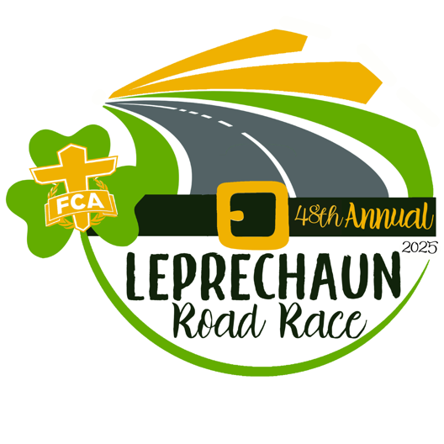

Heart of Georgia Fellowship of Christian Athletes is seeking sponsorships for the 48th Annual Leprechaun Road Race that will be held on March 14th, 2026 at 8:00 A.M. at Dublin High School. This will be a fun St. Patrick’s event for the whole family.
Please partner with us and check your level of commitment. Return this form to Spence Lovett of FCA (478-279-2868) or mail the form to address below.
Your sponsorship will enable us to expand our FCA ministry in the Heart of Georgia community by providing scholarships to athletes and coaches to FCA camps, providing Bibles for our area teams, and supporting our FCA clubs in the public and private schools.

Please scan the QR code below to register your sponsorship online or return this page and make checks payable to Fellowship of Christian Athletes at the address below. To include your company in advertising media or t-shirts, sponsorship monies and logos need to be received by March 4th, 2026. Thank you!

Heart of Georgia FCA 1285 7th Street
Dudley, GA 31022

SPONSOR NAME ____________________________________________________________________________ SPONSOR CONTACT ________________________________________________________________________ CONTACT’S EMAIL _________________________________________________________________________ MAILING ADDRESS _________________________________________________________________________
SPONSORSHIP LEVEL: ____PRESENTING ____PLATINUM ____GOLD ____SILVER
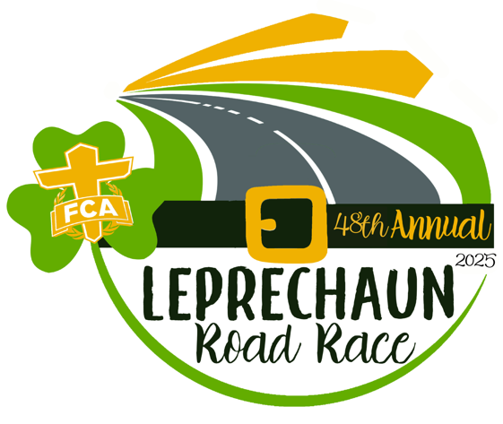

Sponsorship Packages

Chick-fil-a, Presenting Sponsor, $5,000
(Limited to ONE business)
- 15 individual race registrations
- Largest logo or name included on race banner, shirts ~700 & HOG webpage
- Opportunity to set up company tent at race
- Business acknowledged on Heart of GA FCA Social Media event post
- Yard sign on race course
- Opportunity to advertise in ~ 700+ participant packets

Platinum Sponsors, $1,000
- 5 individual race registrations
- Prominent logo or name included on race banner, shirts ~ 700 & HOG webpage
- Opportunity to set up company tent at race
- Business acknowledged on Heart of GA FCA Social Media event post
- Yard sign on race course
- Opportunity to advertise in ~ 700+ participant packets

Gold Sponsors, $600
- 3 individual race registrations
- Logo or name included on race banner, shirt on ~ 700+ & HOG webpage
- Business acknowledged on Heart of GA FCA Social Media event post
- Opportunity to advertise in ~ 700+ participant packets

Silver Sponsors, $300
- 1 individual race registration
- Name included on shirt ~ 700 & HOG webpage
- Business acknowledged on Heart of GA FCA Social Media event post

