Howard County Cubs Board Minutes
Tuesday,10.6.2021
Attendees |  | Guests
Torrey Roe, President |  | Paul Jordan
Josh Helmberger, Vice-President |  | Shay Harden
Rhiannon Thompson, Sec/Treasurer
Dan Keeney, Social Media

Officer Reports
Torrey called the meeting to order. Guests and coaches were welcomed.
Minutes: The minutes from September were reviewed. Josh motioned to approve the minutes and Dan seconded the motion. No other discussion was made.
Equipment: Kevin was not in attendance. No update.
Social Media: Nothing to update.
Sec/Treasurer: Rhiannon will be working with Chris Tuberty to open the Parent Apparel store. We’re looking at adding crew neck sweatshirt with pocket, bucket hat, ponytail hat, cage jacket, long sleeve qtr zip, compression gear, golf ball marker, ear bands, gym shorts, ¾ qtr baseball shirt (ie. solid sleeves, white shirt), and socks w/ logo.
Rhiannon sent out an email to all parents regarding ProX. They’re offering a discount on the monthly membership.
Rhiannon is waiting to receive background checks on everyone. Please make sure all coaches have a file where they save their birth certificates. The print outs of everything will be included in the coaches packet.
Insurance was paid and expires in Sept 2022. The cost was $1300.61 which is $11.02/team. She will be taking it out of each team’s account soon.
Vice-President: Josh asked about the place on Boulevard and wondered if it would be a good place to lease. We discussed costs and how much we would need to charge per kid to be able to provide an indoor place to play.
President: Torrey has been given available dates/times for practices. Rhiannon sent out an email asking for first, second, and third options for practice times. No two teams requested the same days/times so Torrey will put the schedule together. The cost per year is $350.00.

Tournament schedules are out. Torrey talked to Kory at USSSA and if we book 3 tournaments that list the tournament director as Indiana USSSA Baseball State Office, we will get $25 off per tournament. If we book 5 or more, we get $50 off per tournament. However, one of the tournaments must be the state tournament.
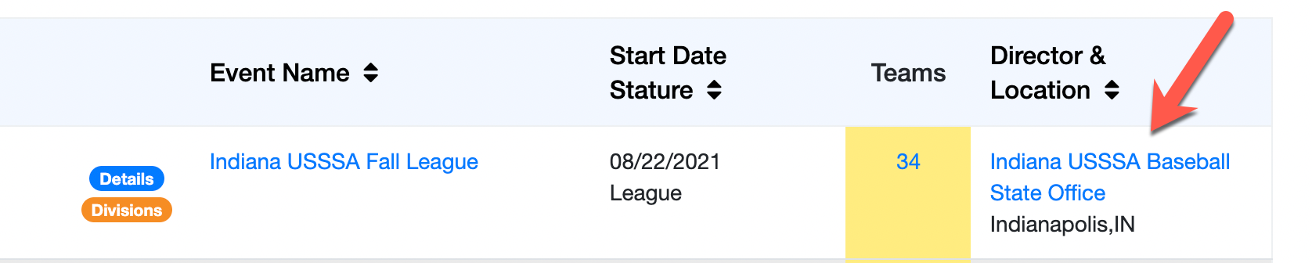
Josh said if people need a new place to play, Ft. Wayne has a great turf complex. There are a lot of good restaurants around the facility, too. Border Wars is another great tournament. Multiple coaches have mentioned to stay away from Cicero tournaments. Crown Point is another great location to try.

Old Business
- Bilaws: Bylaws approved and signed by all board members except Kevin (not present). Josh made the motion and Dan seconded it.
- Uniforms: Uniforms were paired down from 12 to 4 designs that teams can choose from. Rhiannon will send this information out ASAP. Just clarifying a few last things.

New Business
- Uniform Fitting Day: We will have uniform fitting day on Dec 12th at 2pm. The breakdown of teams/times will be available soon. Fitting day is MANDATORY for all players.
- New Bear Logo: An optional logo was brought to the table regarding hats. Paul was going to see if his daughter could re-design the logo. If not, Rhiannon will work on another option.
- Bullpen Discount Code: Michael from Bullpen has requested us to book our tournaments and select the option to “pay later”. He will then give us a discount code to use.

No further discussion. Dan motioned to adjourn the meeting and Rhiannon seconded the motion. Motion passed.

Next Meeting: November 2nd at 7:00pm at B-Dubs

