Howard County Cubs Board Minutes
Tuesday,12.7.2021
Attendees |  | Guests
Torrey Roe, President |  | Brian Gillespie
Josh Helmberger, Vice-President
Rhiannon Thompson, Sec/Treasurer
Dan Keeney, Social Media

Officer Reports
Torrey called the meeting to order. Guests and coaches were welcomed.
Minutes: The minutes from October were reviewed. Dan motioned to approve the minutes and Josh seconded the motion. No other discussion was made.
Equipment: Kevin was not in attendance. No update.
Social Media: A post was made on Facebook where parents can post equipment for sale in the comments. Please utilize this if you have bats, etc to sell!
Sec/Treasurer: Fitting Day is Sunday, Dec 12 at 2pm at The Zone. Enter thru the back door. Coaches will need to bring clipboard (or something to write on) and pen. Please also send out reminders to parents. Rhiannon will give you a spreadsheet to collect sizes and these are due to Rhiannon at the end of the fitting. If you have kids not in attendance, you’ll need all their sizes beforehand. Sizing is attached in the email.
Parent apparel items should be delivered next week. We will open another parent apparel store in January. The new items we requested were all super low stock so we hope that they can be added to the January store. We’re looking at adding crew neck sweatshirt with pocket, bucket hat, ponytail hat, cage jacket, long sleeve qtr zip, compression gear, golf ball marker, ear bands, gym shorts, ¾ qtr baseball shirt (ie. solid sleeves, white shirt), and socks w/ logo.
Rhiannon is currently waiting on background check images from 11U Jordan, 12U Keeney, 13U Pike, 13U Beatty, and 16U Canady. These need to be sent to Rhiannon BEFORE Sunday, Dec 12th in order for her to print them out and add them to your coach’s packet. She’ll be passing them out at the fitting.
Gear update: Helmets (from Bullpen) are currently out of stock. They’re hoping to get more in for January. You’ll be contacted when we can order these.
Bags are being embroidered. Hope to receive those soon. I need to collect bags from Kevin Pike and Paul and get them to Chris Beatty and Brian Canady.
Vice-President: Nothing to update.
President: If you’re renting Burlington- the code is 3792. Please let Torrey know if there are any issues.

Old Business
- Procedure for team discounts for USSSA: If we book 3 tournaments that list the tournament director as Indiana USSSA Baseball State Office, we will get $25 off per tournament. If we book 5 or more, we get $50 off per tournament. However, one of the tournaments must be the state tournament. When the tournaments are in your cart, email kory.scaringe@usssa.com and let him know you’re ready to check out and he will discount them. When you’ll go back into your cart and see the discounted price.
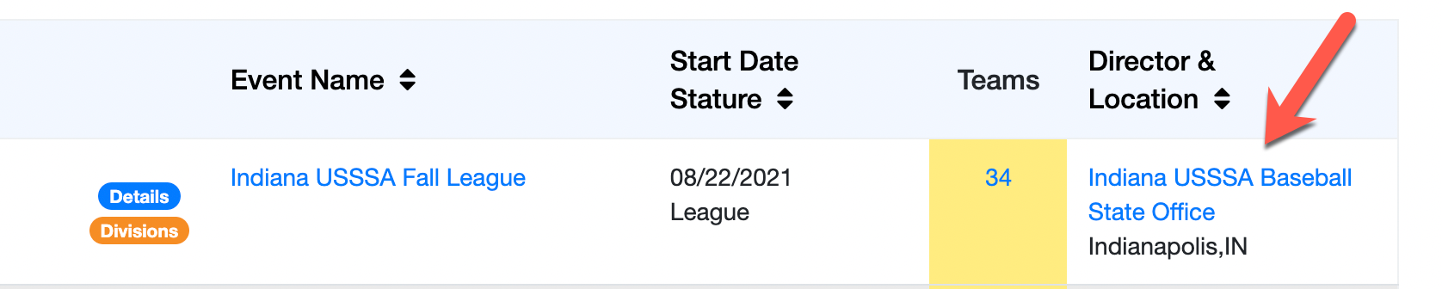

- Procedure for team discounts for BULLPEN: If we book 1-2 tournaments we get 10% off, 3-4 tournaments for 12%, or 5+ for 15% off. Add them to your cart and click “pay later”. You’ll have to pay a small amount of the cost. Then email Michael Tucker at tucker@bullpenathletics.com and let him know you’re ready to check out and he will discount them. When you’ll go back into your cart and see the discounted price.

New Business
- Schedules: All tournament schedules should be set by 1/1/22. They need to be emailed to Rhiannon ASAP to be added to calendar. This can be a screenshot, list, etc. These will be listed on our website.
- Account Reduction: The administrative fee ($100/team) and $350 for Burlington practices (for those using Burlington) will be taken out of your accounts on Monday. Dec 20th.

No further discussion. Josh motioned to adjourn the meeting and Dan seconded the motion. Motion passed.

Next Meeting: January 4th at 7:00pm at B-Dubs

