SMRT TRAINING

KIDS HORSE CAMPS SUMMER 2026
At 17421 state Hwy 8, Morrison, co 80465
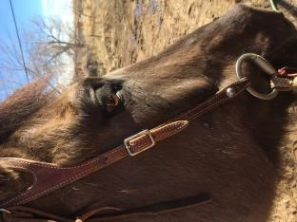
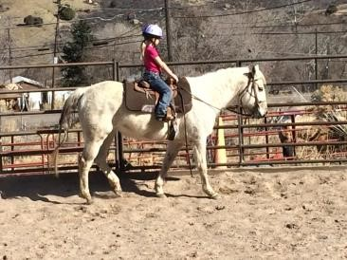
Jenn Glider smrttraining@aol.com

5 DAY KIDS HORSE CAMP
Session #1: June 8th-12th Session #2: July 22nd-26th
Sesson #3: July 13TH-17th
5 to 14 year old boys and girls
All Levels Welcomed!
8:30 a.m -11:30 a.m.
$470 per rider
$50 deposit non-refundable
Thank You!
Cash/check and zelle at smrttraining@aol.com or (303)619-0452 is only accepted! No VENMO PLEASE! THANK You!

******* 5 DAYS OF NON STOP HORSE******
*Riding, Feeding, Cleaning, Tacking, watering, brushing, bathing, Learning the parts of the horse, Learning Safety, Riding Bareback, Riding Lesson, Games on Horseback, Art, Crafts.
*Please bring a healthy snack Daily!
*Please bring Water Bottles, sunscreen, boots and helmets *Parents are always welcomed, but please stay out of round pen, arenas and barn when camp is going on. Thank You.

Please fill out the form below and make checks payable to SmrtTraining and send it. Venmo also accepted @Jenn-Glider Thank You! ___________________________________________________________________________________________
Riders Name:________________________________________
Riders Age:____________________________________
Parents Name:_____________________________________
Address:______________________________________________
Phone Number:______________________________________
Email Address:_________________________________________
Camp Date Requested:_____________________________
Past Horse Experience:________________________________________________________
_______________________________________________________________________________________
Deposit Check #:_______________________________

