SMRT TRAINING
KIDS 3 DAY HORSE CAMPS / SUMMER 2026
At 17421 state Hwy 8, Morrison, co 80465
Jenn Glider(303)619-0452
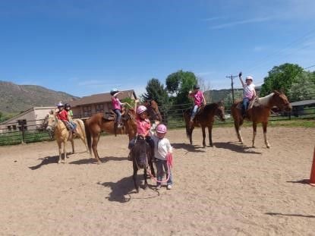 smrttraining@aol.com 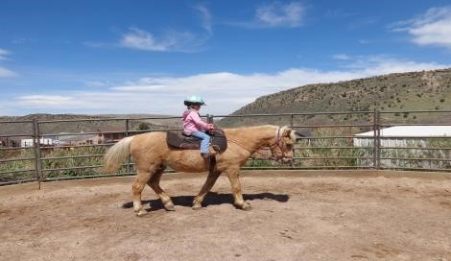

Session #1: June 1st-3rd Session #2 :June 8th-10th Session #3 : June 22nd-24th
Session #4: July 6th-8thSession#5: July 13th-15th Session#6: July 27th-29th Session #7: August 3rd-5th

5 to 14 year old boys and girls Beginners to Intermediates
8:30 a.m -11:30 a.m.
$280 per person /per session
$50 deposit non-refundable Thank You!
******* 3 DAYS OF NON STOP HORSE******
*Riding, Feeding, Cleaning, Tacking, watering, brushing, bathing, Learning the parts of the horse, Learning Safety, Riding Bareback, Riding Lesson, Games on Horseback, Art, Crafts.
*A Healthy Snack will be Provided
*Please bring Water Bottles, sunscreen, boots and helmets *Parents are welcomed to stay and watch the Fun! Fun! Fun!
CASH/CHECK AND ZELLE @smrttraining@aol.com are accepted! PLEASE NO VENMO!
Please fill out the form below and make checks payable to SmrtTraining and send it. Thank You! ___________________________________________________________________________________________

Riders Name:_________________________________________
Riders Age:___________________________________________
Parents Name:________________________________________
Address:________________________________________________
Phone Number:________________________________________
Email Address:__________________________________________
Camp Date Requested:__________________________________
Past Horse Experience:______________________________________________________________
_______________________________________________________________________________________
Deposit Check #:_______________________________

