SMRT TRAINING INETERMEDIATE/ADVANCED KIDS HORSE CAMP 2026
At 17421 State hwy 8
Morrison, Co 80465
(303)619-0452
With JENN GLIDER smrttraining@aol.com
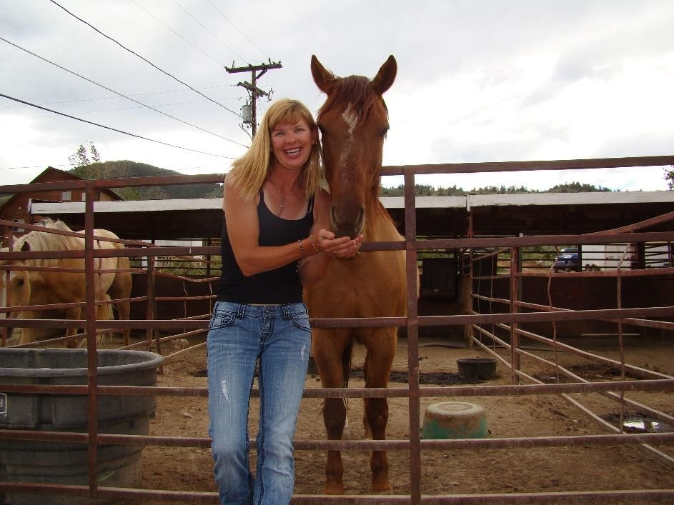
3 Days of Non-Stop Horses!!
Session #1: June 15TH-17TH
Session #2: June 29TH-JULY 1ST
Session #3: July 22nd-24th

Previous Riding Experience and Camp Experience(Riders must be independent at Catching/Leading/Tacking/Reining/ Control at Walk and Trot and starting on Canter) Thank You!
$365 PER RIDER/PER SESSION ($50 NON-REFUNDABLE DEPOSIT) **Bareback Riding*Barrel Racing*Pole Bending*Ground/Round Pen Work*Obstacle Work*Lateral Motion*Collection*Being more Independent*and Fun!
Please fill out the form below and make checks payable to Jenn Glider! CASH/CHECK AND ZELLE ARE ACCEPTED!
ZELLE IS AT SMRTTRAINING@AOL.COM OR (303)619-0452. PLEASE NO VENMO!!!!!
Thank You!!

Riders Name: ____________________________________________
Riders Age: ___________________________________________
Parents Name: _________________________________________
Address: _______________________________________________
Phone Number:__________________________________________
Email Address: ___________________________________________
Past Horse Experience: _____________________________________
Deposit Check # :__________________________________________

