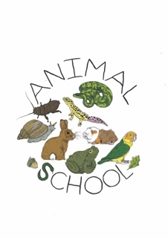
Animal School – 12-Week Course Referral Form
Date of Referral:

Field | Details

Name
Role / Organisation

Contact Email

Referrer Details

Contact Phone

Student Details

Name

Date of Birth

Gender

School / Year Group

EHCP / SEN Status

Allergies / Medical Considerations
Type | Details / Severity | Action Required / Precautions

Animals / Insects

Environmental (e.g., pollen

Food

Medications

Other

Areas of Interest / Strengths
(Tick all that apply and add notes if needed)
- ☐ Art / Creative Activities
- ☐ Gardening / Outdoor Work
- ☐ Animals / Animal Care
- ☐ Practical Tasks / Hands-On Work
- ☐ Teamwork / Ability to Work with Others
- ☐ Other:
- Additional notes on interests or strengths:

Reason for Referral / Areas of Support Required
(Tick all that apply and provide additional notes)
- ☐ Confidence / Self-Esteem
- ☐ Emotional Regulation
- ☐ Social Skills
- ☐ Engagement in Learning
- ☐ Anxiety / Stress Management
- ☐ Behavioural Support
- ☐ Other:
Brief description of why the student is being referred:

Previous Interventions / Support
Intervention | Duration | Outcome / Notes

Risk Assessment / Behavioural Information
Question | Details
Are there any known risks or challenging behaviours we should be aware of?
Has the student been expelled from a school? | ☐ Yes ☐ No
Has the student previously exhibited aggression or violent behaviour? | ☐ Yes ☐ No
Is there a history of criminal behaviour or involvement with the justice system? | ☐ Yes ☐ No
Additional safety notes / precautions for staff or animals
Is there a behaviour support plan in place? | ☐ Yes ☐ No (If yes, please attach)

Parental / Guardian Consent
Field | Details
Name
Relationship to Student
Signature
Date
I give consent for my child to participate in Animal School’s 12-week course subject to a 6 week review and for relevant staff to share information for educational, wellbeing, safety, allergy-related, and interest-based planning purposes.

Six-Week Review

Date of Review

Facilitator

Observations / Progress

Additional Information / Notes

Adjustments / Actions Required

For Animal School Use Only
Field | Details
Date Received
Course Start Date
Assigned Facilitator
Risk Level / Precautions
Notes / Recommendations

