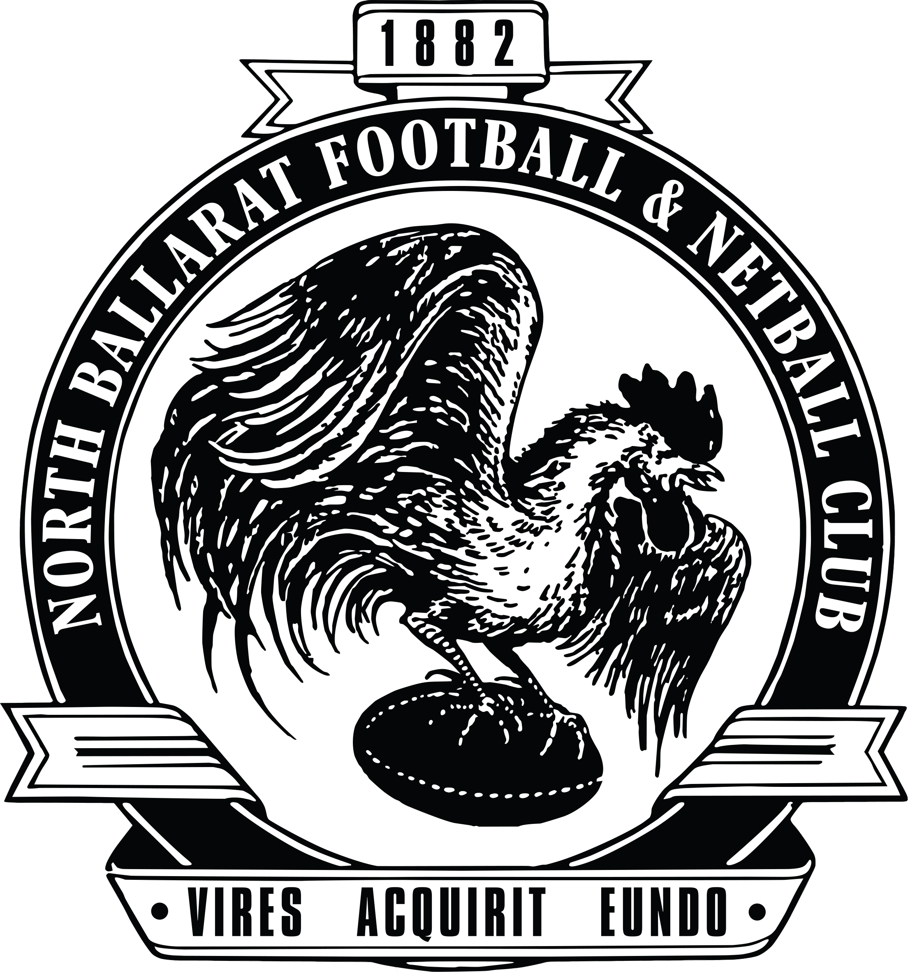
North Ballarat Football Netball Club Inc

ABN 16 136 415 307

Annual General Meeting

AGENDA
The Annual General Meeting (AGM) of the North Ballarat Football Netball Club Inc will be held on Wednesday 11th March 2026 commencing at 7:00pm.

- WELCOME BY PRESEDIENT, Terry Hay

- APOLOGIES

- CONFIRMATION OF MINUTES
3.1 North Ballarat Football Netball Club Minutes of previous AGM held on 17th December 2024 are attached.

Recommended Motion:
That the minutes of the AGM held on 17 December 2024 be confirmed

Moved: Second: Carried

ORDINARY BUSINESS

To receive and consider the following:

The Financial Reports of the Association

Recommended Motion:
That the meeting adopt North Ballarat Football Netball Club’s Financial Reports of the year ending 2025

Moved: Second: Carried

Auditor’s Report’s

Recommended Motion:
That the meeting adopt North Ballarat Football Netball Club’s Auditors Reports of the year ending 2025

Moved: Second: Carried

Board Elections
In accordance with the rules of the association the following three members have been elected. With five positions available and three nominations there was no requirement for an election.
    - Brad Beseler (Secretary 2 years)
    - Lenny Quinlan (Business Operations Director 3 years)
    - Michael Ryan (Football Director 1 year)

CONFIRMATION OF HALL OF FAME & LIFE MEMBERS

Nominees invited to propose the nominations for Hall of Fame & Life Membership

Move: Seconded: Carried

AUDITOR APPOINTMENT

Recommended Motion:
That CountPro be appointed as the new auditors of the North Ballarat Football Netball Club Inc. for the 2025/2026 financial year

Moved: Second: Carried

SPECIAL BUNISESS (To which notice has been given)

No notice of any special business item

- CLOSE OF MEETING

