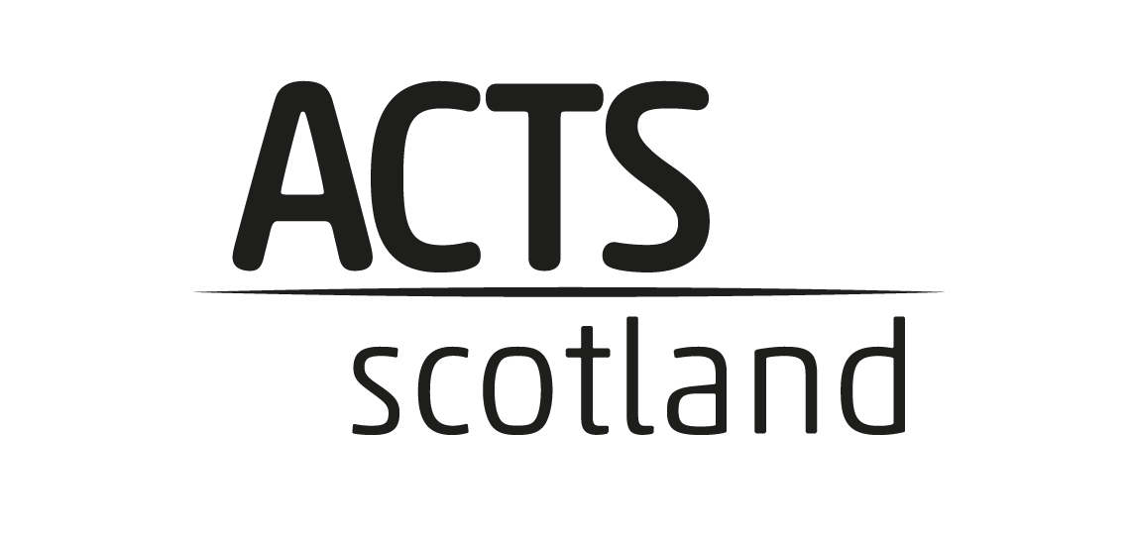
ANNUAL REPORT 2024
Programme: Moving On, Moving Up – (phase 2)
Brief summary of the key activities we've undertaken
The activities incorporate the core skills employers are looking for as well as the softer
skills such as listening, speaking, creativity, staying positive, aiming higher, leadership
and teamwork. Providing training and employment opportunities for young local
residents provides a number of benefits. The activities recycle money in the local
economy by providing jobs, it reduces antisocial behaviour by engaging with and
occupying disaffected young people. The activities will bring a sense of social
responsibility and increase inclusion and empowerment. Increasing the business
activity, trading and commercial viability of the community area as well as
empowering young people with business skills. ASDAN offer imaginative ways of
developing, recording and certificating a wide range of young people’s personal
qualities, abilities and achievements, as well as introducing them to new activities and
challenges. All the programmes link to nationally recognised qualifications, which
contribute to performance tables.

How we have you involved people in developing and delivering your activity?
At the end of every session we ask for feedback from the young people and on the
completion of the Employability Module they complete a self assessment checklist
and we use these to determine if outcomes were achieved for the young people.
At the end of the module we also discuss the Module, pros and cons, future
development,
Improvements, what worked well and we use this to develop and improve the
activities we deliver.
Although the face to face Employability Skill Programme is still very relevant we have
had a big response from young people leaving school (referrals) who are looking to
gain a qualification and work-based activities which the Short Course can provide.
Through feedback from our 2023 Cohorts, we had introduced the ASDAN Short
Courses which are flexible, portfolio-based programmes, designed to accredit up to
60 hours of activity and skills development.
The Short Courses will be delivered through e-learning, or face to face including but
exclusive to the following courses: Sports and Fitness, Gardening, FoodWise and
Environmental.
The feedback from 2024 Cohorts is to increase this range of activities and we now
offer the following.

How have we built on people’s strengths?
The young people we are working with have been disengaged at school, attendance
at school was low and they lacked confidence in their own abilities. We are also
working with young carers, young parents, young people who have turned 16 and left
school without any suitable qualifications for future positive destinations.
What the Academy programme has done is to provide a safe, welcoming and informal
environment for young people to learn at their own pace and without any pressure.
Through our Academy learners have shown growth in maturity and confidence. Pupils
who attended also displayed improved attendance in school, particularly those who
had very poor attendance would always appear on a Tuesday and Friday to attend the
programme.
The young people gained two recognised awards from both the Employability and
Short Course Modules which will undoubtedly help their chances of achieving a
positive destination.
The Academy was able to give the young people increased confidence in their own
abilities, an awareness that they can achieve anything with the correct focus and it
also allowed the young people to overcome their anxiety within a group context.
We also provided clear links and a planned destination for those who had completed
the Short Courses in terms of volunteer work and also in some cases work experience.

Connections we have you had with other organisations?
The Academy delivers the ASDAN suite of programmes and is an ASDAN
Registered Centre.
The Academy is working directly with Secondary Schools in Stirling, and we have
managed to work with many more schools which was one of our targets from Year 2,
to open up the courses to as many people as possible across the Forth Valley.
In Clackmannan we are still working closely with Forbes Maginnis (Virtual
Headmaster) and Catriona Scott (Senior Manager Education Clackmannan Council)
who continue to open doors at the Secondary Schools for the Academy. The pipeline
after the Modules are completed is still to point the young people in the direction of
SDS (Clackmannan) and the Jobcentre.
We have recently received funding from NOLB and this is to employ a Project Co-
Ordinator for 15 hours per week who starts on the 26th November 2024.
The role will involve mentoring, next steps and ongoing support for the young people
to the young people engaged on their provision. The role will be working with young
people aged 16 – 24, stage 4 and 5 of the Stirling Council Employability pipelines
providing opportunities for employment, volunteering, work experience or onto
further education.
Part of the role will also be to engage, maintain and develop working relationships
with partner organisations, other providers, 3rd Sector organisations, Secondary
schools, Colleges, Learning and Employability Team, Stirling Council, Falkirk Council
and Clackmannan Council as these links will be of benefit to our young people taking
their next steps to positive destinations. Over the past five years we have established
a strong core base of organisations and individuals who we work with.
We continue to work with CTSi in Clackmannan, Tracy Duff from SV Enterprise, Lisa
Steele from Schools, Learning & Education (Stirling Council), Andrew McCool,
Opportunities for All Coordinator Schools, Learning and Education at the Stirling
Council Gordon Wright plus Lynn Hadden, Learning and Employability Stirling Council.
The Academy is also working with Lyndsay Reynolds at St Modans High School; Claire
Younger, Social Worker Children with Disabilities Team at Stirling Council; Naomi
MacPhail Outreach Teacher Stirling Council, DYW Co-Ordinator at Dunblane High
School, Fiona at Balfron High School and Val Bjerland, Care Experience Outreach
Teacher (Secondary)
The Academy still has Scottish Spots Futures (SSF) in to deliver a module on Wellbeing
around motivation and Kirsty from Daisy Stirling has also continued to deliver 1 st Aid
courses.
All three of the sessional workers from last year who we had from the University are
still with us and have taken on a more responsibilities in delivering the Employability
Skills Development programme, both as Tutors and Mentors for the young people,
whilst Tony has worked on the Short Courses Delivery.
The new Project Co-Ordinator will also start to deliver the Short Courses after her
training with ASDAN on the 14 th December 2024 and will provide support for the
sessional workers.

What difference are we making?
S4 Pupil (was going to leave school in January 2025)
He found himself having to relocate to another Secondary School when his
parents moved to another town. Marcus by nature is introvert who is struggled to
make friends and by his own admission did not ‘fit’ in. He is on a reduced timetable at
school as school is not really for him but he has a passion for animals especially
reptiles and spiders. So subjects which like Biology he enjoys although he struggles
when it comes to exams.
We were contacted by the school through the DYW Co-ordinator and I met up with
him and showed him the Animal Care Short Course through ASDAN and he
immediately said yes to starting the programme. He has been absolutely
brilliant, is working his way through the all the Modules and it has been so rewarding
to see a young person develop his knowledge and confidence. We have arranged for
him to volunteer at a local Veterinary Clinic and he also volunteers at a shop in
Falikirk which specialises in reptiles which he organised by himself.
He now has new goals and is looking at further education or he might stay on at
school if he cannot find a course which suits him.
He has become a fabulous Ambassador for us and we have had another three
young people starting the Animal Care Short Course from his direct recommendation.

Update from Forbes Maginnis Virtual Headmaster Clackmannan
CMS Leadership Academies (ACTS Scotland) has partnered with the
Clackmannanshire Virtual HT now for around 15 months, and have so far delivered 8
academies.
Almost 70 young people have benefited from this targeted intervention, supporting
enhanced confidence and self-efficacy.
Around 40 of the young people have either been non-attending or very low
attendance at traditional school due to emotional wellbeing, mental health or
complex family circumstances. Almost all young people have completed the course,
leading to a Level 3 Employability Award with 12 individual mini-units that are
recognised by colleges and employers.
It has expanded to include a First Aid Qualification delivered by Daisy First Aid, as part
of the programme. Around 40 young people have achieved this.
Throughout the programme, young people are visited by Skills Development Scotland
which supports next steps and development of pathways to employment.
In the first Cohort, 5 of the 8 went from no plan to having a positive and sustained
destination, 3 returned to school having been non attending and then subsequently
had a positive destination thereafter.
An analysis of attendance with a group of S3 boys and Alloa Academy showed a 10%
increase in attendance across a two term period, this was identified by the depute
headteacher and shared with Education Scotland as part of their inspection of the
school.
Students from Alva Academy completed the program and then went on to undertake
an experience with the Scottish fire and rescue service. These pupils, at that point,
were not attending school but subsequently returned to school as part of a planned
approach alongside the virtual headteacher.
Currently, we are working with a group of S1 students who lack confidence and are
seeing an attendance of 70% at school. The present group at the Academy is
currently at 90% attendance and they report, verbally, increased confidence.
The program has also supported Clackmannanshire leavers. Almost all young people
in S4/5 who have completed the Academy have a positive destination.
This programme is having significant impact for our YP

What have we learnt from our activity this year?
The success we have had and the impact the Academy has had, continues to humble
us as there is such a need for young people to be heard, consulted and directed to
positive destinations.
Our decision to move from Education Through Cashback (ETC) modules to ASDAN
qualifications and Certifications continue to be justified with the buy in from the young
people.
The confidence gained by the young people has been inspiring and is humbling to see the
development of young people to positive destinations
With the young people we are working with we needed to create an environment which the
young people feel safe in and would be happy to participate in an informal setting as far
removed from a school setting as possible.
One of the challenges with the young people was ensuring they got to as many sessions as
possible especially with those young people whose school attendance was poor as there
was a minimum requirement to gain the Certification. Creating the correct environment
has ensured that the young people have come back on a regular basis and there were not
many drop offs.
Once we have completed the Employability Skills Development programme it was pleasing
to see the number of young people who were then interested in doing Short Course
training specific to their area of interest.
What we have also learnt is that the young people do not like it if teachers drop in
unexpectedly whilst on our programmes. There is marked change in atmosphere and the
young people then withdraw into themselves, and the session becomes challenging. We
have had to speak to certain schools about dropping in unexpectedly as it effects
the flow of our session (Fortunately this did not happen as often in 2024).

