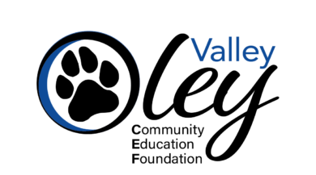
Enhancing Educational Excellence in the Oley Valley
P.O. Box 331, Oley, PA 19547 610-987-4100 ext. 1200
OleyValleyCEF.com OVCEF@ovsdpa.org
As the Oley Valley Community Education Foundation (OVCEF) approaches 30 years of service to the Oley Valley, we are proud of the role our local business community continues to play in strengthening educational opportunities for students and residents throughout our district.
Since our founding in 1996, OVCEF has worked in partnership with educators, community organizations, and local businesses to support innovative programs that extend learning beyond the traditional classroom. From hands-on STEM initiatives and classroom technology to community-based programs through the Oley Valley Community Library, our work is rooted in one shared goal: enhancing educational excellence in the Oley Valley.
During the 2024–2025 school year, OVCEF funded approximately $117,000 in Education Grants benefitting students across all three schools in the Oley Valley School District and awarded $36,000 in scholarships to graduating seniors. These opportunities would not be possible without the continued investment of businesses that believe in the long-term value of education.
We are writing to invite you to become a 2026 Friend of the Foundation Sponsor, helping to provide the stable, year-long support that allows OVCEF to respond to educator needs, invest in innovative learning experiences, and serve both students and the broader Oley Valley community.
Annual sponsorships support OVCEF’s mission as a whole and ensure we can continue funding impactful programs throughout the year. In recognition of our sponsors, we offer meaningful visibility and engagement opportunities designed to highlight your commitment to education and community support. The enclosed sponsorship levels outline the benefits available at each level.
Please note that sponsorship opportunities for specific fundraisers and events will be offered later in the calendar year, providing additional ways to support OVCEF initiatives if you choose.
We would be honored to partner with you in the coming year. If you have any questions or would like to discuss sponsorship opportunities further, please feel free to contact Jennifer Schorr, Executive Director of OVCEF, at 610-987-4100 x1200 or oleyvalleycef@gmail.com.

Thank you for your interest and we look forward to partnering with you.

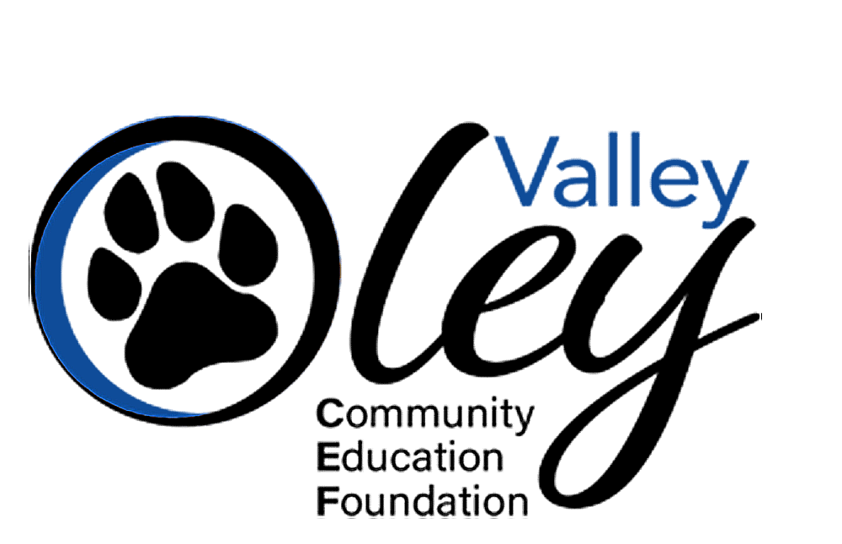

2026 FRIEND OF THE FOUNDATION
SPONSORSHIP LEVELS

Premier Level Sponsor – $5,000
Exclusive Premier Benefits:
- Featured Partner of the Month (with option to select preferred month, based on availability)
Exclusive recognition as our Featured Partner of the Month on the OVCEF website, including:
– A custom graphic featured on our rotating homepage carousel
– A dedicated blog post highlighting your business and community impact, displayed on our homepage for the month
– Recognition on our social media channels
- Education Grant Experience
Exclusive invitation to accompany the OVCEF Executive Director on a visit to see one of the Foundation’s funded Education Grants in action and witness firsthand the difference your support makes for students and educators.
- Exclusive Invitation to Friends of the Foundation Breakfast
Invitation-only event where Premier Sponsors receive a behind-the-scenes look at the innovative Education Grants their sponsorship help make possible.
- Opportunity to Provide Branded Materials at Foundation Events
Premier Sponsors may give us company-branded items like notebooks, pens, etc. to hand out at events OVCEF hosts or participates in, such as the Oley Fair or our Golf Tournament.
- Plus, all Partner Level benefits.

Partner Level Sponsor – $2,500
- Logo, name & recognition of sponsorship level on home page of website throughout the calendar year & social media posts highlighting sponsorship.
- Logo & name on Annual Report mailed to over 600 households and distributed throughout the year at school events, etc.
- Logo & name on Email Newsletters sent out a minimum of 4 times per year to over 2,000 individuals.
- Recognition as a supporting sponsor of all OVCEF fundraising events throughout the year.
- Verbal recognition at all OVCEF events.
- Recognition on the Big Screen during Community Summer Movie events, featuring all Partner & Premier Level Sponsors.

